Digital citizen
9 elements

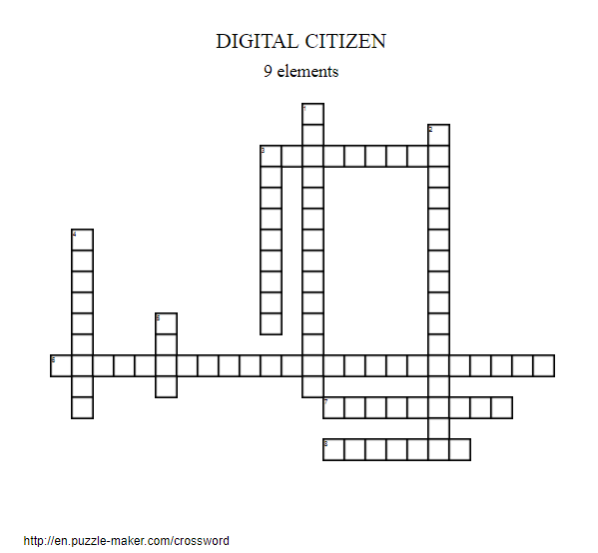

KEY:

EACCESS / full electronic participation in society
ECOMMERCE / electronic buying and selling of goods
ECOMMUNICATION / electronic exchange of information
ELITERACY / process of teaching and learning about technology and the use of technology
ETIQUETTE / electronic standards of conduct or procedure
ELAW / electronic responsibility for actions and deeds
RIGHT and RESPONSIBILITIES / those freedoms extended to everyone in a digital world
HEALTH AND WELLNESS / physical and psychological well-being in a digital technology world
ESECURITY / electronic precautions to guarantee safety

