Digital Citizen – 9 elements
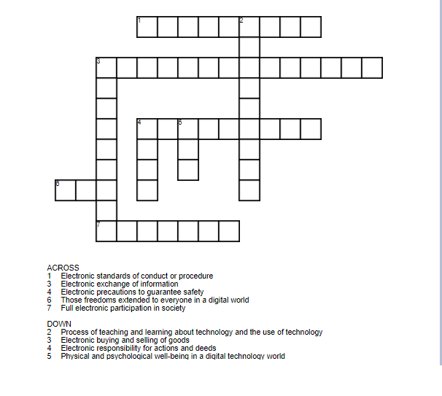

KEY:

EACCESS / full electronic participation in society
ECOMMERCE / electronic buying and selling of goods
ECOMMUNICATION / electronic exchange of information
ELITERACY / process of teaching and learning about technology and the use of technology
ETIQUETTE / electronic standards of conduct or procedure
ELAW / electronic responsibility for actions and deeds
ERR / those freedoms extended to everyone in a digital world
EHW / physical and psychological well-being in a digital technology world
ESECURITY / electronic precautions to guarantee safety

