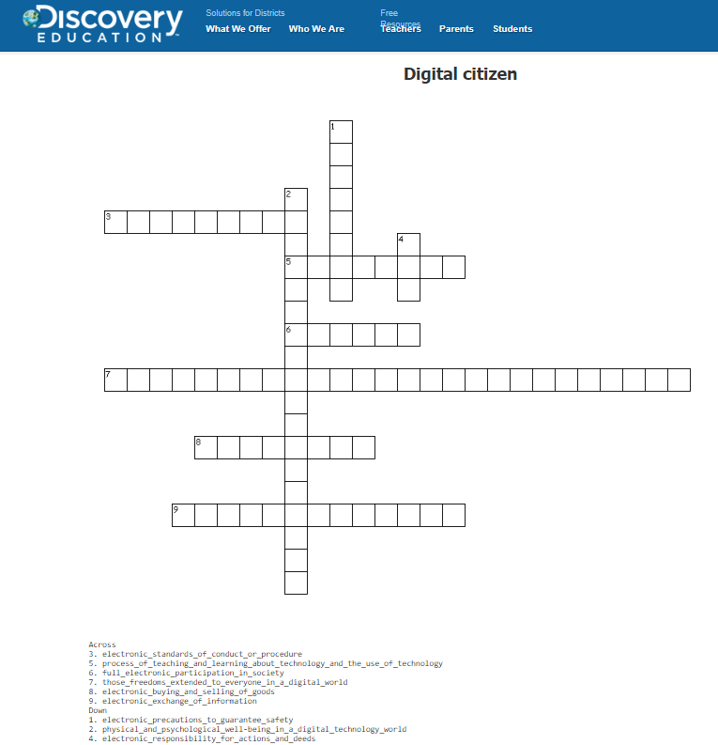

KEY:

ACCESS / full electronic participation in society
COMMERCE / electronic buying and selling of goods
COMMUNICATION / electronic exchange of information
LITERACY / process of teaching and learning about technology and the use of technology
ETIQUETTE / electronic standards of conduct or procedure
LAW / electronic responsibility for actions and deeds
RIGHT AND RESPONSIBILITIES / those freedoms extended to everyone in a digital world
HEALTH AND WELLNESS / physical and psychological well-being in a digital technology world
SECURITY / electronic precautions to guarantee safety

