The relationship between sender and receiver.  When two people have a conversation, different factors play a role, such as the relationship between sender and receiver.  If you are angry with someone, you may have a critical and cold tone towards the person, even if they are saying something sensible and have some good points. |  |  | Body language  Pay attention to people, they might say something but their body reveals their true feelings and intentions.  Pay attention to people, they might say something but their body reveals their true feelings and intentions.  We can express our feelings, but we also need to show them. This is often done throw certain non-verbal cues, such as open or closed body language, hand gestures or facial expressions. Next time you are in a conversation or are watching someone speak, try to determine what their body language is conveying, and what it contributes to their overall message. |  |  | Efficient communication in a team  - Good Communication is not necessarily efficient communication  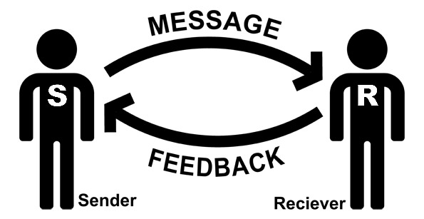

The positive response  As a team player, it is essential give constructive and thoughtful replies. If you are in a group it is important that everyone contributes in the effort to arrive at a certain conclusion. Is it therefore important to have positive, and especially, relevant input for your team.  Here are some ways to achieve this |  |  | Expectations  It is crucial that everyone has and understands certain expectations for the working process. With that, it might be practical to have actual requirements for what each member should do. Distributing work and making sure each member knows what is expected of them and what to do.  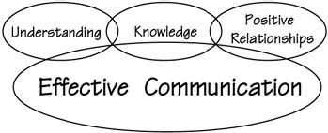  The three cornerstones of effective communication are understanding, knowledge and positive relationships. To understand and be understood is very important. When we listen to what other people say, we understand the words and the |  |  | .meaning of the sentences, but the verbal part of the communication is far from enough to understand the full meaning of what is being said. There are also other factors to take into account, such as nonverbal signals, as in body language, the context of the situation. Preexisting knowledge will also play a part in the communication process, as it is important to make sure that everyone is one the same level of expertise, or at least take it into account if that is not the case. Lastly, positive vibes and relationships will greatly improve what you get out of the process, and improve willingness to cooperate.  Made by  Caroline, Lucian, Maria  Mathilde, Robert, Zilas

