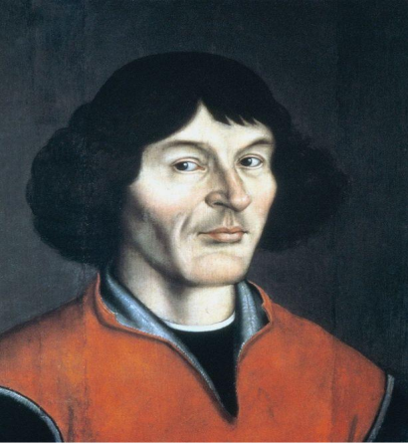
Mikolaj Kopernik (1473-1543), astronomer, mathematician, economist, doctor, priest; He introduced the heliocentric theory of modern science. He studied at the Akad. Krak., Then from 1496 in Bologna (astronomy) and 1501 in Padua (law and medicine); 1503 obtained a doctorate in canon law at Ferrara; at the end of 1503 he returned to Polish (Warmia). In 1504-1510 he was sekr. and medical aide uncle, Bishop of Warmia L. Watzenrode and stayed depth. in Lidzbark; In 1509 he published his Latin in Krakow. translation gr. letters Theophilactus Simocattes; 1510 as a canon settled in Frombork, here conducted observations astr. and he wrote depth. work; From 1516 to 1519 and in the first half. 1521 was the Administrator of the Chapter in Olsztyn; during the war pol.-Teutonic 1520-1521 defended the castle Olszta. against the Teutonic Knights. He was interested in issues of econ., Which was the result of his project to reform the monetary union (1517); a memorandum on the matter submitted by Koprenika to the regional council in Torun (1519), was expanded (1526) and incorporated in the form of a treaty Fri. Monetae cudendae ratio; Copernicus formulated in the principles of monetary reform based on the project improvement and unification of Prussia coins. and a half.; formulated the law econ., according to which bad money drives out better; This right was later called Gresham's law, which was attributed to his discovery. 1510 Copernicus gave outline of the heliocentric theory, in a paper Fri. Commentariolus; It was not published, but circulated in copies, of which 2 were found only in the nineteenth century.
The main work of Copernicus, containing lecture astronomy included in the aspect of the earth's rotation around the axis and circulation together with the other planets around the sun, created from 1515 to 1530. Although Copernicus has not decided on the announcement of the results of their investigations sciences., Only (1535) on the initiative B. Wapowski ed. Almanac (lost) based on arrays astr. De revolutionibus ... news of the theory of the world was widespread in Europe; 1539 arrived in Frombork GJ von Lauchen, called. Rheticus (Rheticus) to become acquainted with it; He bowed Koprenika to issue the work; extracts from it, known under the abbreviated title Narratio Prima, drawn up by Rheticus, was published in Gdansk in 1540; 1541 gave Rheticus Copernicus' work for publication in Nuremberg; the print watched A. Osiander; He withdrew without the knowledge of Copernicus his preface, and put in its place their own, not signed, depicting the Copernican theory as a hypothesis for easy calculation; it was inconsistent with the position of Copernicus, explicitly expressed in the Letter of dedication to Pope Paul III, printed at the beginning of the same book; work was published in 1543 Fri. De Revolutionibus Orbium Coelestium (On the Revolutions of the Celestial Spheres). Copernicus' work, threatening the established views on the construction of the world, did not immediately met with a positive response among both scholars and church authorities. Since the switch. Sixteenth and seventeenth centuries. Copernican theory was gaining more and more supporters, and to consolidate its most contributed G. Bruno, J. Kepler and Galileo. Even the life of Copernicus's theory was met with strong opposition M. Luther, Ph. Melanchthon and Calvin J., as contrary to the text of the Bible. Church katol. initially he did not occupy official positions against the Copernican theory, but later, after the Council of Trent declared it to be the opposite worldview rel .; The Congregation of the Index released (1616) decree condemning De revolutionibus ...; the Index librorum prohibitorum work of Copernicus was removed 1758. The Copernican Revolution (later called as speech and the work of Copernicus) was to overcome the idea recognized for centuries, taking on the old idea of ​​the heliocentric system (introduced to astronomy by Aristarchus of Samos) and for creating the concept of full and close as it was possible in the context of contemporary knowledge, scientific foundation.
Copernicus put forward the claim, which states that if within a large circle rolls without slipping a circle with a radius twice smaller, it is arbitrary, but fixed point of a small circle moves on a large diameter.

