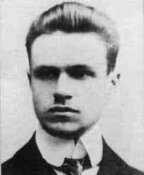
(1888 - 1920)
Co-founder of the Warsaw school of mathematics, initiator and co-founder of the journal "Fundamenta Mathematicae", devoted to the set theory, topology and the foundations of mathematics, a prominent organizer of mathematics in Poland.
Janiszewski studied in Zurich and Göttingen and Paris, where he received a doctorate in mathematical sciences.
Courses taught at Scientific (scientific institution in the years 1906-1915 focuses Polish intellectual elite of the Russian sector), as well as at the University of Lvov. In 1915. He was appointed lecturer reviving the University of Warsaw.
Janiszewski research interests mainly related to the topology. The work in this area gave statements which still retain essential and are known in the literature as a mathematical theorem Janiszewski.
In 1915 she published "Handbook of self-taught", a collection of articles many scholars Polish, which is an interesting synthesis of contemporary mathematical knowledge, which published its own series of treatises on mathematics.
In 1918 the University of Warsaw under the direction of Janiszewski and Mazurkiewicz and Sierpinski working group of Polish mathematicians, which concentrated its activities in the field of topology, set theory and their applications. Consistent implementation of the concept Janiszewski led to the numbering in the world of the Warsaw school of mathematics.
Janiszewski name was called one of the prizes Polish Mathematical Society.

