Image Analysis
Denotative analysis
Motive – What kind of image is it (photograph, painting, drawing)? What does it depict?
People – Are there people in the picture? What are they doing? How are they dressed?
Environment – Which is the environment and how is depicted?
Composition – How is the image composed? Describe the colouring. Is there depth in the picture? How would you describe its perspectives? Where is the centre of the picture? What’s in the foreground and what’s in the background?

Connotative analysis
Interpretation – What atmosphere does the image give? Who is/are the person/s in the image? Does the environment give any clues to who the person/s is/are? Is there something happening outside of the image that we cannot see?
Time – Describe the time of the image. Is there a specific time when the image is taken/painted?
Message – What does the artist/photographer wish to tell us? Is there a message? Does the message come through?
Experience – What does the image make you think and/or feel? Can it tell us something about our lives? What questions would you like to ask the artist/photographer?

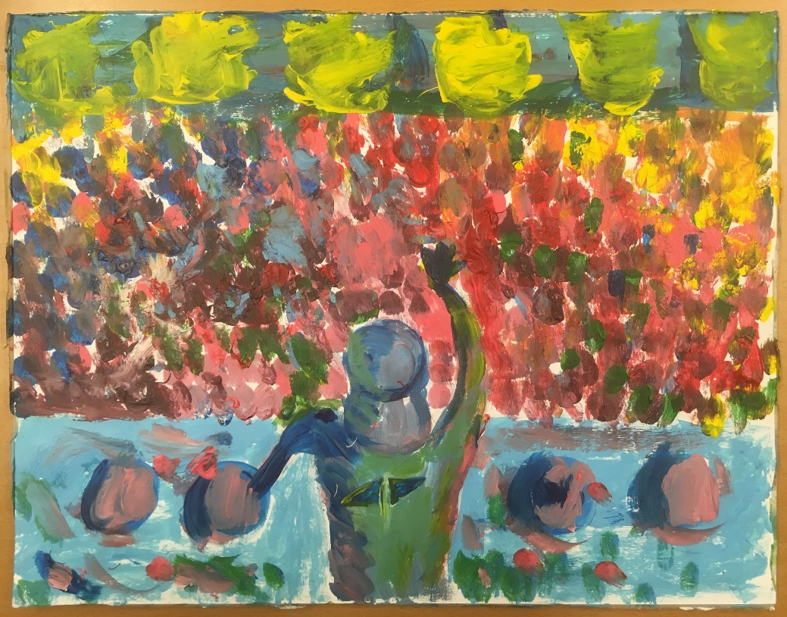

Motives – it’s a painting created by a painter inspired by Avicii. You can see it due it is him standing on the stage behind the DJ booth exactly as he did when he preformed. The painting is telling the story by him preforming and doing a consert somewhere in the world in front of a huge crowd.

Persons – The people in this painting are all looking like they’re having a blast even though they are only small dots of paint. It’s the feeling of the picture as a whole that gives the impression of the happy, joyful audience. And the DJ, that might be Avicii, is dressed in a black hoodie with his emblem on the back.
I can’t really tell what the rest is dressed in but looks like they’re dressed in happy emotions, as weird as it may sound. It looks like they’re just expressing their feelings and that the joy of the concert just flows out of them making them look colorful and joyful.

ENVIORMENT- The paintor is showing a view of a concert and it´s painted in waterpait. It´s not painted very precisely, there aren´t any strickt contours witch makes the picture look less real. The paintor want´s to get a overwiew with still see what rhe picture want´s to show

interpretation - I see i man standing infront of a bunch of people. It’s a whole crowd whose watching him standing on the stage. He performs and everybody in the crowd chears and admires his music. He looks like a typical DJ with cap backwards, which I see as a classic style for a DJ. He puts on a show and watches all of his fans screaming and sing along to all his songs.
We are not allowed to see his face but can see how his arm is facing towards the ceiling. I get a picture that he’s having fun and enjoying himself up on the stage, but maybe we’re wrong to say that because we haven’t seen his facial expression.
We can see which person the artist has illustrated by the mark on the shirt. In the middle of his t-shirt you can see two triangels facing eachother. That’s the famous DJ Avicii’s emblem. He was a Swedish artist who passed away in the beginning of 2018.

Time – I believe the painting is painted after his death. I get the feeling that the painting is created to pay tribute to him. The art looks like it’s in the late summer night because you can see the sky being dark blue but still shining up the night.

Message - When I first figured out what this image really shows I instantly get a lot of feeling rousing through my mind and body. I get a feeling of joy and a feeling of living in the moment. The picture shows a man standing over a large crowd putting on a show, and it really looks like he’s on top of the world, figuratively speaking.
I feel like the artist is trying to send the message of living on top of the world when were experiencing and living our real-life dreams. How great joy and positivity can make us feel like we’re on top of the world and that the whole world is watching. I think that’s why the painted audience is giving the impression of a really big never-ending mass with people.

Composition – The painting is painted from a bird point of view, with that said we can see the whole audience and the DJ, who looks a lot like the famous DJ Avicii who passed away 2018. The perspective is a overlook of the whole concert with the DJ in the centrum and the never ending crowd of audience in the background.
The mass of people really gives the impression of a deep never-ending audience, but it’s painted simple. And the painting also gives the impression of a big scale concert and that we only get to see a fraction of the crowd, and the concert itself.

Experience – The thing that really graps me to this picture is that the picture shows a certain types of emotions. The crowd symbolise happiness for me and the DJ that we think is Avicii maybe symbolise happiness also but it can be anger or depression too beacasue Avicii had some personal problems under his time as a DJ. If I could ask some questions to the Painter that made this picture I would ask if this picture was made before he passed away or after. And why he or she choosed to make this picture of Avicii.

