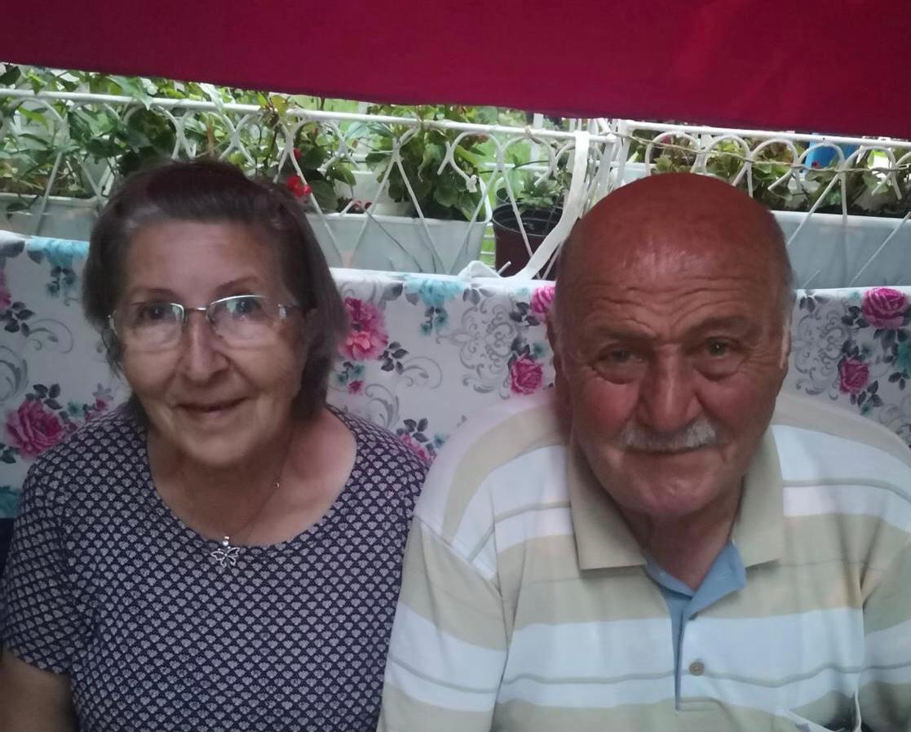

•Please introduce yourself, tell us your name, what is your country of origin and when you migrated to Turkey?
-Hello my name is Muzeyyen Im 75 years old. Im originally from Macedonia I migrated in 1956 to Turkey

•How did you enter to Turkey were you legal?
-I entered to Turkey with my father’s car, completely legally

•What about your family did they come with you?
-Yes they were with me

•What was your initial accommodation?
-it was our relatives’ home

•As a newcomer did you manage to find labour under, what conditions?
-Yes I found, I worked in a knitwear factory for 2 years.

•How did you learn the Turkish language, have you ever had the chance to attend lessons of Turkish language or culture?
-I didn’t have difficult conditions. It wasn’t bad because our ancestors lived together in Ottoman times, therefore I knew Turkish.

•What is your current occupation, would you say that Turkey’s policies provided you labour opportunities?
-I live in my house right now, in my opinion government of that time helped enough and Turkish people helped so much us to adapt.

●Did you stay in Turkey ever since or were you deported/forced to return?

-No, we have never been deported since 1956 because the first thing we did when we arrived was to get a permit.

●What is your current legal status in Turkey? Have you got Turkey citizenship? Would you say that Turkey’s policies helped you improve your legal status?

-Yes, I have a residence permit in Turkey right now. There are very useful articles in Turkish policies for immigrants.

●What is your current relationship with your family? Would you say that Turkey policies helped you improve the relationship with your family?

-My father died 4 years after I came to Turkey, but my children and grandchildren thank me very much for immigrating to Turkey.

