Our Halloween Jokes by Middle 3

- Who won the skeleton beauty contest?
No body.

- What do skeletons say before dining?
Bone appétit

- What do you get when you cross Bambi with a ghost?
Bamboo

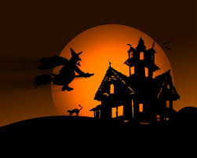

- What does Tweety bird say on Halloween?
Twick or tweet

- Where do mummies go for a swim?
To the Dead Sea

- Where do ghosts buy their food?
At the ghost-ery store.

- What do baby ghosts were on their feet?
B00-ties.

- Why was the Mummy so tense?
SHe was all wound up.

- When does a ghost have breakfast?
In the moaning.

- What do you call a witch who lives at the beach?
A sand-wich.

- What s a Mummie’s favorite type of music?
Wrap!

- Why didn’t the skeleton dance at the party?
Because he had no body to dance with!
- Why didn’t the skeleton cross the road?
Because he had no guts!

- Who does Dracula get his letters from?
His fang club.

