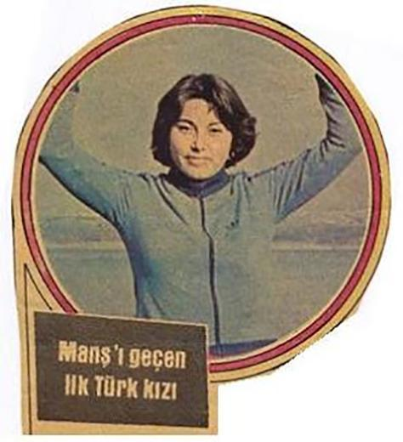
WHO IS NESRİN OLGUN?

Nesrin Olgun, (b. 1957, Adana), swimmer, physical education teacher. The first Turkish woman to swim across the English Channel.

He started swimming at the age of 7 and got several degrees. Turkey also struggled with table tennis and took degrees. In 1979, he graduated from Ankara Gazi Institute of Education, Department of Physical Education. 28 August 1979, 15 hours and 47 minutes swimming in the English Channel by swimming in the Baskent Schools as a head coach to many children in the sport of swimming. It has achieved great success by crossing the Bosphorus at an early age.

