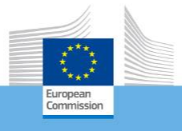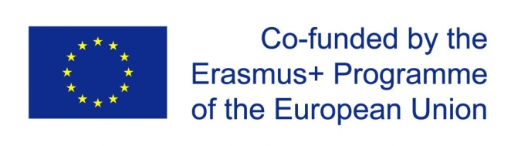
Erasmus+ Programme – Strategic Partnership
Project Name and Nr:
Learning together
219-1-IT02-KA229-062383_3
“Digital Citizenship Education”

The Council of Europe’s action with regard to the digital life of children over the last decade has been aimed mainly at their safety and protection in the digital environment rather than their empowerment through education or the acquisition of competences for actively participating in digital society.
However, supporting children and young people to participate safely, effectively, critically and responsibly in a world filled with social media and digital technologies has emerged as priority for educators the world over. The notion of digital citizenship has evolved to encompass a range of competences, attributes and behaviours that harness the benefits and opportunities the online world affords while building resilience to potential harms.
To address the issue the Steering Committee for Educational Policy and Practice (CDPPE) of the Council of Europe launched a new intergovernmental project entitled “Digital Citizenship Education” in 2016. The aim of this project of the Education Department (DG Democracy) is to contribute to reshaping the role that education plays in enabling all children to acquire the competences they need as digital citizens to participate actively and responsibly in democratic society, whether offline or online.
This website is intended not only to provide information and knowledge about Digital Citizenship Education but also to encourage discussion and experience sharing.
The Project 'Digital Citizenship Education' is related to the work of the Education Department which is part of the Directorate of Democratic Participation within the Directorate General of Democracy ("DGII") of the Council of Europe.
Digital Citizenship Education Project
The aim of the Digital Citizenship Education (DCE) Project is the empowerment of children through education or the acquisition of competences for learning and active participation in digital society.
The DCE Project builds on the achievements of the Council of Europe’s longstanding programme on Education for Democratic Citizenship and Human Rights Education (EDC/HRE), and the initial results of the project on Competences for Democratic Culture, as well as co-operation activities in other sectors (Internet Governance and Children’s Rights). It was approved by the Steering Committee for Educational Policy and Practice (CDPPE) at its 2015 plenary meeting and launched in March 2016 as part of the 2016-2017 programme.
The initial phase of the DCE Project comprises the following elements:
a review of both formalised literature and informal literature (blogs, wikis and websites), examining the concept of digital citizenship, current digital education policies and contemporary digital education practices and challenges in schools;
multi-stakeholder consultations/debates on policy issues regarding the place and better use of online resources and contemporary information technologies (e.g. social networking sites and Web 2.0 or Educational Web 2.0 sites, as well as personal devices) in school settings (curricula and schools organisations), and mapping the administrative and legal responsibilities for school leaders, teachers, students and parents;
on the basis of the report on these consultations, take steps to develop Policy Guidelines to further support national authorities in developing DCE policies to address learning issues as well as the needs of students, and to provide guidance in policy development to help protect students working in open, collaborative, online environments;
the promotion and sharing of best practices from member states on effective interactive programmes for the acquisition of digital citizenship competence for students through the curriculum, and for teachers through initial and in-service education;
based on the experience of member states, establish a set of descriptors of DCE competence and guidance for the integration of such descriptors in current citizenship education curricula;
the development, in partnership with other sectors of the Council of Europe, policy orientations with regard to cross-cutting contemporary educational and legal issues that school authorities face today, such as: cyber-bullying including cyber-misogyny, cyberbullying of teachers, privacy, sexting, digital addiction, student-teacher relationships through social media (Facebook; etc.), digital safe schools, freedom of expression online, and human rights of students in digital settings.
Following the launch of the project, an ad hoc expert group (DCE Expert Group) was set up comprising experts in the fields Internet Governance and Children’s Rights as well as from the education sphere. The Secretariat asked the DCE Expert Group to conduct a review of existing literature on the concept of digital citizenship as well as a multi-stakeholder consultation on the place of DCE projects and programmes in school settings (curricula and schools organisations) and mapping the administrative and legal responsibilities for school leaders, teachers, students and parents.

