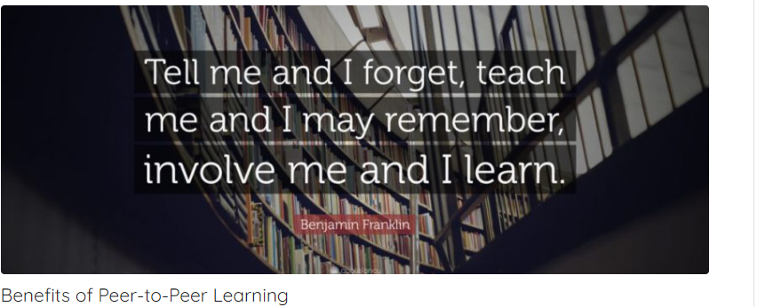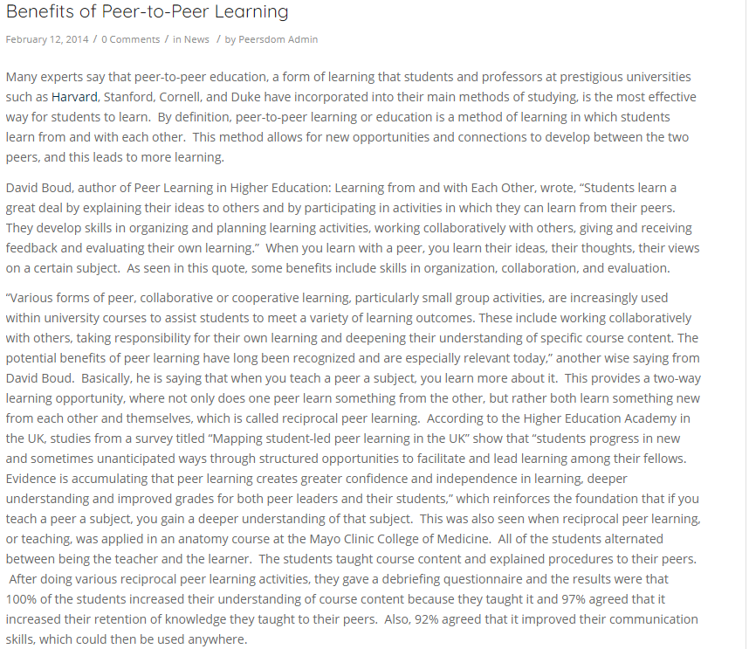
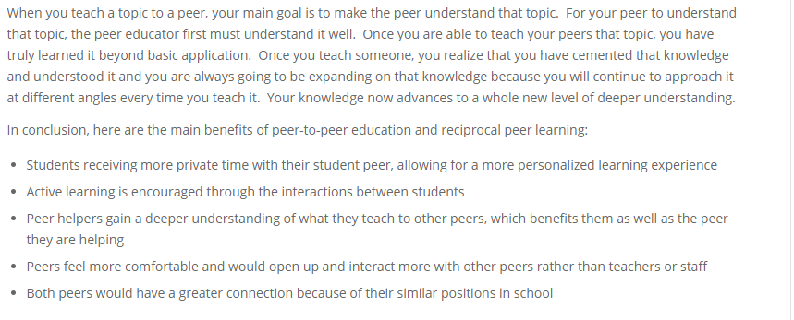
Peer learning is not a single, undifferentiated educational strategy. It encompasses a broad sweep of activities. For example, researchers from the University of Ulster identified 10 different models of peer learning (Griffiths, Housten and Lazenbatt, 1995). These ranged from the traditional proctor model, in which senior students tutor junior students, to the more innovative learning cells, in which students in the same year form partnerships to assist each other with both course content and personal concerns. Other models involved discussion seminars, private study groups, parrainage (a buddy system) or counseling, peer-assessment schemes, collaborative project or laboratory work, projects in different sized (cascading) groups, workplace mentoring and community activities.
The term 'peer learning', however, remains abstract. The sense in which we use it here suggests a two-way, reciprocal learning activity. Peer learning should be mutually beneficial and involve the sharing of knowledge, ideas and experience between the participants. It can be described as a way of moving beyond independent to interdependent or mutual learning (Boud, 1988).
Students learn a great deal by explaining their ideas to others and by participating in activities in which they can learn from their peers. They develop skills in organizing and planning learning activities, working collaboratively with others, giving and receiving feedback and evaluating their own learning. Peer learning is becoming an increasingly important part of many courses, and it is being used in a variety of contexts and disciplines in many countries.
The potential of peer learning is starting to be realized, but examination of the ways in which it is used in existing courses suggests that practices are often introduced in an ad hoc way, without consideration of their implications. When such practices are used unsystematically, students unfamiliar with this approach become confused about what they are supposed to be doing, they miss opportunities for learning altogether, and fail to develop the skills expected of them. Much peer learning occurs informally without staff involvement, and students whoa re already effective learners tend to benefit disproportionately when it is left to chance.
Formalized peer learning can help students learn effectively. At a time when university resources are stretched and demands upon staff are increasing, it offers students the opportunity to learn from each other. It gives them considerably more practice than traditional teaching and learning methods in taking responsibility for their own learning and, more generally, learning how to learn. It is not a substitute for teaching and activities designed and conducted by staff members, but an important addition to the repertoire of teaching and learning activities that can enhance the quality of education.
It is important to consider who are the 'peers' in peer learning. Generally, peers are other people in a similar situation to each other who do not have a role in that situation as teacher or expert practitioner. They may have considerable experience and expertise or they may have relatively little. They share the status as fellow learners and they are accepted as such. Most importantly, they do not have power over each other by virtue of their position or responsibilities. Throughout the book we will be discussing the role of students who are in the same classes as those from whom they are learning.
Peer teaching, or peer tutoring, is a far more instrumental strategy in which advanced students, or those in later years, take on a limited instructional role. It often requires some form of credit or payment for the person acting as the teacher. Peer teaching is a well-established practice in many universities, whereas reciprocal peer learning is often considered to be incidental-a component of other more familiar strategies, such as the discussion group (see, for example, Brookfield and Preskill, 1999). As a consequence, until recently, reciprocal peer learning has not been identified as a phenomenon in its own right that might be used to students' advantage.
Reciprocal peer learning typically involves students within a given class or cohort. This makes peer learning relatively easy to organize because there are fewer timetabling problems. There is also no need to pay or reward with credit the more experienced students responsible for peer teaching. Students in reciprocal peer learning are by definition peers, and so there is less confusion about roles compared with situations in which one of the 'peers' is a senior student, or is in an advanced class, or has special expertise.
Reciprocal peer learning emphasizes students simultaneously learning and contributing to other students' learning. Such communication is based on mutual experience and so they are better able to make equal contributions. It more closely approximates to Habermas' notion of an 'ideal speech act' in which issues of power and domination are less prominent than when one party has a designated 'teaching' role and thus takes on a particular kind of authority for the duration of the activity.
We define peer learning in its broadest sense, then, as 'students learning from and with each other in both formal and informal ways'. The emphasis is on the learning process, including the emotional support that learners offer each other, as much as the learning task itself. In peer teaching the roles of teacher and learner are fixed, whereas in peer learning they are either undefined or may shift during the course of the learning experience. Staff may be actively involved as group facilitators or they may simply initiate student-directed activities such as workshops or learning partnerships.
According to Topping's review of literature, surprisingly little research has been done into either dyadic reciprocal peer tutoring or same-year group tutoring (Topping, 1996). He identified only 10 studies, all with a very narrow, empirical focus. This suggests that the teaching model, rather than the learning model, is still the most common way of understanding how students assist each other. Although the teaching model has value, we must also consider the learning process itself if we want to make the best use of peers as resources for learning.
As mentioned earlier, it is important to recognize that peer learning is not a single practice. It covers a wide range of different activities each of which can be combined with others in different ways to suit the needs of a particular course. It is like peer assessment in this regard (Falchikov, 2001) and it is unfortunately similarly misunderstood as referring to a particular practice.
Si chiama peer learning (o peer education) e in Italia esiste da poco: la nuova frontiera della trasmissione delle conoscenze è lo scambio tra pari.

La classica lezione frontale, ormai, è demodé. E, dicono gli studi, in molti casi anche poco utile all’apprendimento. A prendere il suo posto non solo a scuola, ma anche nei progetti didattici realizzati in altri contesti, è arrivato il peer learning o peer education, che letteralmente significa educazione tra pari: un cambio di prospettiva che vede i più giovani al centro del sistema educativo.
Cos’è il peer learning
Si tratta di un metodo di insegnamento nato negli anni ‘70 negli Stati Uniti d’America e che ha iniziato a prendere piede anche in Italia in tempi relativamente recenti. Gli obiettivi di questo sistema sono diversi: si va dal potenziamento delle abilità individuali degli studenti alla prevenzione di comportamenti socialmente negativi (come il bullismo) attraverso meccanismi di influenza sociale ed emozionale.
Come funziona il peer learning?
I peer e il principio di similarità
Il principio base del peer learning è che la conoscenza si trasmetta tra “pari grado”, cioè tra persone simili, per età, status e problematiche: il che le rende, agli occhi di chi impara, interlocutori credibili e affidabili, degni di rispetto. Il primo passo in un progetto di peer learning è dunque proprio quello di individuare questi peer, cioè questi pari grado, che non hanno ruolo di insegnanti nei confronti dei loro coetanei, bensì di tutor, persone con cui intraprendere uno scambio attivo di idee ed esperienze.
Spesso i peer sono adolescenti. Il motivo è molto semplice: anche se i progetti di peer education possono coinvolgere qualunque fascia d’età, quella adolescenziale è considerata la più problematica e dunque anche quella in cui iniziative di questo tipo possono offrire il massimo beneficio, sia in termini di trasmissione delle conoscenze, sia in termini di relazione tra coetanei.
Il ruolo degli adulti
Questo metodo non annulla in alcun modo l’autorità degli adulti (insegnanti, formatori, educatori), che anzi nella peer education hanno un ruolo di supervisori e di facilitatori dell’interazione tra giovani.

L’educazione tra pari, o peer learning, favorisce l’apprendimento e rafforza la fiducia e il rispetto
Il gruppo di lavoro
Formati i giovani peer, si passa al lavoro di gruppo con i coetanei. Il punto di forza dei peer educator è quello di utilizzare la comunicazione paritaria, cioè lo stesso linguaggio dei destinatari, che può essere perfettamente compreso e accettato. All’interno del gruppo, i peer sono agenti di cambiamento e, pur essendo protagonisti dell’azione di trasmissione della conoscenza, non instaurano un rapporto gerarchico con gli altri studenti, non giudicano, non tengono lezioni: continuano a stare sullo stesso piano.
Learning by doing: imparare facendo
Altra caratteristica del peer learning è quello di imparare attraverso l’azione: diversi studi scientifici hanno infatti dimostrato come la miglior tecnica per comprendere a fondo tematiche e concetti complessi sia proprio quella del «fare», attraverso l’operare e le azioni. I peer sono dunque chiamati ad aiutare e a supportare i coetanei durante i laboratori o le attività di gruppo organizzate dagli educatori in qualità di facilitatori.
Non solo: i peer facilitano anche la riflessione che segue l’azione, permettendo agli altri studenti di acquisire consapevolezza delle proprie azioni: si parla quindi di learning by doing accompagnato dal learning by thinking.
I vantaggi del peer learning
Questo sistema di trasmissione delle conoscenze ha diversi vantaggi, sia per i peer, sia per i coetanei. Migliora l’autostima dei peer, li mette alla prova, migliora le loro abilità relazionali e di comunicazione. I coetanei apprendono i concetti più facilmente, in un ambiente di lavoro in cui si sentono a proprio agio, senza voti o giudizi, sviluppando anch’essi competenze e risorse. La peer education, inoltre, proprio perché favorisce rispetto reciproco, fiducia e cooperazione tra pari, è da considerarsi anche un sistema di prevenzione verso fenomeni negativi, come il bullismo. Il principio di similarità, infine, permette specialmente agli adolescenti di affrontare argomenti e temi che difficilmente si discutono con gli adulti, come l’amicizia, l’amore, la sessualità, la diversità.
Definition
The term peer learning refers to situations where peers support each other in learning processes. There are different forms of peer learning such as peer support groups, supplemental instruction, peer tutoring, peer teaching, and peer-assisted learning. Peer learning emphasizes the experience of all participating students. Peer learning is the acquisition of knowledge and skill through active helping and support among peers who are equals in standing or matched companions. Peer learning occurs among peers from similar social groupings, who are not professional teachers, helping each other to learn and in doing so, learning themselves (Topping and Ehly 1998). On the other hand, the term peer assessmentdescribes the process undertaken by students to assess each others’ work in related peer group tasks. Students contribute to the evaluation procedures by having input in.
Abstract
This study conceptualises patterns of peer talk and interaction and the potentials for learning inherent in a peer tutoring setting in an undergraduate nursing education skill centre. Third-year students are responsible for training first-year students in performing nursing procedures. The paper identifies patterns of peer interaction as they occur in a pre-training reflection setting where students prepare for practising the procedures. Three interaction patterns are identified: a tutor-led question-and-answer pattern and two exploratory patterns: cumulative-exploratory and dispute-exploratory. The analysis additionally uncovered three ways of dealing with the object of learning: recitation, re-contextualisation and thematic errors and sloppiness. We suggest that analyses of peer learning need to go beyond the level of interaction and also address its content. Furthermore, interaction patterns might afford an expansive or more restrictive way of framing and dealing with the object of learning.

