THE LICEO PASCASINO SCHOOL-ITALY
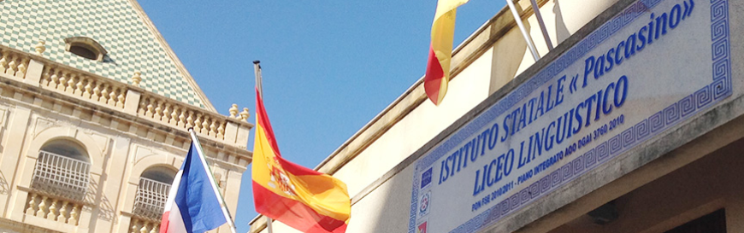

The Liceo Pascasino is a High School, divided in three different parts: Economic Liceo, Humanistic-Social Liceo and Linguistic Liceo.
In total the school has 830 students in two different buildings, one in the city center, the other one in the outskirts. The school has three digital laboratories, a gym, a football area, a modern library and a big conference room. All classrooms have artistic paintings on the wall done by our students. The aim of the school is realize the innovation, the internationalization and the inclusion. The teachers apply, in the daily didactics, innovative methods, as such as cooperative learning, peer to peer education, flipped classroom, use digital devices for the researches and organize debates and competitions related to UN goals with awards. An important powerful point is the internationalization, the school makes stages, Erasmus projects with different countries in Europe, use mother tongue teachers in different school subjects, organize events, meetings and competitions in English, French and Spanish to improve language skills. Most of all our school cares about all students and supports the pupils with difficulties through a special didactic path. When technology changes, it impacts the kinds of things we want and need. Updates to technology change what we desire; as we desire new things, technology changes to seek to provide them. The same goes for education considering a few of the key ideas in progressive education like: mobile learning, digital citizenship, design thinking, collaboration and creativity, that every student benefits. As these force their way into schools and classrooms, they assign and design the thinking of teachers.

