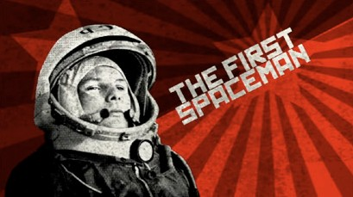
Name:

Webquest Space conquest!

1.Go to https://www.space.com/16159-first-man-in-space.html
Read the first and second paragraphs and answer the following questions :
When did Gagarine become the first man in space ? ……………………………………………..
How long did he stay in space ? ……………………………………………..
What nationality was Gagarine ? ……………………………………………..
Where is he buried?
Where is his spacecraft exhibited ?
Which other nation was in this space competition ? ……………………………………………..

2.The first men on the moon

https://www.nasa.gov/audience/forstudents/k-4/stories/first-person-on-moon.html

Look at the photo and write the names of the first men on the moon
names:………………………………………………………………………….
date:……………………………………………..…………………………………………
Name of the craft that landed on the Moon : ……………………………………………
How long did the trip last all together ? ……………………………………………

3.Neil Armstrong
https://kidskonnect.com/people/neil-armstrong/
Armstrong said these famous words : "That's one small step for (a) man, one giant leap for mankind.
How long did they stay on the Moon : ……………………………………………………
Did a woman go on the Moon ? …………… How many men ? …………………..
When was Armstrong born ? ……………………………………………………
How far is the Moon from the Earth ? ……………………………………………………
What is Saturn V? ………………………………
What is the name of the last mission to the moon?
Which President of the USA decided that it was important to go to the Moon ? …………….

4.Katherine Johnson
https://www.nasa.gov/audience/forstudents/5-8/features/nasa-knows/who-was-katherine-johnson-5-8

Who was Katherine Johnson ?

When did she work for the NASA?

Why was her work very important ?

5.The space station
https://www.nasa.gov/audience/forstudents/k-4/stories/nasa-knows/what-is-the-iss-k4.html
What is the space station?

How far is it from the earth?

How old is it ?When was the first piece of the space station launch ?

How many bedrooms are there in it ?

How many people can live there?

What do scientists study there?

6.First European astronauts https://en.wikipedia.org/wiki/List_of_space_travelers_by_nationality#Bulgaria
https://en.wikipedia.org/wiki/List_of_European_astronauts

nationality | Name | date
France
German
Spain
Austria
Italy
Hungary
Belgium
Bulgaria
Czech
Polish
Romania
Sweden
Slovakia
Great-Britain

What is Philae? http://www.henry4school.fr/Travelling/travel/philae.htm

In mythology who is..?
Saturn

Apollo

Now propose 3 questions for the etwinning game.

