BULLYING
Bullying is when someone shows rude or mean behavior to another person. The people who do bullying are called bullies. Bullying is directed repeatedly towards specific and general targets or subjects. Bullying can be defined in many different ways depending on its context. Bullying doesn't have to be physical. It can be things that people say.
Bullying is not only violence against the bullied person. It's also bullying when other people hide it from those in power (teachers, bosses), other people who see it ignore it, or when the bully is helped to get away with it. Bullying can also be saying mean words said to people face to face.
Bullying can happen at school, work, at home, on the internet (cyber-bullying) or somewhere else.
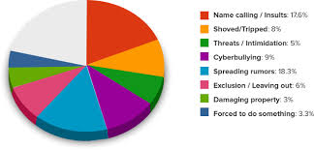

Kids who are bullied
Kids who are bullied can experience negative physical, school, and mental health issues. Kids who are bullied are more likely to experience:
- Depression and anxiety, increased feelings of sadness and loneliness, changes in sleep and eating patterns, and loss of interest in activities they used to enjoy. These issues may persist into adulthood.
- Health complaints
- They are more likely to drop out of school.

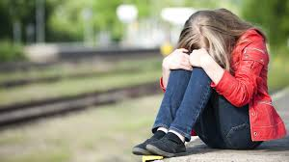

Kids Who Bully Others
Kids who bully others can also engage in violent and other risky behaviors into adulthood. Kids who bully are more likely to:
- Abuse alcohol and other drugs in adolescence and as adults
- Get into fights, vandalize property, and drop out of school
- Have criminal convictions and traffic citations as adults
- Be abusive toward their romantic partners, spouses, or children as adults

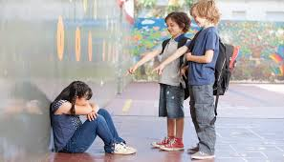

Bystanders
Kids who witness bullying are more likely to:
- Have increased use of tobacco, alcohol, or other drugs
- Have increased mental health problems, including depression and anxiety
- Miss or skip school

Personal Opinions
Bullying and cyber bullying are two major problems that young teens and adults have. These two things are not the same, but they do in fact intersect one another. Lots of people are committing suicide every year just because of this problem. It starts online then it can lead to neighborhoods or even at your own house. An important key to know if you’re being bullied, is to talk to someone about it, don’t keep it to yourself. Cyber bullying happens on many of the common places online. It’s really important to think before you post anything personal about yourself online.
Parents and teachers need to be more aware when it comes to being bullied. No matter if it’s online or on school grounds. If teachers or faculty members see someone getting bullied they should take the bullies to the principal’s office for a talk on the harm they are causing. The same thing goes for parents, if they know that their child or children are being bullied, they need to do something about it.

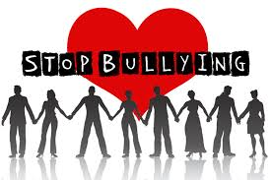

7th Junior High School of Ioannina

