Antonela Mrsić
Škola likovnih umjetnosti, Split, Croatia
School of fine arts, Split, Croatia

We choose happiness - project evaluation
Detailed evaluation consisted of 30 evaluation and self evaluation questions from which 12 questions and statements at the second part were only for the teachers. Evaluation was available via Google forms. There were 67 participants who filled out the evaluation form from whom 76,1% were students and 23,9% were teachers.
The first few questions referred to the project in general. More than 50% participants rated the project with the highest vote and if we add those who rated it with 4 out of 5, we can say that the vast majority liked it. Ratings are presented in the Picture 1.
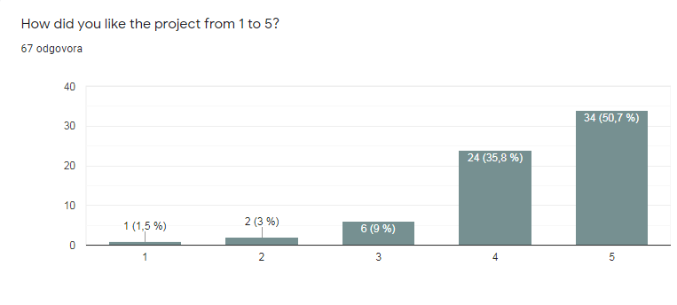
Picture 1. General opinion of the project
Second question referred to how comfortable participants felt during the project and results are presented in the Picture 2.
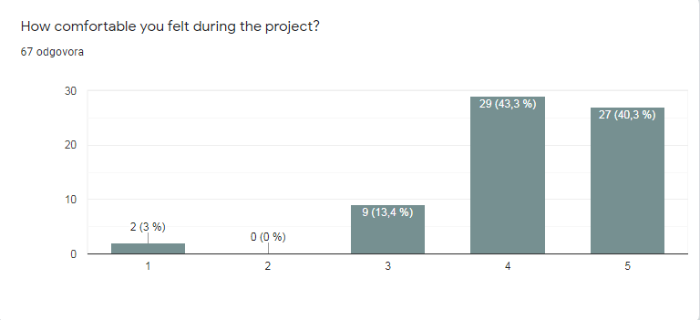
Picture 2. Feelings of the participants during the project
88,1% participants said that activities and topics were suited to the age of the students, while 4,5% declared that some of them were too serious.
Regarding their contribution to the project, most of them rate themselves with 4 out of 5 (55,2%), 23,8% are completely happy with their contribution while 7,5% can't decide.
Most of the participants were completely (43,3%) or moderately motivated (32,8%) during the project and 60,2% of them completely agree that the projects' topic is relevant while 20,9% rated it with a 4 out of 5.
Worth mentioning is also that more than a half (52,2%) of the participants assess that activities were clearly connected to the topic. The same percentage of them assess activities as useful.
When it comes to the favourite activity, most of the students express that their favourite activity was Mental health and happiness – brochure reading and Zoom meeting (34,3%) that shows the students' need to speak and learn about this topic and that they consider it important. In the second place they put What do I do to make myself happy – activity description, eBook - Manual for happiness (26,9%). These two activities were two most demanding and these results show that we could put our expectations a bit higher. Also, it shows that students have a need to talk about their experiences and to share it with others.
We can be happy with the communication in the project as it's shown in the Picture 3.
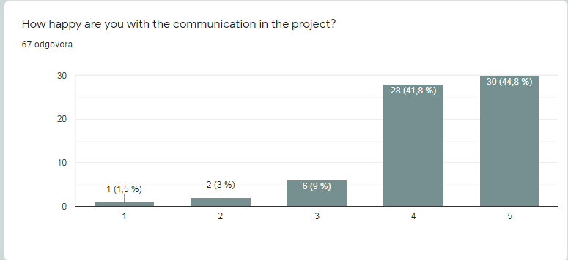
Picture 3. Assessment of the communication in the project

74,6% participants think that they acquired new skills and competences during the project that shows a great impact of the project while 11,9% said that they practiced ones that they already possessed. Regarding the expectations from the project, they were completely fulfilled for 40,3% of the participants, 38,8% rated it with 4 out of 5 and 19,4% (13 participants) with 3 out of 5.
49,3% or 33 participants felt motivated to learn more about metal health after participation in this project and if we add those who rated their motivation with 4 out of 5 (32,8% or 22 participants) we can say that this project had a strong positive impact on the awareness as it’s shown in the Picture 4.
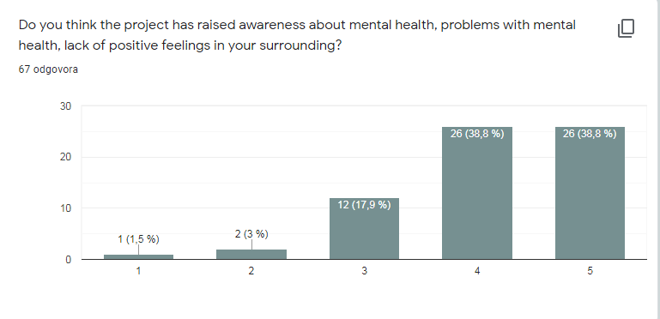
Picture 4. Assessment of the correlation of the raised awareness in the surrounding with the project
One of the most important results we got from this evaluation is that more than half students and teachers would participate in the similar project again (53,7%) while 29,9% rated their will with 4 out of 5 that represents a big percentage and can be motivational for the future projects.
When we asked what they would change about the project, answers were focused on the lack of the time since it was a short term project and a small number of online meetings which was also a consequence of the short term project.
Here are some answers that they gave on a question what was good in the project:
„ topics and activities, especially those related to mental health.“
„the main idea was good and necessary“
„contact with people from different countries“
„Everything was good but especially zoom meetings“
„The good thing about this project was bringing happiness to everyone so they don't feel sad and alone“
„for me this project is improve my english so ı love the zoom meetings and the happiness messages are very good :)“
„Focus, direction, timeline, outline, Zoom meetings, activities, friendliness, mutual respect, the English language and common values as a basis for understanding and teamspirit, Exchange and strengthening of digital skills, and so much more ....“
„I loved that we were able to learn more about happiness and mental health and to hear opinions on the topic from other people.“
The second part of the questionnaire was related to teacher impressions so 76% of them said that they were completely happy with the group coordination and 68% were completely happy with communication with a project author. Instructions for the activities were clear and 79,2% teachers completely agree with that while 17% rated it with 4 out of 5.
The problems that teacher highlighted are the lack of time and difficulties they faced because of distant schooling but we can conclude that even they were struggling, this project helped them to stay in touch with their students during the quarantine and that is confirmed in the Picture 5 where we can see the assessment of the fact that this project made them closer with their students.
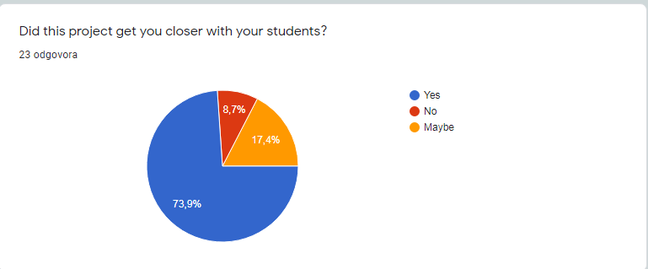
Picture 5. Teachers' assessment of the projects' contribution to their relationship with the students.
This fact (Picture 5) we consider one of the most important results of the evaluation if we take in consideration how important is the relationship between students and teachers in maintaining the mental health of the students. Also, this shows the importance of the eTwinning projects in creating a positive school atmosphere.
79,2% of the teachers assess the instructions for the project activities and meetings as excellent.
The following questions referred to the situation in their schools. Half of the teachers (50%) is completely happy with the representation of the mental health in their school curriculum and 16,7% rate it with 3 out of 5 while less than a half of them (43,5%) thinks that their students are opened when it comes to the conversation about the emotions, more than a quarter (26%) rates it with 3 out of 5 or lower which is a fact to think about if we know how important it is to verbalize, recognize and regulate emotions in the mental health aspect.
The next thing we wanted to know is if the teachers can see the influence of this project on their students and results are presented in the Picture 6.
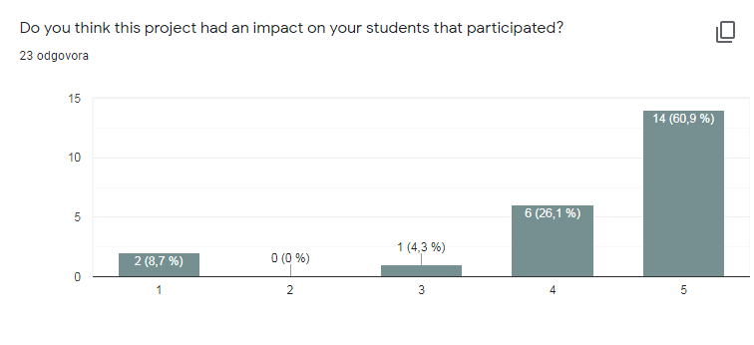
Picture 6. Impact of the project on the students
We consider it an enormous success since it showed that the influence was strong and we created this project with the aim to have an influence on the students since we consider it important in these difficult times. When we asked teachers to explain how, we got answers like these:
„They understood the importance of this topic in life, and especially in these life circumstances. And pass it on to their colleagues“
„they got courage to talk about their feelings“
„They are more interested in multicultural events“
„They opened“
„They gained self confidence. They saw what they could do. They are very happy to participate in the activities.“
„They could enhance a number of skills (intrapersonal, communication, digital, social, intercultural, language skills...)“
„they realized how much is necessary to feel confident with the spoken language; they found out that emotions are a good way to feel connected without borders or mental walls“

26,1% of the teachers think that this project had an influence on the students that have not participated and 34,8% rate it with 4 out of 5. However, the rest had struggles with the dissemination because of online schooling. They explained:
„We often discussed about the project during the lesson“
„yes, because they talked to each other about the project“
„They wanted to learn about our project and asked what we were doing so that they could have time to think about their happiness as well“
„They all regretted not participating in the project.“
„not sure because school was closed so the only way was to be informed by the school website where the project has got a lot of evidence. They might have read the article on our local newspaper but we don't have a school page on instagram or facebook. We are planning to decorate school walls as soon as we are allowed to do that (not evident..nothing could be hung or manipulated before) and videos are going to be shot to give their impressions about the project“
Last but not the least was the question about their impressions, suggestions and comments and here are some of them:
„Please we do these zoom meetings because they ımprove our english! Love u See ubTake care Bye!“
„I was happy with the project and I hope there will be a another one“
„Hope we come together with some of our colleagues in another eTwinning/Erasmus + project in the future“
„Thank you for the good idea of the project“
„Thank you so much for all the collaborations. We're so happy.“
„It was a very nice project that I had fun and learned about.“
„I'm grateful and happy! Many thanks!“
„I really enjoyed it and I believe it's been a great experience for all the participants.“
„My suggestion is to go further and make this project a good start for an Erasmus project.“

And as suggested, the project became base for the Erasmus+ project that is submitted and is waiting for a response.
To conclude, this evaluation helped us a lot to finalize our experience and to be able to get some instructions for the following projects. Also, it showed a big need for projects like this and we think it can be a motivation for future ideas. As a project author, I am very happy and I think it was a great idea to dedicate my time to something like this.
Results that show the biggest success are the ones related to the impact of the project on the students and on the relationship between teachers and students. Also, it is important to highlight students’ impressions and their motivation for a project, especially for those activities we consider serious and the most demandive. These results give a clear image since the evaluation was so detailed.
Hope that this experience will continue to raise awareness, spread impact and influence schools’ curricula to highlight positive development in their programs and to encourage activities that promote socioemotional competences as the predictors of mental health and positive relationship with school.

