THIS VACCINE WILL CHANGE EVERYTHING!
I think especially in a few months, we are going to hear about this topic a lot. I’ve just heard that two medicine companies, which is called Pfizer and BioNTech, has found the covid-19 vaccine. In fact, they launch the vaccine delivery trial in four US states. They will run the pilot programme in Rhode Island, Texas, New Mexico and Tennessee. I want to give you some simple information about the vaccine. Because I think you are all wondering, too. I did some research about it and its developers, Pfizer and BioNTech, said that it had been tested on 43,500 people with no safety concerns raised. Actually it is really a big deal to test a brand new vaccine on thousands of people. Of course I know it has to be tested on many people before launching it. It is just extraordinary for me. And I was already interested in biology but now I am even more interested. Because of that, I also want to mention about how it would work.
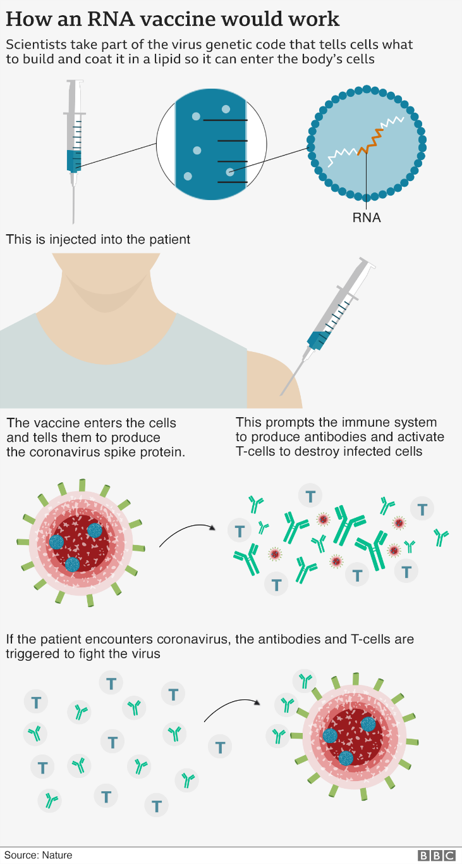
Here is a simple picture from BBC to help you understand easily. It is a new type of vaccine called an RNA vaccine and uses a tiny fragment of the virus' genetic code. This starts making part of the virus inside the body, which the immune system recognises as foreign and starts to attack.

It is given in two doses - three weeks apart - and early data suggests it protects more than 90% of people from developing Covid-19 symptoms.
It actually sounds pretty good. It has an effective content and simple working principle. I hope there will be no results contrary to expectations.
On the other hand, we are all wondering who will get the vaccine first and how soon we can have. It actually depends on how old you are. The age is one of the most important risk factors as you know. Especially if someone is over their 50s, it is much riskier than young people. Because of that they told that they would give them priority. And I think that’s also what it should be.

I hope as soon as possible we can go back to normal. I mean days without any lockdown, with all together without any social distance and hanging around without any mask on. I really want to go to school and also I am really excited about our project but it seems we cannot go anywhere for a while. But make sure that good days are waiting for us. I wish we could see each other as soon as possible. Please take care of yourself and stay healthy!!!

Zeynep Selin O.

