How much I know about myself?
The solitude has covered far more part of our lives with covid-19. And I want to talk about this from my point of view.
Before the quarantine, I had always been with the others and I had never been alone for a long time like this. I know it was a big opportunity, especially when we compare it with today’s world but let’s get into my psychological state of mind. I always believe that the life actually based on infinite possibilities. Eventually any person becomes a subject to it. I’m not sure whether you thought about it before but in my opinion it’s really hard to identify ourselves against this possibilities and quickness. After all, I always tried to look back at my own choices clearly and decided what I want from this life without any external factors. But the basic daily routines and necessities had to make me not to get out of this vicious circle.
And my story actually started there. Everyone had to be alone in this process and the “daily” routines have a lot changed by this way. In spite of the all negations about Covid-19, I tried to stay in self-quarantine as long as possible to make a progress for my self-improvement. I know this was a bad situation but not an excuse for letting everything out. Also it was a really big opportunity to think about myself, my future and my purpose. And also the other things that I have always wanted to throw out my mind. I finally found a calm place and time to make up my mind about everything during quarantine. Besides, the probability of staying at home for longer periods made me set my own goals on my own. Doing this every day made me really self-disciplined and determined person. Or maybe I just realised it!
At first, I made my room cosier place to have the time of my life. Then I read a lot of books, which I couldn’t have a chance to read before, and wrote several short articles about my point of view of life and solitude. Now I can see clearly what I felt and thought at these days when I looked at these writings.
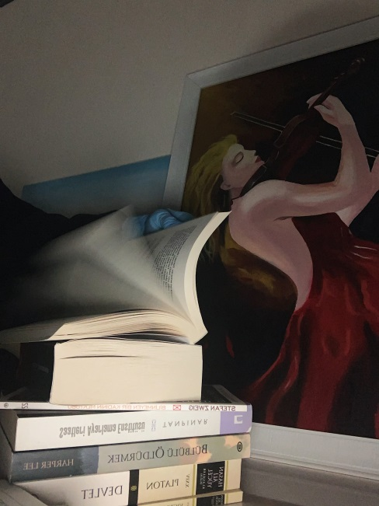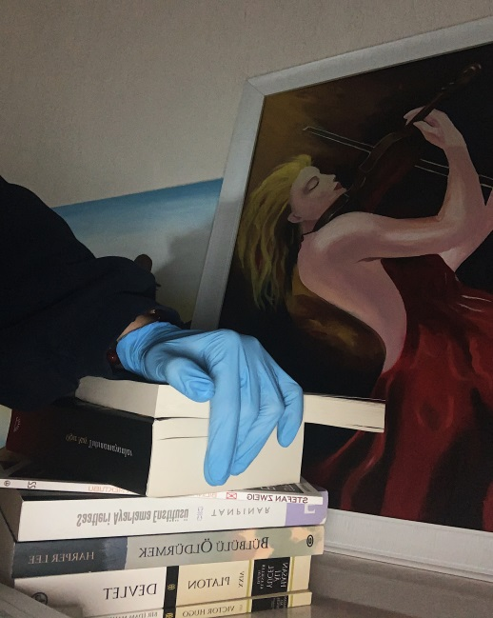

Then I completed my old drawings, which had always been drawn hastily. Also I discovered a new interest of me: Analog Photography. The photos that I take actually help me to project my feelings. In other words, I noticed that I am much more creative and vivacious when I’m alone.
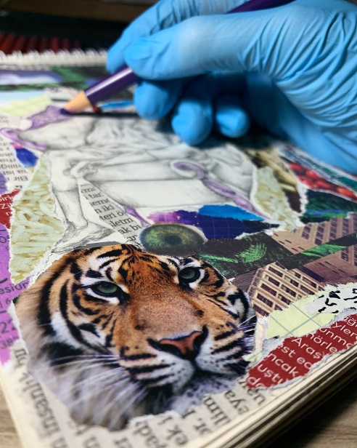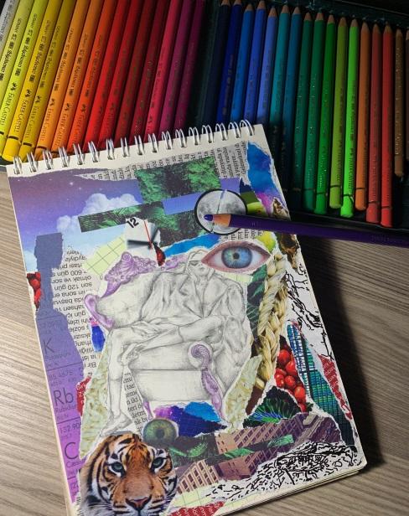
As a result, I can say that time is everything nowadays. It can be turned into whatever you want especially at these days. This lockdown helped us to sum up everything in our lives and realise what kind of person we are. And I think that awareness is one of the essential things in life, which is going on against all, even covid-19.

Betül A.

