How will Covid-19 shape our future?
As you know that COVID-19 came to Turkey in March. After that our school closed for one week. At that time we were in quarter semester break. After semester break our school started to deliver online lessons via Zoom. Before the pandemic I wanted to study medicine in Turkey and I don’t have any idea about other jobs. We had 2 lessons per day from March to June. In May I joined Loy community which builds start-up. Until July I worked at least for 3 hours for start-up as a product manager. After that I realised that I love creating new things. In summer I watched a bunch of videos about engineering and business and I decided to work in business&technology. On August 31 our school started again. Online classes are less efficient than face to face education but we must stay at home. As I have lots of free time during this lockdown and I started to learn new skills for my future. Also two of my friends want to become an engineer in the future and we decided to start coding lessons. We communicate every day for improving our coding skills and we have lots of fun. I can say that pandemic gives me time for recognize myself and I found a purpose in my life during that time. Also I learned that sometimes solitude could be a good thing to think about the importance of “now”.
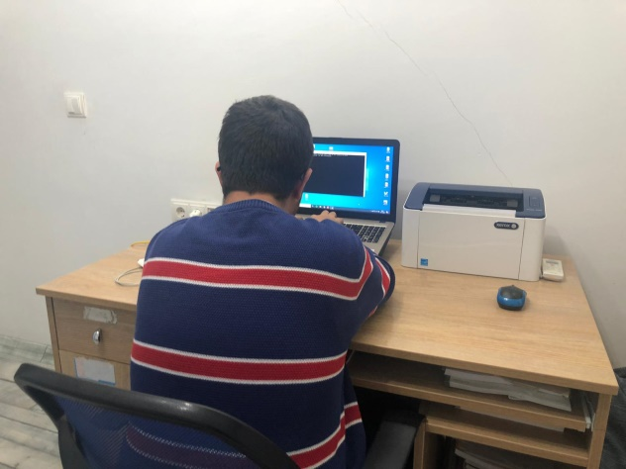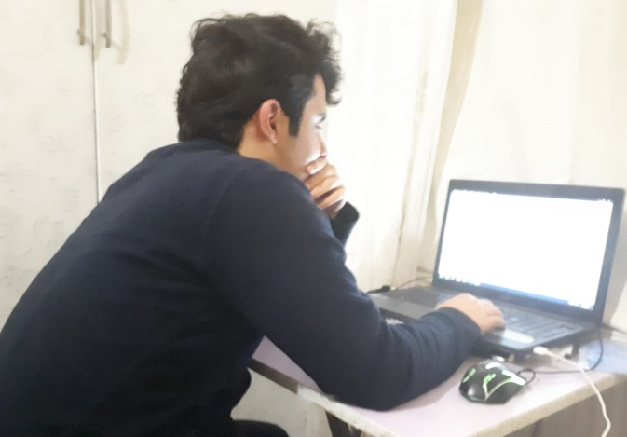
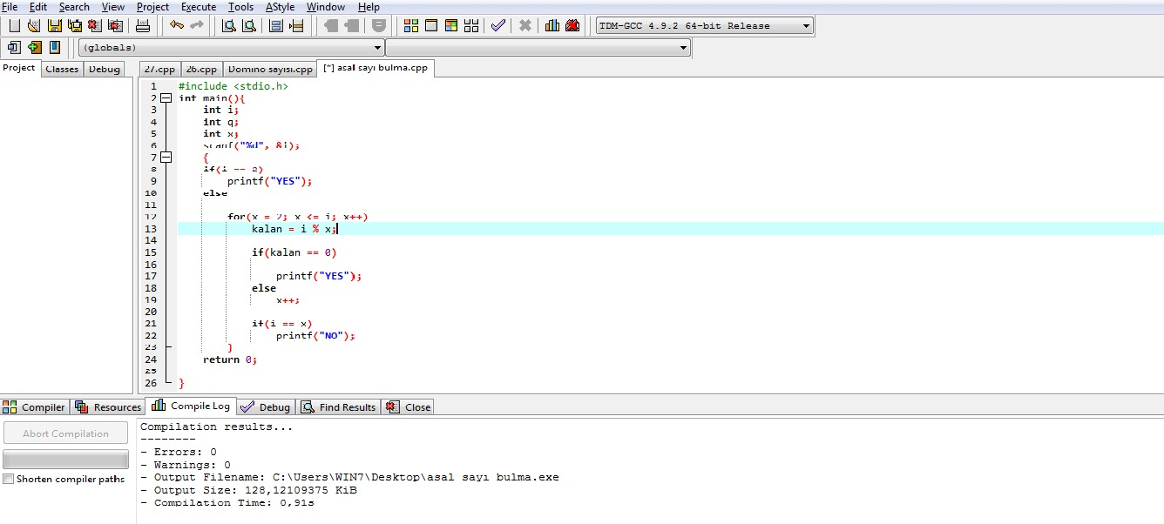

As you know, we had very bad experiences as a whole humanity last spring. Covid 19 disrupted all our dreams and plans and these bad experiences still continue. This past spring we suddenly tried to adapt to the quarantine conditions and this was awful for an idealist students. Prohibitions, quarantines, doctors who did not know what to do, state administrators who didn’t explain the things clearly and increasing economic crisis began to disturb people after a while. Fortunately, my brother, whom I could spend time during the quarantine period, was also at home and I learned a lot about engineering from him. I’ve always wanted to be an engineer but I didn’t know what to do. One day he told me that I need to learn software. First of all, I learned from him what software is and where it is used. Then I realized that my friend Toprak was also interested in software. But he would like to be a software engineer but I want to be an aircraft engineer and I was thinking of using the software directly on unmanned aerial vehicles. We started watching the code videos together and then programming. Nowadays we are preparing for the Istanbul science competitions together. In these unprecedented times, a lot of people think negatively, but we think that we can shape our future with what we plan to do in our free time during lockdown.

Toprak K. & Üveys A.

