TOPIC: ONLINE BULLYING AND HATE SPEECH AMONG TEENAGERS
ERASMUS+ PROJECT: HEADS UP! YOUNG TECHNOLINGUA EMPHATIC MINDS

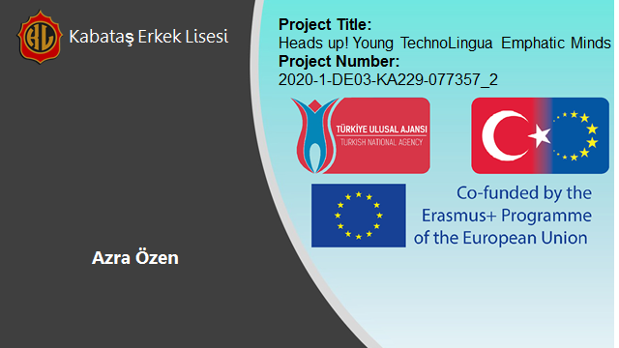

HATE SPEECH AND CYBERBULLYING

- INTRODUCTION TO TOPIC

Hate speech and discrimination have always been a relevant topic for the society. As the day- to-day events are reallocated to online platforms, hate speech and bullying have shifted along with it to online platforms such as social media and other communication applications. As the data indicates, 41% of adults have personally experienced some kind of online harassment. Nevertheless the percentage of teenagers is higher than the adults at 58%. (Pew Research Centre, 2021)

Bullying is one of the main struggles a teenager faces on a daily basis. Alongside with the adolescence, discrimination and hate-based actions peak. This type of hateful behaviour can cause severe damage to pre-teens all their lives. Bullying previously starts in a place all kinds of teenagers are together: the school. Grouping and discrimination among the adolescence is now online. Teens are more prone to experience hate speech online than in person, as the anonymity in the digital platforms hides the identity of the hater.
Mental health is inevitably a target of online bullying and occupies utmost importance. Thus, this on-topic issue is in need of long term solutions and needs to be understood by the related community: adolescents.

- KEY TERMS

Hate speech: The term hate speech is understood as any kind of communication in speech, writing or behaviour that attacks or uses pejorative or discriminatory language with reference to a person or a group on the basis of who they are, in other words, based on their religion, ethnicity, nationality, race, colour, descent, gender or other identity factor. (The Strategy and Plan of Action on Hate Speech, UN) The hate speech builds upon the differences among the community. The inability to easily accept the difference of opinion is the main source.

Xenophobia: Xenophobia is the fear or hatred of that which is perceived to be foreign or strange. It is an expression of perceived conflict between an in-group and an out-group and may manifest in suspicion by one of the other's activities, a desire to eliminate their presence, and fear of losing national, ethnic or racial identity. (Wikipedia)

Digital citizenship: Digital citizens belong to the digital society. They use technology to actively engage in and with society. Digital citizenship empowers people to reap the benefits of digital technology in a safe and effective way. Digital citizenship is a right; digital skills enable people to exercise this right. (The European Schoolnet) A digital citizen speaks up for the community's rights on the internet and uses it in order to benefit from it.

Discrimination: Discrimination is treating people differently from various reasons such as age, race, gender, socioeconomic background and religious beliefs. It is a type of hateful action against people just because of who they are. Discrimination occurs when a citizen is not satisfied with how they are treated among the community. This can show up in our lives as misconceptions, traditions and other forms underlying patterns of the society.

- ONLINE BULLYING AND HATE SPEECH AMONG TEENS

Online bullying can show up in various forms such as a text deliberately sent aiming to hurt somebody, spreading rumours, leaking photos or videos to humiliate someone, threatening or creating fake accounts in order to intimidate the peers. These marginalizing actions can be towards an individual as well as a whole ethnic group, religion and race. This outlines the differentiation between hate speech and bullying. Hate speech is mostly targeted towards a larger group. This type of hate is themed as xenophobic, racist, sexist or ableist and shows up as jokes. Jokes can be seen as innocent or entertaining, but exceedingly harmful and offensive to target groups.

Bullying is a stereotyped action among adolescents. Why is this type of behaviour so frequent that it is normalized?

Teenagers who are going through issues themselves are prone to be a bully. Mostly they are craving for being in the limelight or have an ideology of putting somebody down will make them feel better. This motive reads as hateful action will cause a raise in their self-esteem and confidence. Young adults who feel unheard or incapacitated desire the feeling of being vigorous and having the strong hand among their peers. It can also be a coping mechanism to anger and unhappiness. Adults mostly have developed a coping mechanism for day-to-day problems. In the meantime, teenagers feel lost and abandoned while coping with issues due to the fact that they lack experience. This leads them to consult hateful behaviour.
Most teenagers state that they come across more hateful content or bullying in online platforms than in real-life. Bullies tend to be held less accountable and can easily get away with the action. The anonymity of the internet is the basis of the online-bullying culture. A person who lacks self-esteem is not likely to come up to their peers and express their perspective. In online platforms such as Twitter and Instagram it is way accessible to express one's opinion and post it as the whole world can see. It can be viral in the shortest amount of time. As mentioned, the freedom of speech plays a key role in social media platforms. The expression of one's opinion is the main goal of having these platforms to begin with. Nevertheless, the freedom of speech ends when it is malicious and hurtful for the receiver. This is a demanding responsibility for the platforms. Considering the amount of content being posted online it is humanly unachievable to go through all of them. The Artificial Intelligence Systems take action when it comes to content reviewing and removing. Content removal is a sensitive topic thus it is said to be limiting the freedom of speech, which is considered a human right. Additionally, the AI systems are yet not as qualified to review content scrutinizingly. This can cause a lack of removal of hateful content or removal of non-hateful content.

Another con of online-hate is that it follows one everywhere and all the time. Bullying in school in most instances ends at home. On the other hand, online hate is not avoidable, which can cause severe wellbeing issues. The constant peer pressure can be draining. It is advised to take time off from the internet. It may be seen as impossible these days, but by putting the phone down and taking a self-care day incredible improvements in the teenagers’ mental health can be observed.

It is a non-negligible fact that the internet is not in a vacuum. It is a creation of our society which needs to be handled accordingly. The hate and bullying online is a production of real-life issues. Thus removing hate speech online is not enough to tackle this issue. Educating the new generation on this issue, raising awareness and addressing the issue from its root causes will provide the long-term solutions.

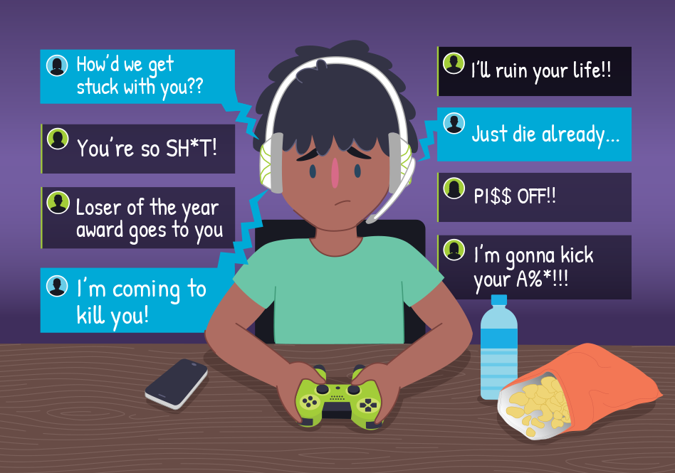

- DIGITAL CITIZENSHIP AND COPING WITH ONLINE HATE

Majority of adolescents who face online bullying and hate speech are susceptible to shut their eyes to it and take no action. It is a common idea that the action teenagers take will not have an impact or be inefficient. In contrast with this misconception, the actions taken by teenagers have utmost importance whilst tackling bullying.

What shall the young generations do?
There are three main steps:
- calling it out publicly
- show support to victims
- report content that can help platforms identify coded words, expressions, jokes

Firstly, when bullying is observed or experienced, it is needed to be talked about. In schools, at homes by parents, and most importantly by peers. By talking with friends and showing support to each other severe damage can be prevented. Sharing is one of the healthiest coping mechanisms.

To take action considering long-term issues, reporting the content to the platforms, speaking up to responsible elders such as counsellors, teachers and parents is of utmost importance. By reporting hate speech, the Artificial Intelligence systems can work efficiently and more reliably. One small step can trigger mass solutions and start the change.

By being a digital citizen, knowing the rights and responsibilities plays a crucial role. The right of self-expression must be protected whilst not crossing the lines of others vulnerabilities. It is a responsibility of a digital citizen to speak up publicly about online bullying and hate speech, and raising awareness about the right of self-expression.

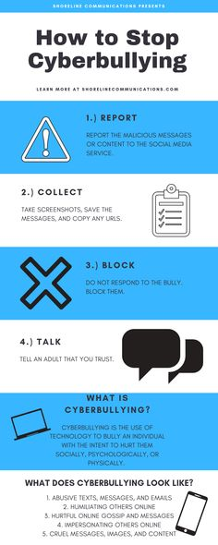

E. QUESTIONS TO ASK OURSELVES

- 1. Are algorithms discriminatory while removing hateful content?
- On social media a lot of racist, homophobic, xenophobic and anti-semitist content is encountered. Why are these not being taken down? The Artificial Intelligence systems can be coded to act discriminatory against races and ethnic groups.

- 2. Is removal of hateful content against the freedom of speech?
- Some say none of the ideas posted online should be removed, due to the fact that everyone has a right to express themselves.
- 3. How do we respond to hateful action individually or collectively?
- When we encounter bullying or hate speech, we all tend to act differently. As the age changes and the world becomes an online-dominated place, how do we show our support to peers facing issues and how can we show up more for them?
- The attitude of an individual is crucial. But the manner of a group is fatal. As groups of young people, we all act as a society. Feeling belonging to a group is a human need. How do we act as a group whilst tackling bullying? Do we all speak up and stand for the victims and hold bullies accountable?

- 4. Is mental health taken as seriously as it should be taken?
- Mental health is a health issue. Some may say it is not handled as one and being avoided. How important is your mental health to you and what do you do to just take care of yourself?

F. FURTHER READING
- https://www.unicef.org/end-violence/how-to-stop-cyberbullying
- https://www.pewresearch.org/internet/2018/09/27/a-majority-of-teens-have-experienced-some-form-of-cyberbullying/
- https://parents.au.reachout.com/common-concerns/everyday-issues/cyberbullying-and-teenagers
- https://www.coe.int/en/web/european-commission-against-racism-and-intolerance/hate-speech-and-violence

G. BIBLIOGRAPHY

- 2021, Presentation by Kyriaki Topidi, European Centre for Minority Issues, Online Forms Of Racism In Europe
- Common Sense. (2019, September 17). Teen Voices: Hate Speech Online [Video]. Commonsense.Org. https://www.commonsense.org/education/videos/teen-voices-hate-speech-online
- A Majority of Teens Have Experienced Some Form of Cyberbullying. (n.d.). Pew Research. https://www.pewresearch.org/internet/2018/09/27/a-majority-of-teens-have-experienced-some-form-of-cyberbullying/
- 8 Reasons Why Teens Bully Others. (n.d.). Verywellfamily.Com. https://www.verywellfamily.com/reasons-why-teens-bully-others-460532
- How to combat child bullying and tackle bullying at school Excerpts summarised from Neil Marr and Tim Field’s book. (n.d.). Bullyonline.Org. https://bullyonline.org/old/schoolbully/tackle.htm

