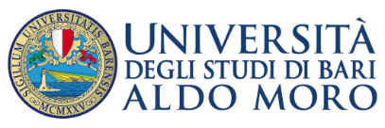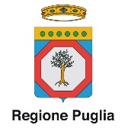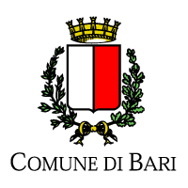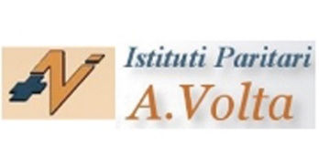
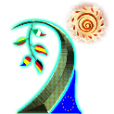Save our Resources - 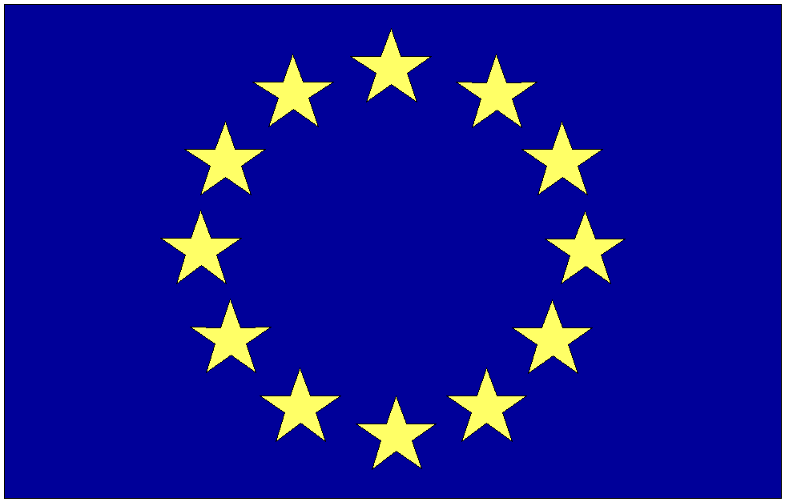 Erasmus+
Nature and Biodiversity ----- Culture and Cultural Heritage
Bari Meeting 1/8 April 2017
1st April arrival of the German delegation 10 students 2 teachers, airport Bari Palese 16,50
1st April arrival of Lithuanian delegation 4 students 2 teachers, railway station
2nd April arrival of the Romanian delegation 5 students 2 teachers Bari Palese airport 12,20
2nd April arrival of the Spanish delegation 9 students 2 teachers Bari Palese airport 21,20
Discovering nature in the city,visiting the old town ( meet at 10 in the morning German and Lithuanian ) (Report of the activities International group German, Lithuanian and Italian students) dinner meet in Pizzeria, taste the local Italian Barese pizza
Università degli Studi “Aldo Moro” Bari, Italy
3rd -4th-5th April 2017
3rd April 2017 – Salone degli Affreschi
9.00-9.15 Opening
Mariella Fanizza – Erasmus coordinator of the project of the A. Volta Institute
Alma Sinibaldi – Journalist A.B.A.P (Association of Apulian Biologists Environmentalists)
Giuseppe Pirlo – Managing Representative of Bari University for Digital Agenda and Smart City
9.15-10.00 Welcome
Antonio Felice Uricchio – Rector of the University of Bari
Marco Lacarra – Councillor of Apulia Region
Michelangelo Cavone –Councillor of Bari Municipality
Mario Bosco – Headmaster of the Volta Institute
10.00-10.30 Biodiversity in the Urban Park of Lama Balice between protection and enhancement: the BASE Project. Discussion.
Elvira Tarsitano – Bari University – Dept. Veterinary Medicine
10.30-11.00 Feeding the Future - Creating Momentum: C.A.N.A.P.A. Discussion
Marcello Colao – A.B.A.P.

11.30-13.00 Exhibition: Organization
Mariella Fanizza – Erasmus coordinator of the project of A. Volta Institute
13.00-15.00 Lunch (Panzerotti sulla muraglia ) Panzerotti on the walls of the old town, lab learn how to make panzerotti.
15.00-17.00 Exhibition, Students Meet Virtually Lucretius manifestoes , talk show, video
15.30 - 17.00 What about? Nature around Europe Video presentations of the 5 partners of the project the Song of the meeting
17.00-18.00 Opera Concert
18.00-18.30 Report of the Activities (international group Romanian-Spanish)
Dinner meet at 20 at Vino e cucina restaurant the old town taste the typical traditional barese food
4th Aprile 2017 – Salone degli Affreschi
9.00-9.15 Opening
Mariella Fanizza – Erasmus coordinator of the A. Volta Institute
Alma Sinibaldi –A.B.A.P. journalist
Giuseppe Pirlo – Managing Representative of the University of Bari for Digital Agenda and Smart City
9.15-12.00 Educational workshops: Art, Philosophy, Chemistry, Digital education, International folk calendar, Trivial game, Goose game.
12.00-13.00 Students’ group to organize the Europe Day to be held on 9th of May to celebrate peace and unity in Europe
Mariella Fanizza – Erasmus coordinator of the A. Volta Institute
13.00-15.00 Lunch restaurant mama puglia
15.00-17,30 Educational workshops: Art, Philosophy, Chemistry, Digital education, International folk calendar, Trivial game, Goose game. Results.
Titus Lucretius: presentation of materials
18.30 Disassembling the exhibition and Report of the activities (international group Lithuanian – Italian)
Free dinner

5th April 2017 – Centro Polifunzionale Studenti room , close to the university
9.00-9.15 Opening
Mariella Fanizza – Erasmus coordinator of the A. Volta Institute Bari
Alma Sinibaldi –A.B.A.P. journalist
Giuseppe Pirlo – Managing Representative of the Bari University for Digital Agenda and Smart City
9.15 - 9.30 Presentation of the project "Save our resources"
Tim Gockel – Project Coordinator of Städt Humboldt-Gymnasium Cologne Germany
9.30 - 9.45 Presentation of the Module "Nature and Biodiversity"
Mariella Fanizza – Erasmus coordinator of the A. Volta Institute Bari
9.45 – 10.00 Presentation of the Module "Culture and Cultural Heritage”
Juan Carlos Juarez Granados – Erasmus coordinator of the IES EL PALMERAL Vera SP
10.00-10.30 "The Green in the City". Discussion
Carla Tedesco – Town planning Assessor of Bari Municipality
10.30-11.00 Certificates and Prizes Distribution
11.30-12.00 "Nature and Biodiversity". Discussion.
Vincenzo Campanaro
12.00 -12.30 Participation Processes: “The role of the Council”. Discussion.
Elda Perlino – C.N.R. and Chair of Environment Council of the Municipality of Bari
12.30-13.00 Conclusion
Giuseppe Pirlo – Managing Representative of the University of Bari for Digital Agenda and Smart City
Mario Bosco – Head of the Volta Institute
15,30 teachers meeting meet at A,Volta school
17,30 Celebrating Europe, folk Apulian dances International party taste European, International food.
( The students prepare a report of activities international group Romanian – German)
6th April meet at 8 at central railway station to go to visit the salt fields Margherita di Savoia labs and visit of the fields from 10 to 13
13,20 lunch restaurant
15,30 visit Trani the white cathedral by the sea, the Svebian castle, taste the famous Italian ice cream
18,30 Bari railway station
- Free dinner for the teachers, students come back hom
- the students prepare a report of the activities (international group Spanish Lithuanian)
7th April meet at 8 central railway station to go to Polignano a mare to see the erosion of the sea, the caves walking by the sea front 11 visit of the contemporary art museum Pino Pascali , a museum set in the nature by the sea.
11,30 visit of Masseria dei monelli a biodiverse fattoria ,lab how to make cavatelli (hand-made pasta) taste traditional Italian barese food, enjoy natural garden.
Afternoon the Leaving of the Lithuanian delegation
16,30 visit Monopoli the old town the castle enjoy the famous Italian coffee and ice cream
18,30 Bari central station
Free dinner students come back home
8th April leaving of the all delegations

