Title | Module
Aims | - To develop a more accurate and complete understanding of nuclear energy resource.  - To identify the advantages and challenges of nuclear energy.  - To be able to list possible sources of radiation.
Key competences. | With this module students will develop the following competences:  - Linguistic competence: being able to express and interpret concepts, facts and opinions; interacting linguistically in an appropriate and creative way.  - Mathematical competence, applying mathematics to count the amount of the radiation.  - Competence in knowledge and interaction with the physical world, recognizing processes and describing them, representing data in the form of a graph or a scheme.  - Competence in the treatment of information and digital competence, using Internet, PC, smartphones, etc. in the search of and the treatment of information.  - Social and civic competence, participating in group work in an effective and constructive way, expressing active position towards the use of nuclear power.  - Cultural and artistic competence, having necessary values and principles, and demonstrating appropriate attitudes and behaviour; creating films, preraring presentations, videos or other pieces of information on the topic ”Nuclear Power”.  - Competence in learning to learn, building on prior learning and life experiences in order to use and apply knowledge and skills in a variety of contexts.  - Competence for autonomy and personal initiative, empowering the critical approach in order to confront the topic of nuclear power and search for responsible solutions.
Approx. time | 6 sessions (Material Annex)
Methods | Different methods are used
Age | 12-19
Assessment | SESSION 6  Answering the questions about the issues the students have learnt during sessions 1-5.
Necessary material | PC, projector, smartphone / tablet with access to the Internet, camera, board, pens, coloured pencils, etc.
Remarks | Background information for teachers (Annex 3)
WEB LINKS | - http://www.nuclear-power.net/  - https://whatisnuclear.com/

Material Annex

ACTIVITIES | SUBJECT / AREA | LEVEL /AGE
1. “Warm-up” | ANY LESSONS | 12-19
  - Find where nuclear power plants are located in your country.
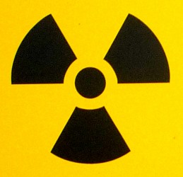
  - What 3 things come to your mind when you see this symbol? List them and discuss them in the group.
  - What do you know about impacts of nuclear energy on health? Answer the questions:
- Health impacts from Fukushima.
- Health impacts from Chernobyl.
- Calculate the yearly dose of radiation you get. | MATHS, PHYSICS | 12-19

CALCULATION OF THE YEARLY DOSE OF RADIATION

Radiation is all around us, all the time. We're exposed to radiation when we fly and when we get medical treatment - and whenever we leave the house. There are different kinds of radiation. The problems we're concerned about come from ionizing radiation.
Radiation dosages are measured in sieverts - but because these are so big we're talking about millisieverts mSv (a thousandth of a Sievert).
Answer the questions and find out what is YOUR yearly dose of radiation.

- Have you had an X-ray, CT (computed tomography) scan in the last 12 months?
YES NO (0 mSv)
Select ALL your x-rays.
- Skull (0,02mSv)
- Chest (0,1 mSv)
- Spine (1,5 mSv)
- Abdomen (0,6mSv)
- Pelvis or hips (0,75 mSv)
- Limbs and joints (0,06 mSv)
- Dental film (0,005 mSv)
Select ALL your CT scans.
- CT scan: head 2 mSV
- CT scan: heart 16mSV
- CT scan: full body 10mSv
- CT scan: addomen $pelvis 15mSv

- Choose elevation (altitude) of your town.

Vilnius 97,5 meters (0,02mSv)
Cologne 54 meters (0,02mSv)
Vera 99 meters (0,02mSv)
Bari 5 meters (0,02mSv)
Ploiesti 160 meters (0,02mSv)

- Cosmic radiation 0,26mSv

- Internal radiation from food and water (e.g., potassium) (0,4mSv)

- Do you have porcelain crowns or false teeth? YES (0,007mSv) NO (0 mSv)

- How many kilometres have you traveled by jet this year?
(0,01mSv per every 1610 km)
………………………
- How many times did you go through a screening machine at the airport over the last year?
(0,0003mSv each)
…………………………….

- Are x-ray luggage inspection machines used at your airport?
YES (0,0002mSv) NO (0 mSv)
- Do you smoke? NO (0 mSv)
YES. How many packs of cigarettes do you smoke per day? (0,0049mSv per pack)
……………………..
- Do you live in a stone, brick, or concrete building?
YES (0,07 mSv) NO (0 mSv)

- Do you wear a luminous wristwatch?
YES (0,0006mSv) NO (0 mSv)

- Do you have a smoke detector in your home?
YES (0,0008mSv)
NO (0 mSv)
- Do you live within 80 kilometres of a nuclear power plant?
YES (0,09 mSv) NO (0 mSv)
- Do you live within 50 miles of a coal fired power plant?
YES (0,0003mSv) NO (0 mSv)

TOTAL…………………..mSv

The average person safely absorbs about 3,65 millisieverts of radiation annually.

ACTIVITIES | SUBJECT / AREA | LEVEL /AGE
- Group Work (time for this work – up to 1-2 weeks). | IT, ART, CHEMISTRY, LANGUAGES, GEOGRAPHY, PCHYSICS | 15-19
  - Students are divided into 5 groups. Each group gets a task from the list presented.
  - Each group chooses what to do: a poster, a presentation, a short film, a description, a leaflet, etc.
  - Each group searches for information. They can use https://whatisnuclear.com/
  - TOPICS (additional questions):
- What is nuclear energy?
- Problems with Nuclear Power
    - Nuclear Waste
    - Dramatic accidents
    - Cost
- What is a nuclear reactor?
- What is Nuclear Waste?
    - What do we currently do with our nuclear waste?
    - What should be done with nuclear waste?
    - Recycling nuclear waste.
    - What is nuclear recycling?
- What is radiation?
    - What is radioactivity?
    - Health and Radiation?
    - How much risk is acceptable?
  - Performs the chosen task on the given topic.
  - The tasks performed are presented and results are discussed.

ACTIVITIES | SUBJECT / AREA | LEVEL /AGE
- Analysis of the diagram (image). | ANY LESSONS | 15-19
  - The image depicts “The nuclear fuel cycle”. Write in the names of every element of the diagram (as you think it might be called.)
  - Read the short text.
  - Check if the names are indicated correctly.

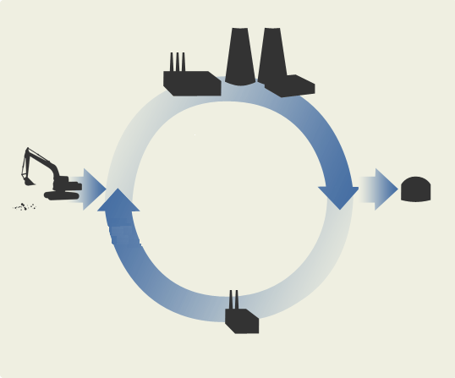
Picture 1 ©http://www.vae.lt/lt/ziniu-centras/branduolinio-kuro-ciklas
TEXT:
The nuclear fuel cycle is the entire process of producing nuclear fuel and energy, including scientific-research work. The cycle consists of 4 phases.
Mining, production of nuclear fuel. Uranium ore is mined and nuclear fuel is produced from it.
Production of energy. Nuclear fuel is used in a nuclear power plant – energy is produced. Disposal. If the fuel used in not recycled, it is transported to a storage facility − a geological disposal facility.
Recycling. The nuclear fuel set for recycling is transported to a recycling facility. Up to 95% of the recycled nuclear fuel can be reused for production of new fuel and production of energy in nuclear power plants.

ACTIVITIES | SUBJECT / AREA | LEVEL /AGE
- A timeline of nuclear energy. | PHYSICS | 15-19
  - Discuss the timeline in the group.
  - Indicate 3 the most important elements.

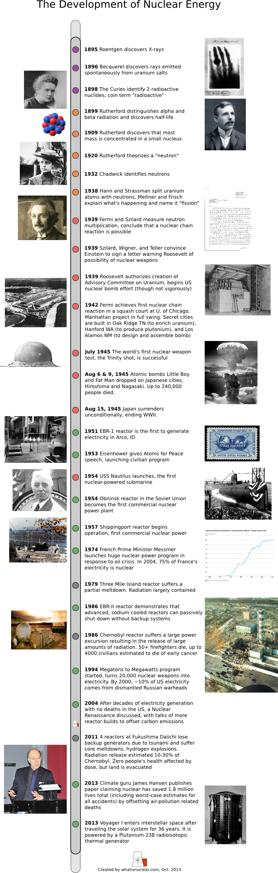
https://whatisnuclear.com/articles/nuclear_history.html

ACTIVITIES | SUBJECT / AREA | LEVEL /AGE
- Debates | LANGUAGES | 16-19
  - Students are divided into 2 groups: “FOR” and “AGAINST”. Each group reads a sentence: “The first step to solving the problem of nuclear waste is to stop making it”.
Sentence from: Pandora’s+False+Promises_Final_May13_2013)
  - A group fills in the table with 3-5 statements.
  - Each group presents its statements.
  - The most important statement of each group is selected.
  - Results are discussed.

“The first step to solving the problem of nuclear waste is to stop making it”
(Sentence from: Pandora’s+False+Promises_Final_May13_2013)
 | ARGUMENTS “FOR” | ARGUMENTS “AGAINST”
1
2
3

ACTIVITIES | SUBJECT / AREA | LEVEL /AGE
- Assessment
Answer the questions/ complete the sentences:  - I think nuclear energy is.............  - The nuclear fuel cycle is………..  - What kind of problems can occur with Nuclear Power sources?  - What do you know about radiation?  - When are we exposed to radiation?  - What impact can nuclear energy have on your health? | ANY LESSONS | 12-19

