ERASMUS+ PROJECT
SAVE OUR RESOURCES

EUROPEAN
RESOURCES & ENERGY
CURRICULUM

Istituto Paritario "A. Volta"(ITALY)
Etminiškių gimnazija (LITHUANIA)
IES El Palmeral (SPAIN)
Colegiul Tehnic Elie Radu Municipiul Ploiesti (ROMANIA)
Humboldt-Gymnasium Köln (GERMANY)

The European Resource and Energy Curriculum
Created by
Etminiškių gimnazija
Colegiul Tehnic Elie Radu Municipiul Ploiesti
IES EL PALMERAL
Istituto Paritario "A. Volta"
Humboldt-Gymnasium Köln

This project has been funded with support from the European Commission. This publication reflects the views only of the authors, and the Commission cannot be held responsible for any use which may be made of the information contained therein.

Preface
“Why do we need to educate young people in using resources responsibly?”

Europe is one of the richest regions in the world. However, this wealth comes at a price: We live at the cost of future generations and therefore it is vital to find ways to save our finite resources.

The aim of the "European Resource and Energy Curriculum" is to improve education for sustainable development and create awareness for consumption and the use of resources.

It is the result of the ERASMUS + project “Save our Resources”, which was carried out by five teams from schools in Italy, Lithuania, Spain, Romania and Germany. We worked together to develop modules and materials for students in Europe to increase their knowledge about the dependability on resources and make them aware of how to use resources in a sustainable way.

This curriculum wants to enable teachers all over Europe to work with their students in order to achieve the competences students need to recognize the problems of consumption and waste of resources and energy.

Different teaching materials have been created in order to develop basic and comprehensive skills and are presented as an online document open to the public. The curriculum contains specific lesson drafts with suggestions to innovative teaching methods like cooperative teaching, self-evaluation, and problem-oriented lesson models. As these aims are reached by working in a foreign language, the language competence of all the participants (teachers and students) will improve significantly. All modules of the curriculum were put into practice, discussed and evaluated.

The curriculum contains several modules which can be worked on separately. The topics refer to examples from reality where the discussed issue is shown. The modules are useable in cross border implementation and have a different recommended age or subject where they can be used. All of them are adaptable to the country, region and classroom you work in. Please, feel free to adapt it to your needs!

The aims of our project are diverse. We think that only when viewed from different angles they contribute to a common improvement of education in Europe. If we can motivate you to work with our materials, we will have achieved our goal!

Competences

Education is a key agent for change towards sustainable development. Education for sustainable development (ESD) improves the capacity of individuals, communities and society as a whole to make informed judgments and choices in favor of sustainable development. Therefore, our project corresponds to the UNECE Strategy for Education for Sustainable Development and the goals for sustainable development by the UNESCO.

For example, until 2020 the emission of Carbon Dioxide in the European Union should be reduced by 20% in comparison to 1990. This is one of "The 5 targets for the EU in 2020". This aim should be reached by introducing 20% of energy from renewable sources and by a 20% increase in energy efficiency.

The main objective of our project is to create a responsibility in using resources to contribute to these aims. As a European target these efforts only can be reached by a cross-border project.

The main idea of our work is to educate in sustainable development. Every module contains a specific list of competences which can be improved by working on them.
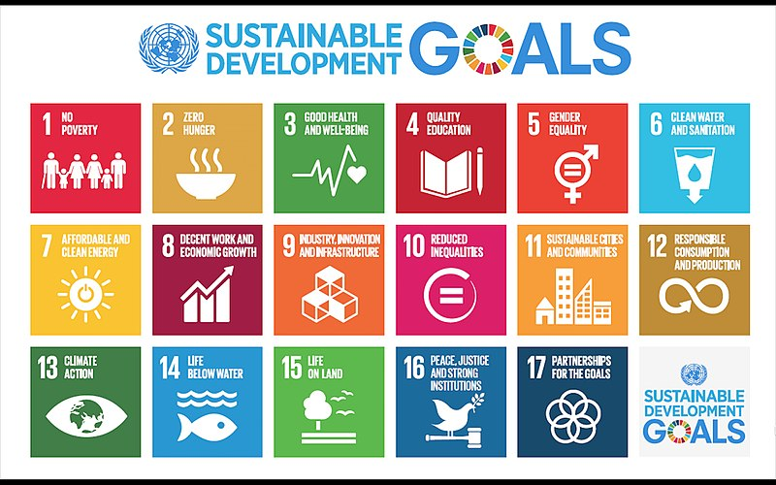

Module overview

- Introduction ^{GER}
- Water as a resource ^{ES}
- Bioenergy ^{LT}
- Solar and Wind energy ^{RO}
- Tourism as a resource ^{RO}
- Natural resources and agriculture ^{IT}
- Cultural resources ^{ES}
- Nature and Biodiversity ^{IT}
- Fossil energy sources ^{GER}
- Nuclear power ^{LT}
- Conclusion ^{ALL/GER}

Copyright

This curriculum consists of different modules created by the participating schools. The modules have passed an evaluation and updating process during the project and can be seen as independent work of each school. That means that every school is responsible for the content and copyright questions for their own modules.

The whole curriculum is licensed as ORS (Open Educational Resources). It is freely accessible and can be used and adapted for educational purpose in a noncommercial way.

School | Module
Istituto Paritario "A. Volta", Bari, Italy | Natural resources and agriculture  Nature and Biodiversity
Etminiškių gimnazija, Lithuania | Bioenergy  Nuclear power
IES EL PALMERAL, Vera, Spain | Water as a resource  Cultural resources
Colegiul Tehnic Elie Radu Municipiul Ploiesti, Romania | Solar and Wind energy  Tourism as a resource
Humboldt-Gymnasium Köln, Germany | Introduction  Fossil energy sources  Conclusion

This project has been funded with support from the European Commission. This publication reflects the views only of the author, and the Commission cannot be held responsible for any use which may be made of the information contained therein.

Licence PD, by MariaGershuni [Public domain], from Wikimedia Commons https://commons.wikimedia.org/wiki/File:Sustainable_Development_Goals.jpg?uselang=de

