Module fossil energy sources

Title | Module
Aims | The students are…  Knowledge:  - aware of the amount of fossil energy sources that are used in their respective country  - aware that fossil energy sources are finite  - able to explain the dependence of our society from fossil energy sources  - able to describe effects of the usage on the environment  - aware of the dilemma which the use of fossil energy sources causes (e.g responsibility for future generations vs. easy access to energy and short-time economic growth)  Skills:  - defining the term “Fossil Energy Source”  - able to describe advantages and disadvantages of different fossil energy sources  - able to discuss about the topic in a responsible way  - able to name alternative energy sources  - improving their English skills  Methods:  - able to work independent on different topics concerning fossil energy sources  - able to lead an open discussion  Assessment/ Acting:  - reflecting their own consumption of fossil energy sources  - discussing ways and alternatives for the future
Key competences | - improving language skills  - acquire specialized knowledge about fossil energy sources  - reflect their own behavior
Approx. time | 12 – 14 lessons (45 min)
Age | 12 - 18
Description of content | First step – Brainstorming “What are fossil energy sources?”  Second step – learning circle  There are four basic (obligatory) and four additional (optional) topics:  - Lignite (brown coal)  - Hard coal  - Natural Gas  - Oil (Petroleum)  optional  - Peak Oil – A society without Oil?  - A society without plastic?  - Environmental effects “The greenhouse gas CO2”  - What can I do?  Third step – A life without fossil energy sources: utopian – dystopian worlds?  Fourth step – Using fossil energies – benefits and dangers
Necessary devices | overhead projector, computer connected to the internet, bilingual/monolingual dictionaries, projector

Materials

Module fossil energy sources
First step – Brainstorming “What are fossil energy sources?”
Aims | - Get a comprehensive insight into the topic  - Be able to define the topic fossil energy sources
Description of content | - “What do these things have in common?” Presentation of different products made of fossil resources – for example plastic bottles, gas can, face cream, light bulb, candle, pieces of lignite or hard coal (you can also use the pictures below).  - “Try to find a definition of the term fossil resources and write a dictionary entry.” (e.g. fossil resources consist of dead organisms and plants, it takes millions of years to form fossil fuels out of the original matter. Nowadays we use lignite, hard coal, natural gas and oil.)  - “Imagine life without fossil energy sources. Talk to a partner.”  - ´´“Our civilization depends on fossil resources” Explain this quote in your own words.´´  - Lead over to the next step (learning circle) where the different fossil resources will be explored.
Approx. time | one lesson

What do these things have in common?

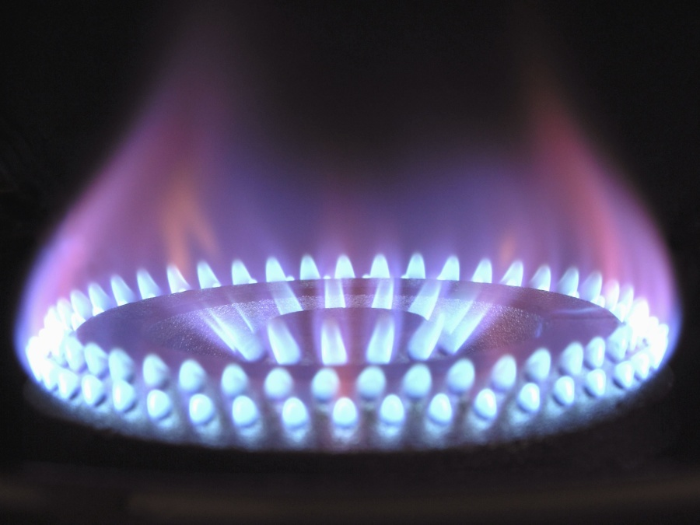
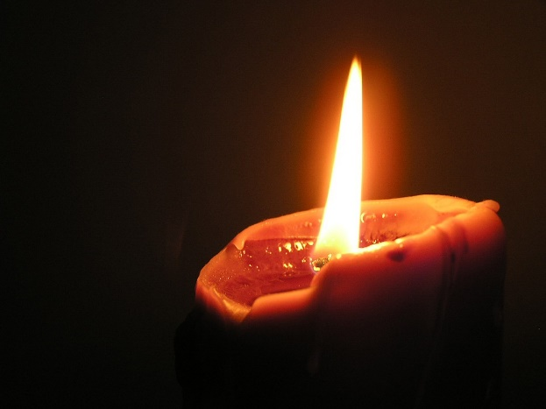

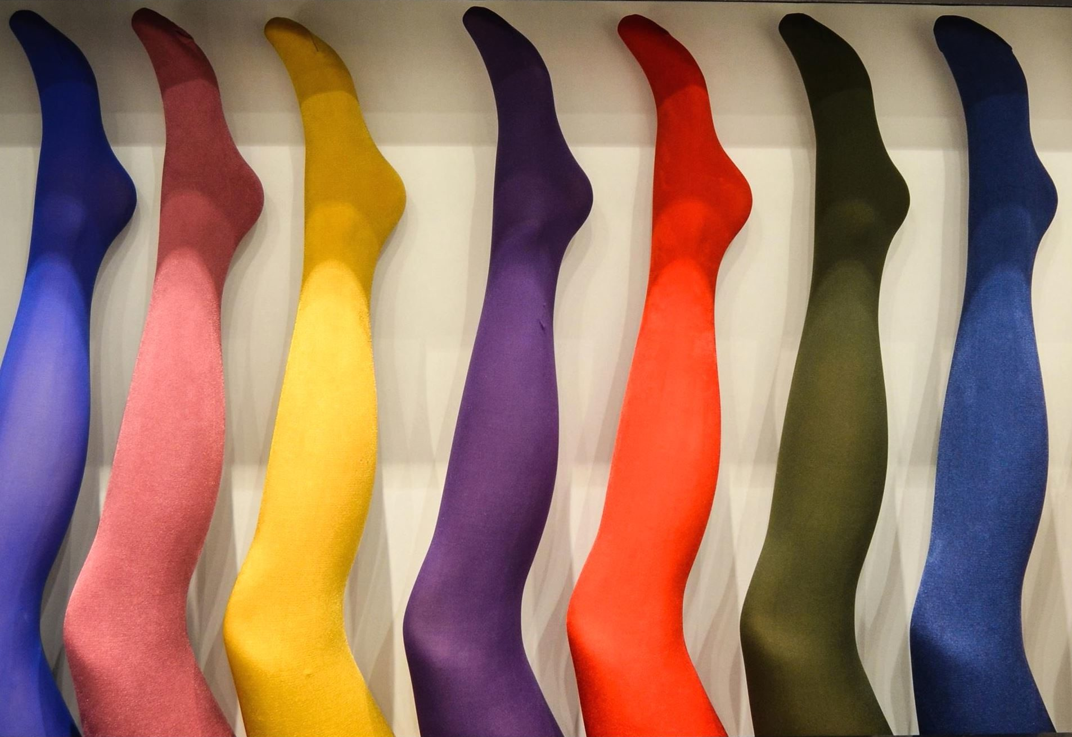
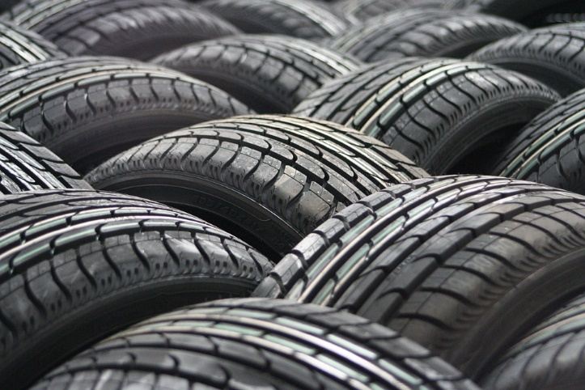

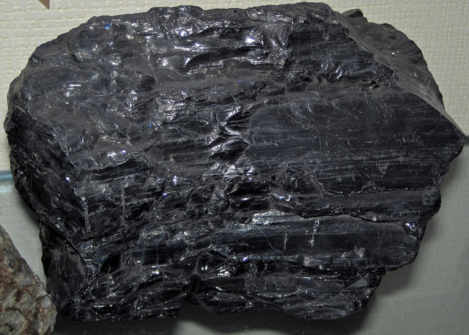

Module fossil energy sources
Second step – learning circle fossil energy sources
Aims | - Being able to describe the formation of hard coal, brown coal, petroleum and natural gas  - Getting aware of the amount of fossil energy sources that are used  - Getting aware that fossil energy sources are finite  - Being able to describe advantages and disadvantages of different fossil energy sources  - Being able to name alternative energy sources
Description of content | - Prepare the eight topics by printing the documents from the material annex.  - The Students need access to the internet via PC or mobile.  - Hand out the checklist for self-evaluation.
Approx. time | 4-6 lessons

Checklist for self-evaluation

How efficient was your work during the following topics?
Obligatory topics
Lignite (brown coal)

Hard coal

Natural Gas

Oil (Petroleum)

Optional topics
Peak Oil – A society without Oil?

A society without plastic?

Environmental effects “The greenhouse gas CO2”

What can I do?

Did you have new insights during the learning circle?

Did the work on the learning circle improve your English skills?
Do you think you will change your behaviour using fossil energy sources?

Topic: Lignite (brown coal)

Answer the following questions by doing research on the internet:

- Explain how is lignite formed and how long does it take to form?
- Where can you find lignite in your country? Create/ design a map.
- Describe the mining process of lignite e.g. in Germany.
- Compare the energy content of lignite to other fossil energy sources.
- Describe how could lignite be replaced in Europe?
- Do research on the latest news about lignite mining in Germany and describe the problems that are occurring there.
Extra
- Make a chart about the amount of energy that comes from lignite in your country.

https://www.thebalance.com/what-is-lignite-1182547
https://euracoal.eu
http://www.spiegel.de/international/business/energy-transition-blocked-by-brown-coal-a-1179537.html
https://www.theguardian.com/environment/2015/jul/07/brown-coal-wins-a-reprieve-in-germanys-transition-to-a-green-future

Topic: Hard coal

What do you already know about hard coal? Make a mind map!

Answer the following questions by doing research on the internet:

- Draw a picture of the formation of hard coal.
- Make a timeline which describes the progress over the years.
- How is hard coal mined?
- Explain what hard coal is mainly used for.
- Which countries in the world and Europe are the ones who produce the highest amount of hard coal. On which place is your country?
- Which countries in the world and Europe use the highest amount of hard coal?
- What are the disadvantages of using hard coal? Make a list
- Complete your mind map with what you have found out while working on this topic.

Topic: Natural Gas

Answer the following questions by doing research on the internet:

- Find natural gas deposits in your country.
- What is natural gas used for in your country?
- How has the amount of natural gas consumption changed in recent years?
- What are possible reasons for the change?
- List advantages and disadvantages of gas consumption.
- In your household, do you use natural gas? If yes, what is it used for?
- In comparison to other fossil fuels, how harmful is natural gas for the environment and for for people?

Topic: Oil (Petroleum)

- Create a mind map about oil using your current knowledge.
- Describe the way how oil (Petroleum) is formed and where you can find it nowadays.
- Crude oil is the foundation of several products. List products in your daily life which are made of oil in a direct or indirect way.
- There are different ways to drill for oil. Find some of them and explain how they differ.
- Fill the table with the advantages and the disadvantages of oil as a energy source. Mind thereby different steps in the production and usage of oil: the drilling process, the processing in a refinery, the usage of the products and the waste at its end.

Advantages | Disadvantages

- Finally complete the mind map with your knowledge.

Topic: Peak Oil – A society without Oil?

Since the 1950s scientists are discussing about the end of the oil sources. There are different expectations and studies how long oil will be available for us.
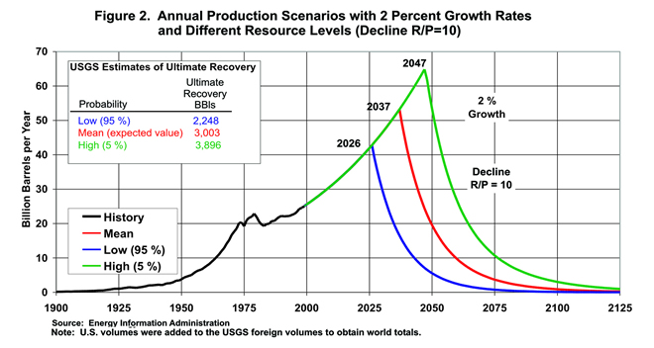
Picture by John H. Wood, Gary R. Long, and David F. Morehouse, US Energy Information Administration [Public domain], via Wikimedia Commons

This diagram shows the annual production of crude oil in the world. There are three different scenarios which show the possible extraction of crude oil. That means the maximum amount of crude oil that can be found and used.

- Why are there three different peaks (2026, 2037, 2047)?
- Do research on the internet to find out about different (conventional and unconventional) ways to extract oil and possible dangers.
- Describe your daily life in 2050 after all oil have been spent. Write a blog entry.

Topic: A society without plastic?

Answer the following questions by doing research on the internet:

1. What does plastic (synthetic materials) basically consist of?
2. How long does it take plastic to decompose?
3. Which alternative (renewable) solutions to synthetic materials can you find? Name advantages and disadvantages.
4. Find out about the Great Pacific Garbage Patch. How does it influence marine life? What can be done about it?

https://www.nationalgeographic.org/encyclopedia/great-pacific-garbage-patch/

Topic: Environmental effects “The greenhouse gas CO₂”

Answer the following questions by doing research on the internet:

- Describe which emissions are released when the different fossil energy sources are burned. Create a table to show the differences.
- Some of these emissions are quite toxic for animals, plants and humans. Carbon dioxide (CO₂) isn’t toxic but also a big problem for our society. Explain how carbon dioxide (CO₂) is affecting the nature.
- Find a graph on the internet which shows the CO₂ concentration of the atmosphere from 1900 until now. Describe the course of the graph and try to explain it. Often the results of Mauna Loa at Hawaii are shown in these diagrams. Why is Mauna Loa at Hawaii chosen?
- Carbon dioxide (CO₂) is the main waste product when fossil energy sources are used. As a greenhouse gas CO₂ is a main reason for the Greenhouse effect. Create a scheme (plan/ picture/ graphic) which illustrates the Greenhouse Effect and the role of CO₂ and try to find the difference between the natural and the anthropogenic Greenhouse effect.
- The increasing Greenhouse Effect is one of the reasons for climate change. Find different results and effects of the climate change in your country/ the European Union/ the World.

Topic: What can I do?

Answer the following questions by doing research on the internet:

- As you have seen our economy depends on fossil energy sources. Without them our usual daily life wouldn’t be possible – but by using them in a large scale we seriously affect the environment in diverse ways and maybe run out of them soon.
- Compare the CO₂ emission of different countries over the world (e.g. Romania, Lithuania, Italy, Spain, Germany, USA, China, Qatar, India, Burundi). Try to find absolute results and results per capita. Describe the difference.
- Sum up your usage of fossil energy sources by finding your personal CO₂ footprint.
https://www.carbonfootprint.com/calculator.aspx
- Explain why the term “footprint” is used here.
- Compare your carbon footprint with your classmates and find the lowest and highest in your class.
- Think about your daily life. Can you imagine areas where you can save fossil energy sources?
- Explain why it is important to save fossil energy sources. If you don’t think it is necessary, explain it.
- Do you think that the changes in energy usage at the moment lead to a sustainable future? Explain your opinion in a few sentences.

Module fossil energy sources
Third step – A life without fossil energy sources: utopian – dystopian worlds?
Aims | The students are…  - aware that fossil energy sources are finite  - aware of the dilemma which the use of fossil energy sources causes (e.g responsibility for future generations vs. easy access to energy and short-time economic growth)  - reflecting their own consumption of fossil energy sources  - thinking about different ways of using energy and alternatives for the future
Description of content | Hand out the task below. You can link the content to different films (maybe just short clips) based on a utopian or dystopian world in the future (e.g. Bladerunner, Metropolis, Total Recall, I Robot, GATTACA, Interstellar).
Approx. time | 2 Lessons

A life without fossil energy sources: utopian – dystopian worlds?

Write a story about our community or society in the future. Mind thereby our use of fossil energy sources in particular. You decide whether it is a dystopian or a utopian future.
You can choose the type of text you like (poem, story, newspaper article …)
If you need help, have a look at the results of the topics you have worked on before or use the questions below.

Think about the fossil energy sources you know and what you have learned about them.
What are advantages and disadvantages?
Which are the consequences for our lives and that for our children?
Think about the fact that fossil fuels might not exist in a couple of years.
What are alternatives? Are they easily to be used in our daily life?
You might want to describe the future in 50, 100, 300 or 1000 years.

Module fossil energy sources
Fourth step – Using fossil energies – benefits and dangers
Aims | The students are…  - aware that fossil energy sources are finite  - able to explain the dependence of our society from fossil energy sources  - able to describe effects of the usage on the environment  - aware of the dilemma which the use of fossil energy sources causes (e.g responsibility for future generations vs. easy access to energy and short-time economic growth)  - able to lead an open discussion  - reflecting their own consumption of fossil energy sources  - discussing ways and alternatives for the future
Description of content | - Lead in by showing pictures to recapitulate the contents of the learning circle  - about the negative effects that the use of fossil energy sources has on the environment (climate change, trash islands, …)  - about the positive effects that the use fossil energy sources has had on our society such as it is (industrialization, technological development, scientific progress, development of transport and infrastructure, employment, …)  - The students brainstorm other important information in partner work also by taking notes  - -Have an open discussion about the benefits and dangers of using fossil sources in the future
Approx. time | 2 lessons

The picture by Magnascan Steven was published under CC0 1.0 Universal (CC0 1.0) Public Domain Dedication; https://pixabay.com/p-580342/?no_redirect
The picture by Miss Vine was published under CC0 1.0 Universal (CC0 1.0) Public Domain Dedication; https://pixabay.com/p-268073/?no_redirect
The picture by James St. John was published under Attribution 2.0 Generic (CC BY 2.0); https://www.flickr.com/photos/jsjgeology/41557476844
The picture by Michal Jarmoluk was published under CC0 1.0 Universal (CC0 1.0) Public Domain Dedication; https://pixnio.com/objects/sock-plastic-object-nylon-colorful-color
A dystopia is a community or society that is undesirable and/or frightening. It is translated as "not-good place", an antonym of utopia. https://en.wikipedia.org/wiki/Dystopia
A utopia is an imagined community or society that possesses highly desirable or nearly perfect qualities for its citizens. The opposite of a utopia is a dystopia. One could also say that utopia is a perfect "place" that has been designed so there are no problems. https://en.wikipedia.org/wiki/Utopia

