Paul Pogba

Paul Labile Pogba was born on March 15, 1993 in Lagny- sur- Marne in Seine-et-Marne. He is a French international footballe.
He was the team captain of under 20 who won the world championship in 2013 , and was elected best player ..
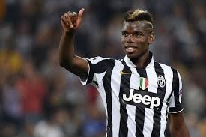
Have you heard of him in your country ?
Romain and Enzo.

