Chocolate Fudge Cake

Serves:8-10
Prep time:20 mins
Cooking time:1 hour
Ingredients:
200g plain chocolate broken into chunks
200g butter
200g light brown muscavado sugar
100ml buttermilk
2 eggs beaten
170g self-raising flour
3 tbsp cocoa powder

- Heat oven to 160 ̊C. Line a 24cm round cake tin with butter and baking parchment. Gently melt the chocolate, butter and sugar into a large pan with 100ml hot water. Set aside for 2 minutes, then stir in the buttermilk followed by the eggs.
- Stir or whisk in the flour until lump free, then pour into the tin. Bake for 50-55 minutes until a skewer comes out clean. Sit the tin on a wire rack to cool.

Ingredients for sauce:
500ml double cream
100g brown sugar
4 tbsp golden syrup
200g dark chocolate
1 tsp vanilla extract

- Melt all the sauce ingredients in a saucepan.

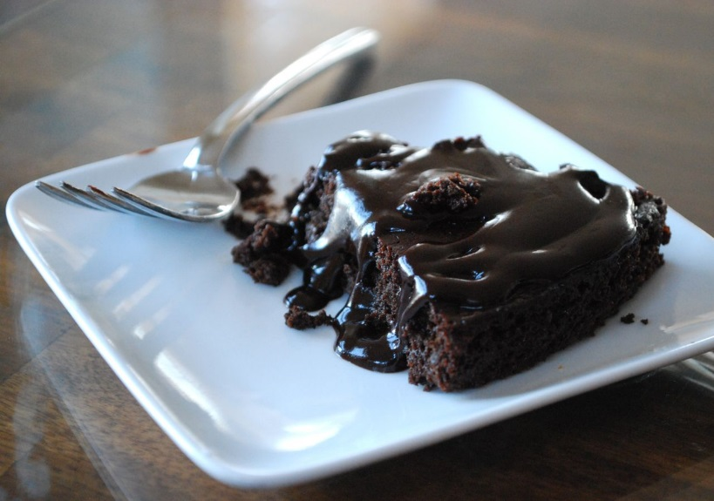
Serve the cake with the sauce and ice-cream if you would like. Enjoy!

