Our traditional Cuisine
Italy is very famous for its food. Every country offers something delicious and typical. To begin, Campania can’t exist without its pizza. All tourists of the world want to taste pizza made in Naples. The lovers of pasta want Italian tortellini or lasagna. All people know pesto ALLA GENOVESE with our aromatic basil. Not to mention our enviable cheese: PARMIGGIANO REGGIANO. Everyone wants to taste a slice of CAPOCOLLO with a slice of Altamura bread. The Italian food is very good and also its wines: for example Chianti and Cirò Librandi.
Calabria, our region, offers many specialties: the spicy ‘NDUJA, SOPRESSATA (a soft spreadable cured meat made with pork meat, herbs, spices and the famous Calabrian chili ), the ice-cream TARTUFO OF PIZZO, STOCCO FISH OF MAMMOLA, the OLIVE SCHIACCIATE (smashed olives), the GIARDINIERA and PECORINO CHEESE OF CROTONE.
Calabria is famous for its food preserves, such as : tuna in olive oil , the Green and black olives in the "BOCCACCI" (glass cans) , or the "Salt anchovies.
A traditional dish prepared for religious festivity or special days is the “pasta chijna” (filled pasta) based on layers of homemade pasta (lasagne) topped with small fried meatballs, slices of hard-boiled eggs, slices of spicy "salami", caciocavallo cheese and grated pecorino cheese (baked). The Spiral Fileja is served with a chilli-falvoured sauce of tomatoes and pecorino.
There are also good local foods based on offal such as “the morzeddu” in the Catanzaro province! It is lamb or kid (young goat) offal cooked with tomato, hot pepper in a pie-like bread container.
Other specialties are Eggplant Parmigiana, Mushrooms picked in the woods and cooked in different ways, dried tomatoes that; "Patati e Pipi", fried potatoes and red peppers.
Calabria is rich in Citrus Fruit such as the Clementines of Calabria, the chestnuts, the figs especially those from Cosenza which are covered with chocolate or worked with spices and dried fruit (almonds, walnuts) to make the famous “crocette” (cross-shaped).
Some traditional desserts of Calabria are:
Nougat (Torrone), "giurgiulene", small nougat made ​​with honey, almonds, candied orange, pistachio nut or sesame seeds. Pitta 'mpigliata (or pitta' nchiusa) based on dried fruit and honey. Mostaccioli (Mostazzoli, 'Nzuddha, Mastazzuolu or Mustazzuali) are typical sweets from Soriano Calabro, made with natural ingredients, flour, Calabrian honey and mulled wine. They are in various shapes. Turdiddri or Cannarìculi , Nacatole, Pignolata and Susamelle are traditional Christmas sweets . Chiacchiere (Gossips) - Sweets prepared to celebrate Carnival (Mardi-Gras), in the shape of a strip, sometimes modeled in various forms, made ​​with a mixture of flour that is fried or baked, then dusted with powdered sugar. Cuzzupe, Easter sweets,
On a Calabrian table you can always find a good glass of wine produced in our region, especially the red one. One of the best wines produced is white and red Cirò wine. Our typical homemade liqueurs are bergamot, made with an extraordinary and prided citrus fruit exclusive of our region, and “limoncello” made with lemon.

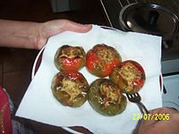 PIPI CHINI

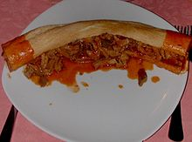 MORZEDDHU

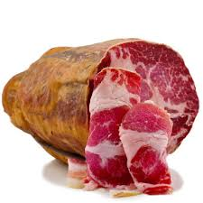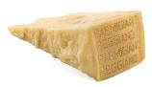

Capocollo Parmigiano Reggiano

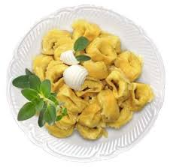
Tortellini Pizza

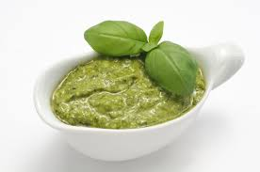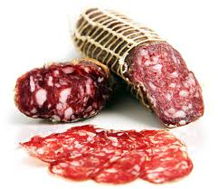
Pesto Sopressata

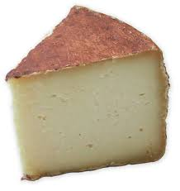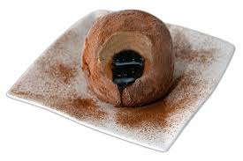

Pecorino Tartufo

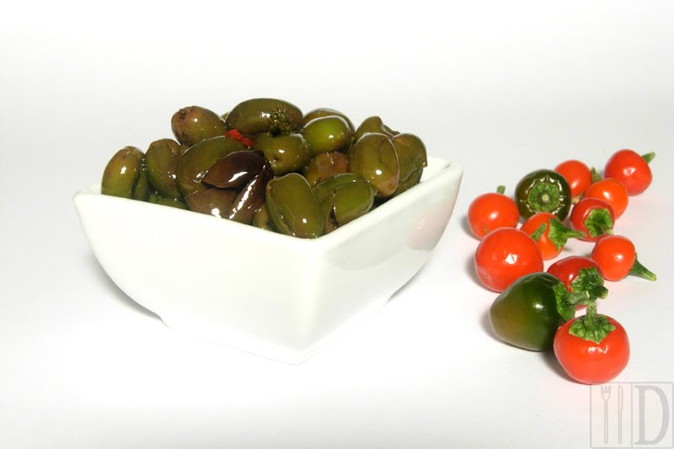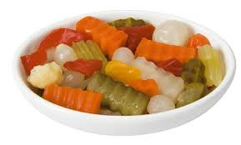
Olive Giardiniera

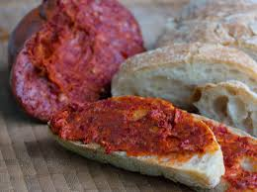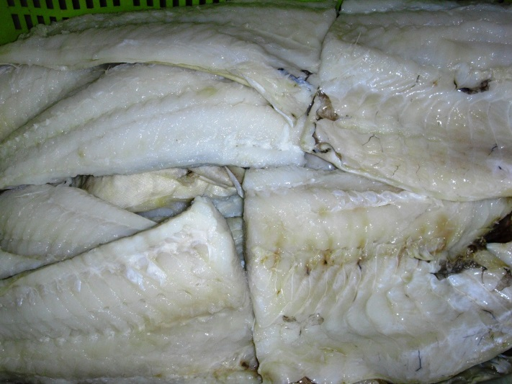
‘Nduja Stocco
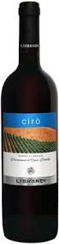
Vino Cirò Librandi

