CARS

All of us dream to drive a car.
We are 12 but when we are 14, according to our laws, we can drive a micro-car.
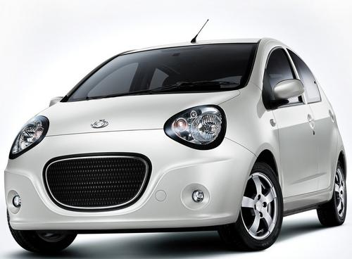
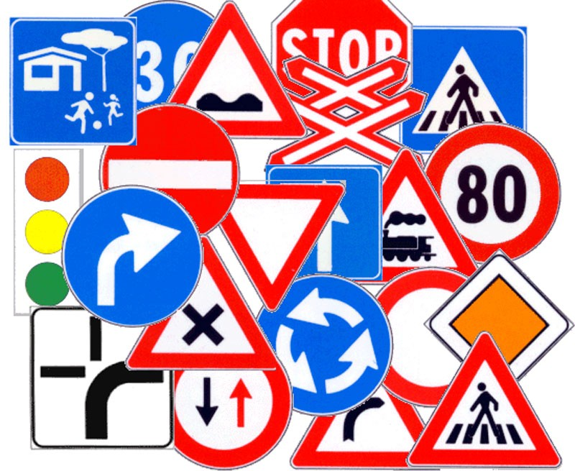

In our town there are many micro-cars. We like them a lot. They are safe because they can’t go fast and we don’t need a special driving licence to drive them but the driver must drive carefully because on the street there are many dangers.

In our English book there is an interesting reading about cars. The title of this reading attracted our curiosity:
GOLD ON THE ROAD
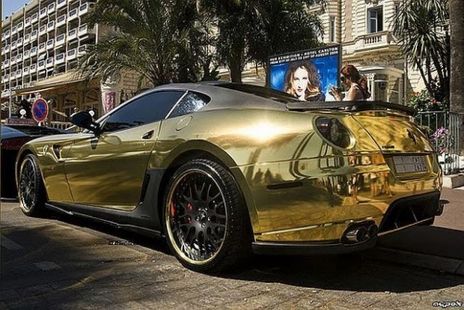
WE want to share this funny article with you all.
“In 2005 the luxury goods company Visualis commissioned an artist to cover a Porsche Boxter in 22 carat gold. Everything about this car says ‘’luxury’’. They now want to produce a limited edition of these super-luxury cars and say that they have already got orders from a few millionaires around the world to buy them!”
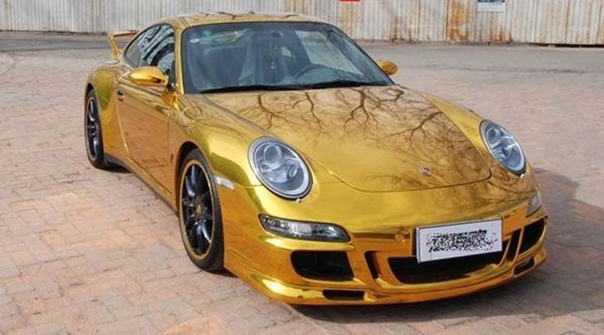
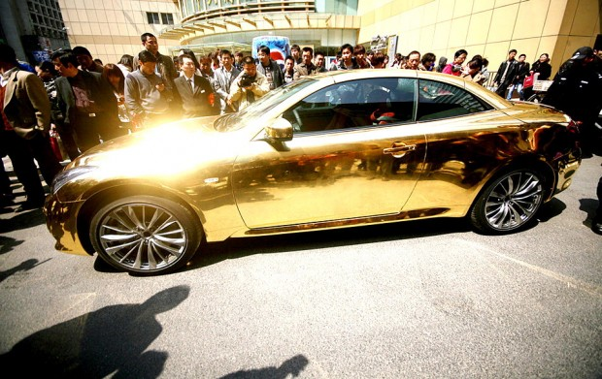
IT is funny ,isn’t it?

Grandinetti Maria Antonietta e Mercuri Aurora

