Successful films in Italy

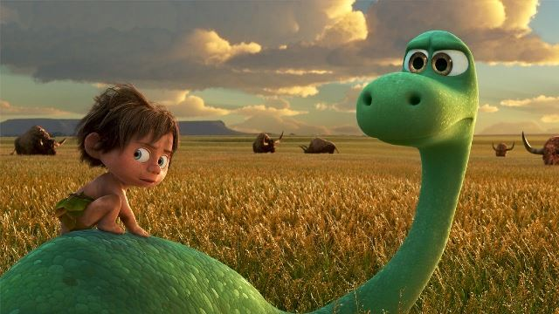

THE JOURNEY OF ARLO
65 million years ago, on the Late Cretaceous the famous asteroid, which would have caused the extinction of the dinosaurs, it lacks the land allowing dinosaurs to continue to populate the planet and evolve to become more intelligent.

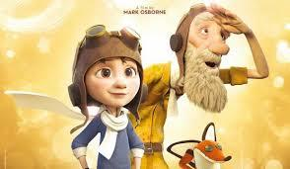

IL PICCOLO PRINCIPE
An aircraft pilot, after crashing in the Sahara desert, meets a strange child who asks him: "draw me a sheep", amazed the pilot does not understand the reason for that strange question; gradually the child began to speak, and told him to be the prince of a distant asteroid on which there were three volcanoes, a small rose and himself…

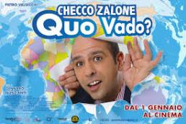
QUO VADO
Checco Zalone is a guy who has reached ​​all the expectations he had in his life , he wants to be eternally boyfriend not to face the problems of marriage and he wants a job done safely and forever….

TV PROGRAMMES

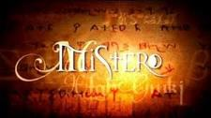

MISTERO
Mistero is an Italian TV program on mysterious events around the world.

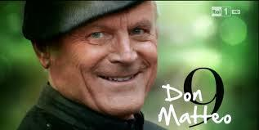

DON MATTEO
Don Matteo is about a special detective in the service of Go(o)d.

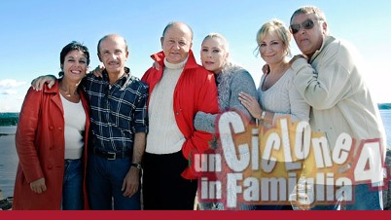

UN CICLONE IN FAMIGLIA
About two very different Italian families, but linked by the love of their children.

SHOWS

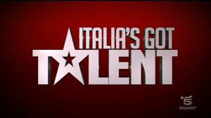

ITALIA’ S GOT TALENT
Italia’ s got talent shows every talent’s potentialities …

AMICI
Amici is a show where you can sing dance and above all share everything you have with those around you ...

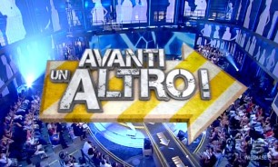

AVANTI UN ALTRO
Avanti un altro is a tv show where contestants must answer questions asked by Paolo Bonolis and played by funny people.

FAVOURITE ACTORS

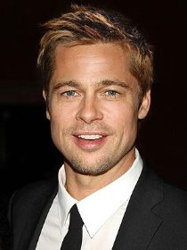

Brad Pitt is one of the most beloved international actors starring in many films including , " The Big Bet " . He is currently married to actress Angelina Jolie .

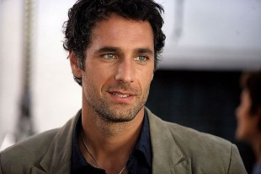

Raoul Bova is a very famous actor and former Italian swimmer.
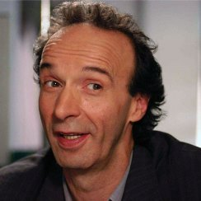

Roberto Benigni is known all over the world for his skills. He won an Oscar for the film :”Life is Beautiful".

Autori : Amri Mourad, Cappello Ilaria, Cianflone Ilva.
Classe: II G

