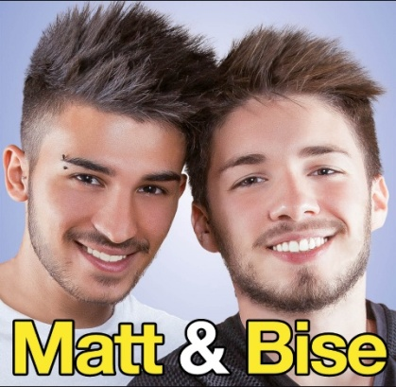
HELLO! These are the most famous Italian youtubers.
Matt & Bise
- Matt & Bise are two youtubers. They are followed by very young people. Their videos are fantastic and in the YouTube channel there are a lot of videos.
Antony Di Fancesco
He is very popular in Italy. He is 18 years old and he is a star for teenagers. He sends videos about strange things: for example not to speak for 24 hours.
Alberico De Giglio
Alberico is known on youtube as the Albericoyes. He makes videos of all kinds with his sister. They are very funny.
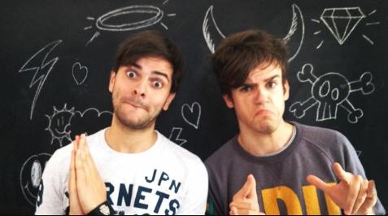
iPantellas
They are very famous for their mini-videos. In their videos they play different characters, telling funny jokes. Their YouTube channel has more than1.450.000 people. Their names are Daniel and Jacopo.
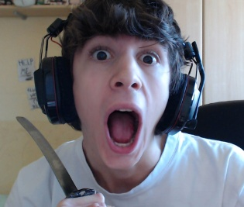
Favij
His real name is Lorenzo Ostuni. He is 20 years old. He is the most popular Italian youtuber. Favij loves videogames. He sends videos every day and he is the idol of lots of teenagers. His YouTube channel has more than 2.250.000 viewers, and he sends more than 750 videos. He is very funny.

Dexter
His real name is Luca Denaro, but on YouTube his name is ilvostrocarodexter. He chose this name from the serial killer who kills the serial killers. In his YouTube channel there are a lot of videos of his Fifa15 match. In his channel there are more than 7.000 people.

Autori: Bonaddio Denise, Cerminara Syria, Clej Alex, Mazza Christian

Classe: II A

