The day when they cooked and we tasted the Cheese Scones
On Friday, 15th January at 2 pm
The pupils of "4e Segpa" (special needs) came into our classroom with Mrs Baudoin, the cookery teacher.
This recipe is the Cheese Scones.
The "4e segpa" got this recipe from their e-Twinning epals, from Wales.
In the Cheese Scones there are some milk, some mature cheddar or some grated cheese, a piece of butter, a pinch of salt and some flour.
Mrs Geffroy, our English teacher and Mrs B. talked about Welsh recipes and e-twinning.
It was very good and delicious.
The pupils of 4A will come back into our class in April. They'll cook a recipe taken from our eTwinning project, the European Teen Magazine !
So, we would like to thank the pupils of 4 A and Mrs B. for their kindness.
We're looking forward to seeing you again!
Thank you to Jules who took the photo although it's a little bit blurred.
Manon, Adèle, Michelle et Marion.
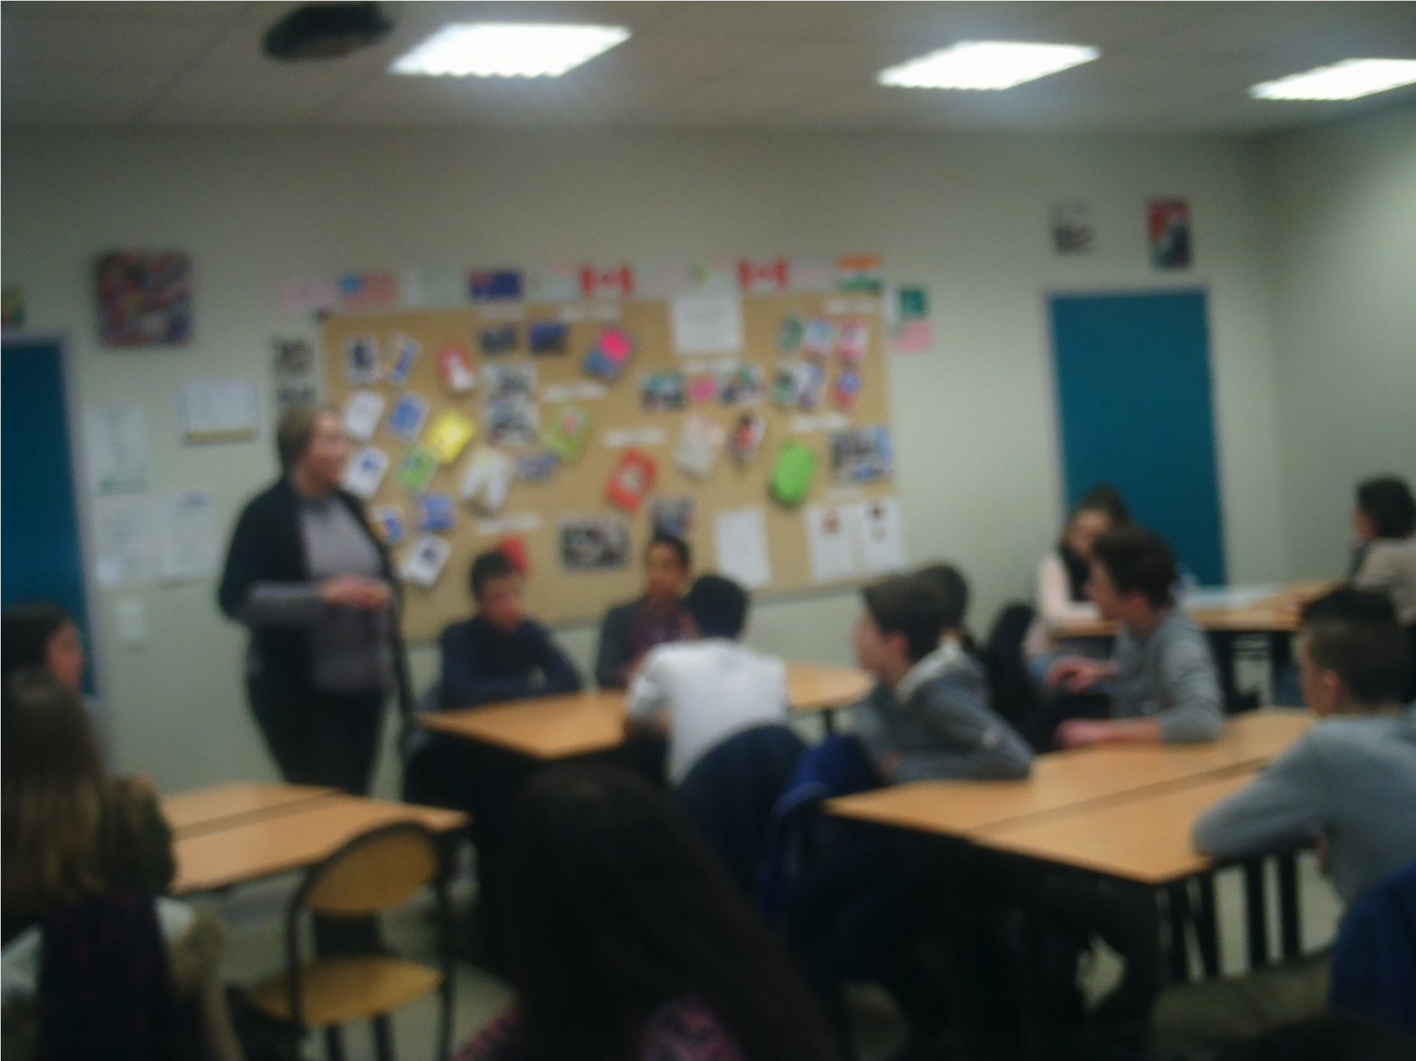
On the next page, you'll find the Cheese Scones recipe that we tasted.

