SCHOOL LIFE

We are Martina and Federica, two students of I.C. Ardito Don Bosco where we attend class II G. Our experience in school is very nice, expecially since we study with wonderful teachers and we have a lot of fun all together.
Our school is very large and welcoming, the classrooms are painted in bright colours and are full of space for us students. We have interactive whiteboards in every classroom so that to facilitate learning.
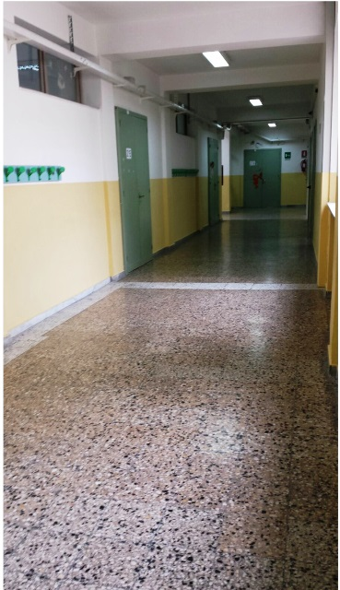

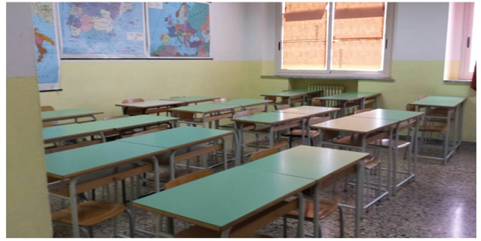

Recently, together with our teachers, we did two linguistic stands in the corridors, one for Great Britain and one for France.

The British stand is full of photos, pictures and models of some London monuments, such as The Tower Bridge, the London Eye, the famous double decker buses, the Parliament and the Big Ben and many others.

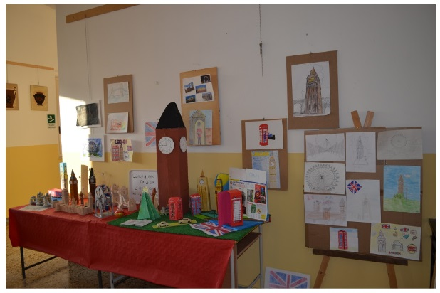

On the French stand there are a small model of the Eiffel Tower, some fashion magazines and advertisings of wine and champagne bottles.

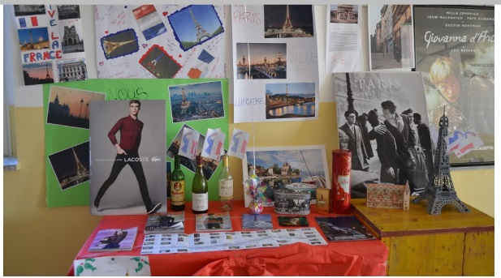

In those days the school orchestra played for us students; it is a great orchestra and the winner of last summer important music competition. We had some photos on local newspapers too.
