DELIGHTFUL TURKEY
By WINSTON
October 2018
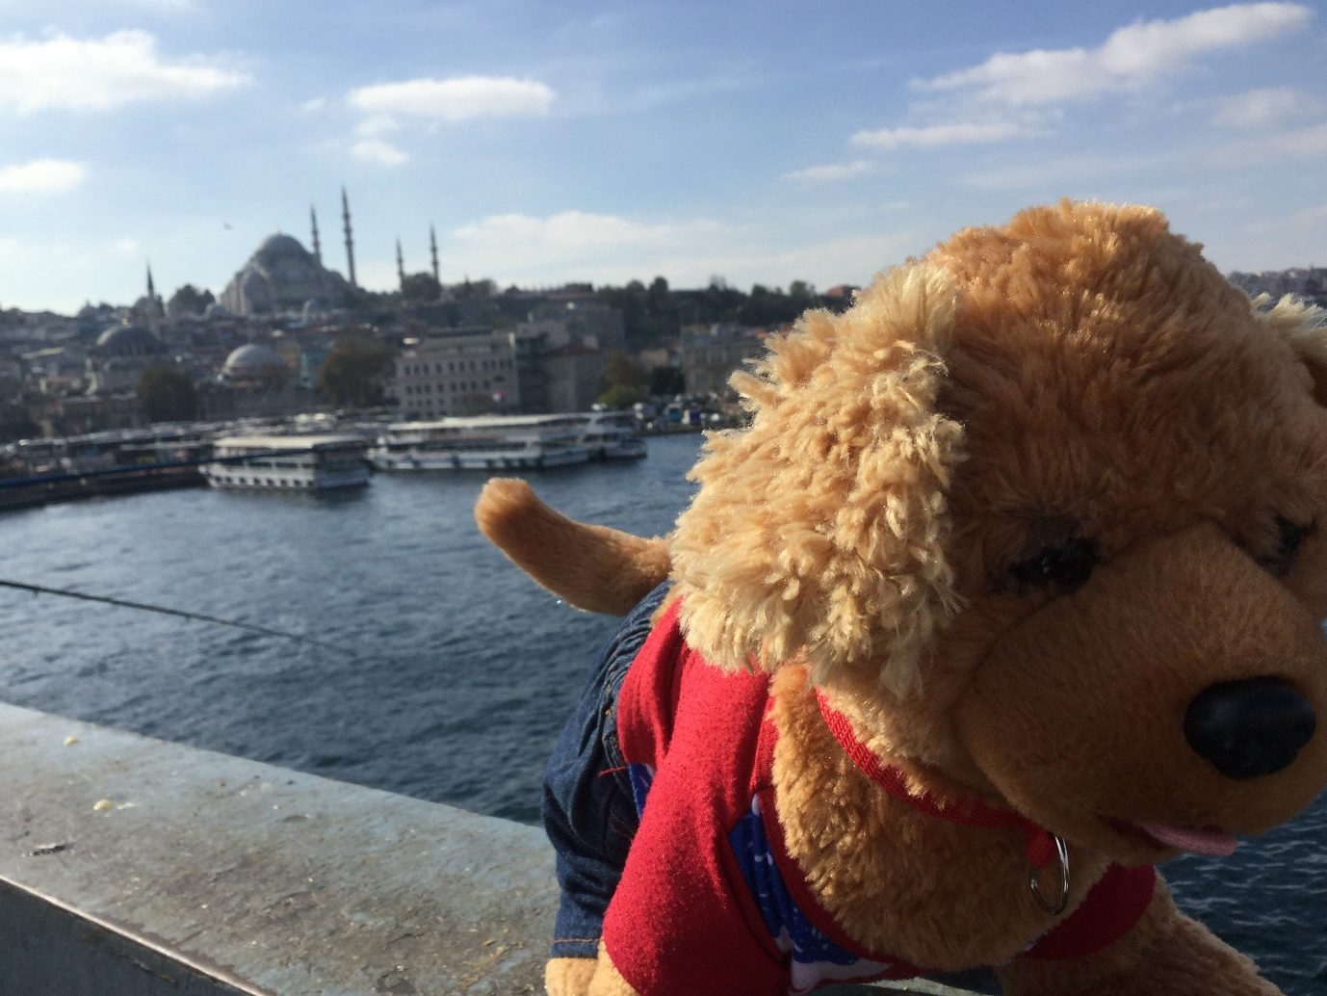
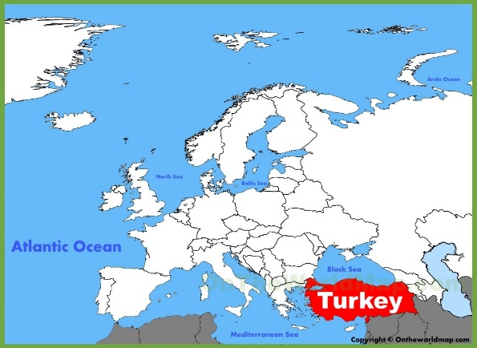
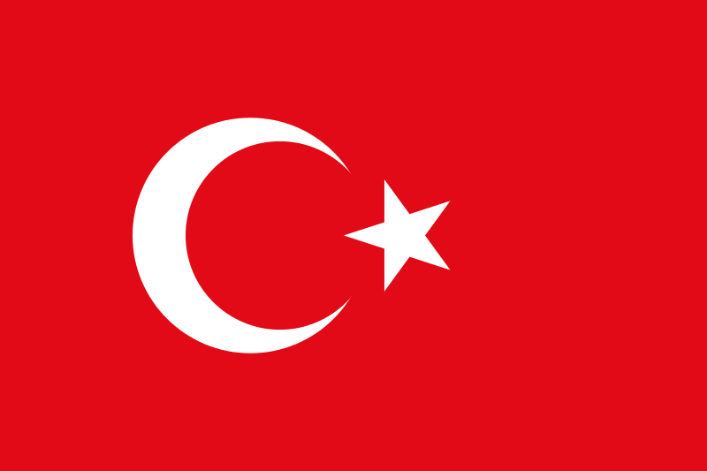

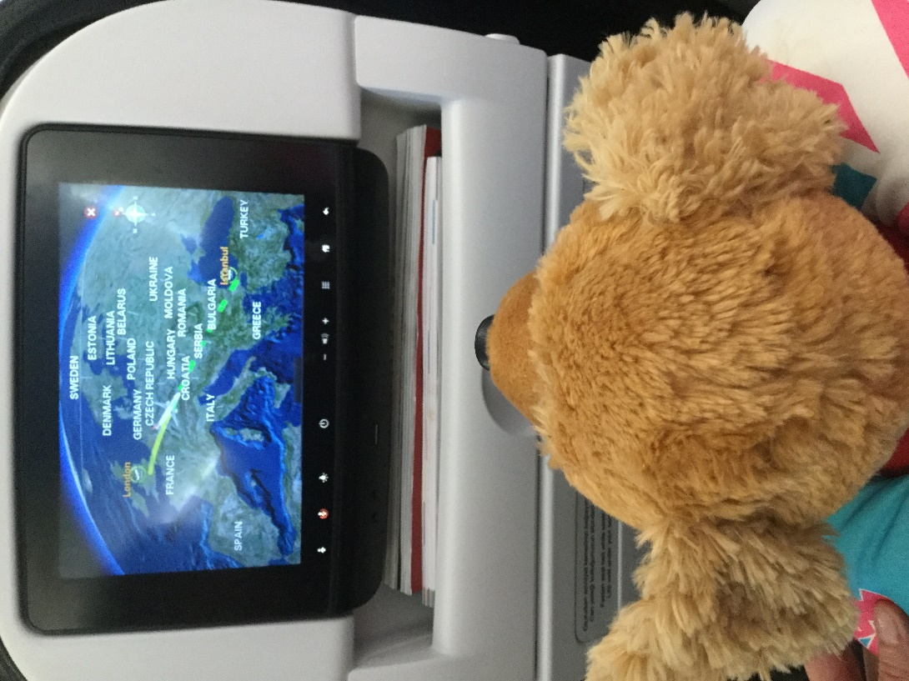

It was a long 4 hour flight to Istanbul, the capital city of Turkey. Here are some of the things I learnt about Turkey during the flight:
- At 5,137 m Mount Ararat is the tallest mountain in Turkey.
- Kilizirmak also known as the Red River is Turkey’s longest river that flows entirely within the country without flowing into other countries. It is 1,355 km in length.
- Lake Van is the largest lake in Turkey,
- Turkey has active volcanoes and is also prone to earthquakes.
- People in Turkey speak Turkish, Arabic, Kurdish, Greek and Armenian.
- Most people in Turkey are Muslim.
- The currency here is the Turkish Lira.

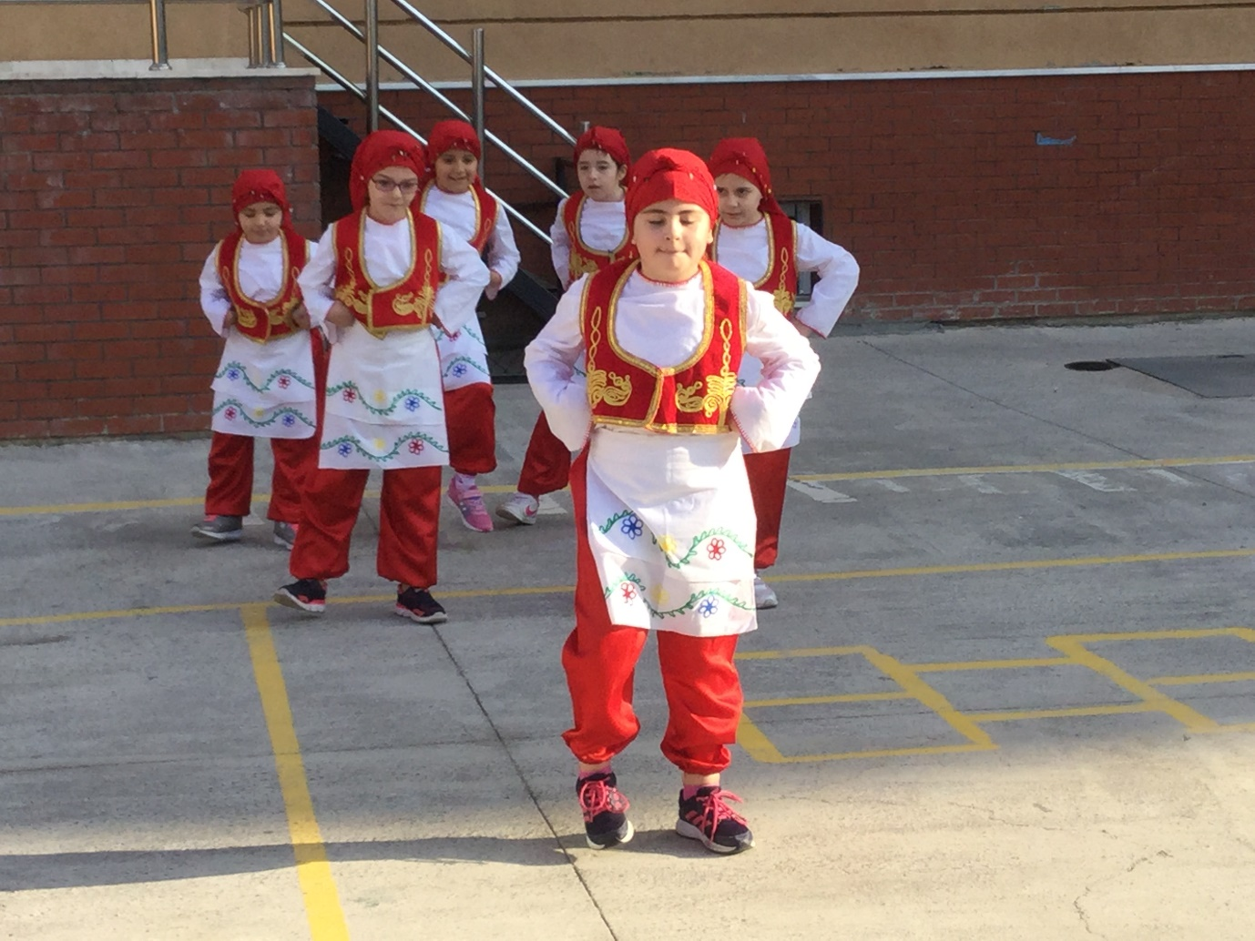
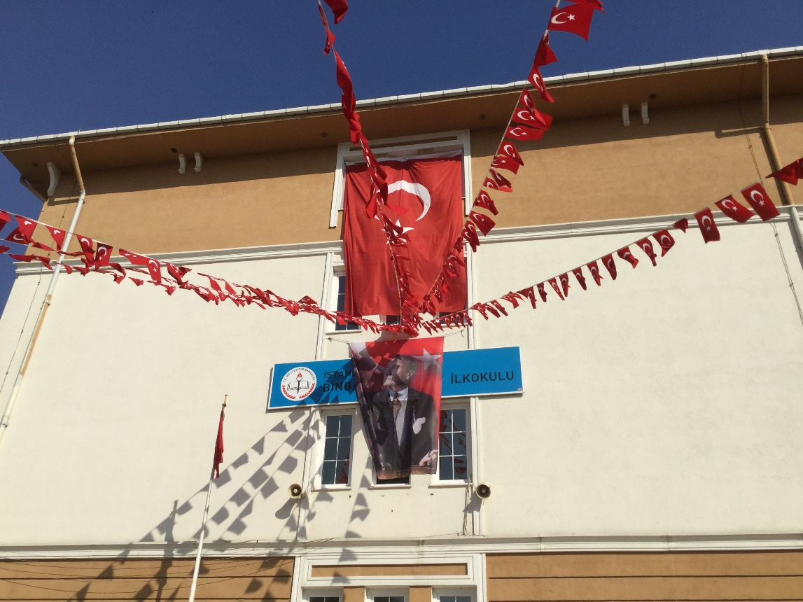
When we arrived at the school, the children greeted me warmly and performed a wonderful traditional Turkish dance. Turkish flags fluttered in the gentle breeze showing that the children here, just like us, are very proud of their country and school.

Next, the children showed me how to make pine cone candles.
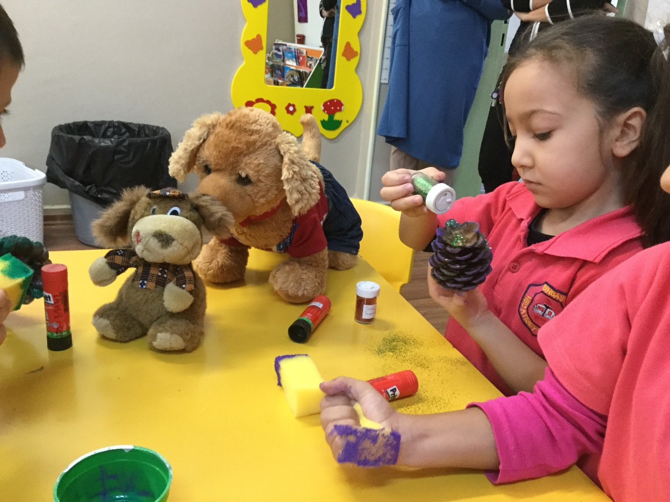
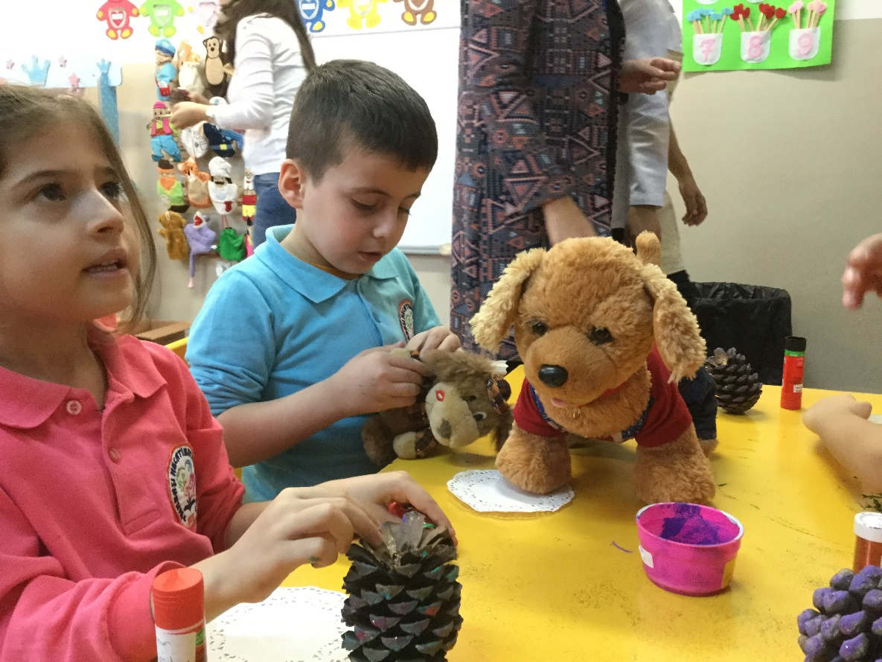
After that, they sang some songs and showed me their outdoor learning area and 'Pet's Corner'.
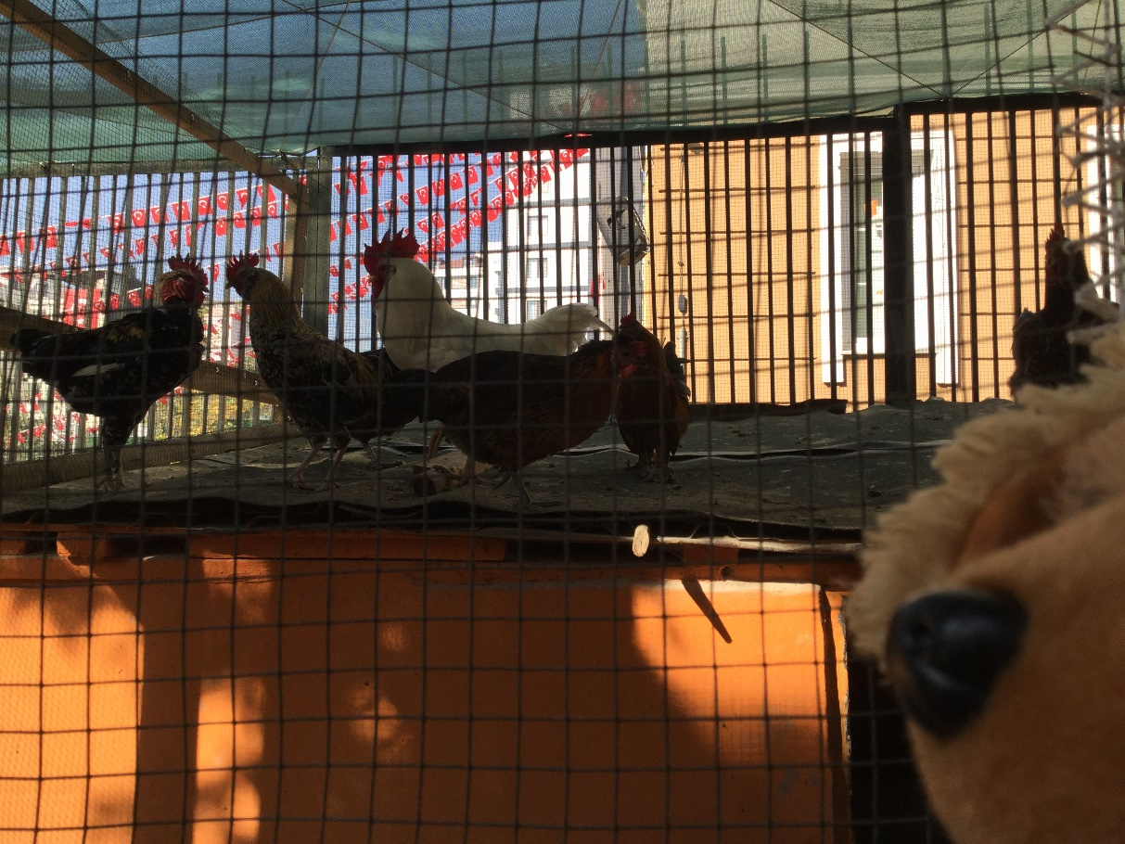
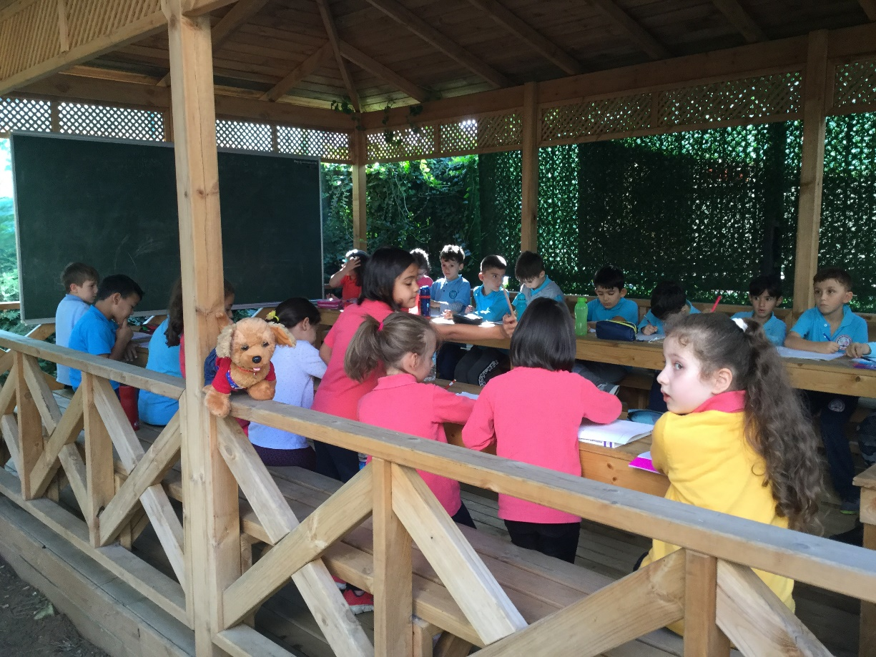

Learning with the Turkish children was great fun.
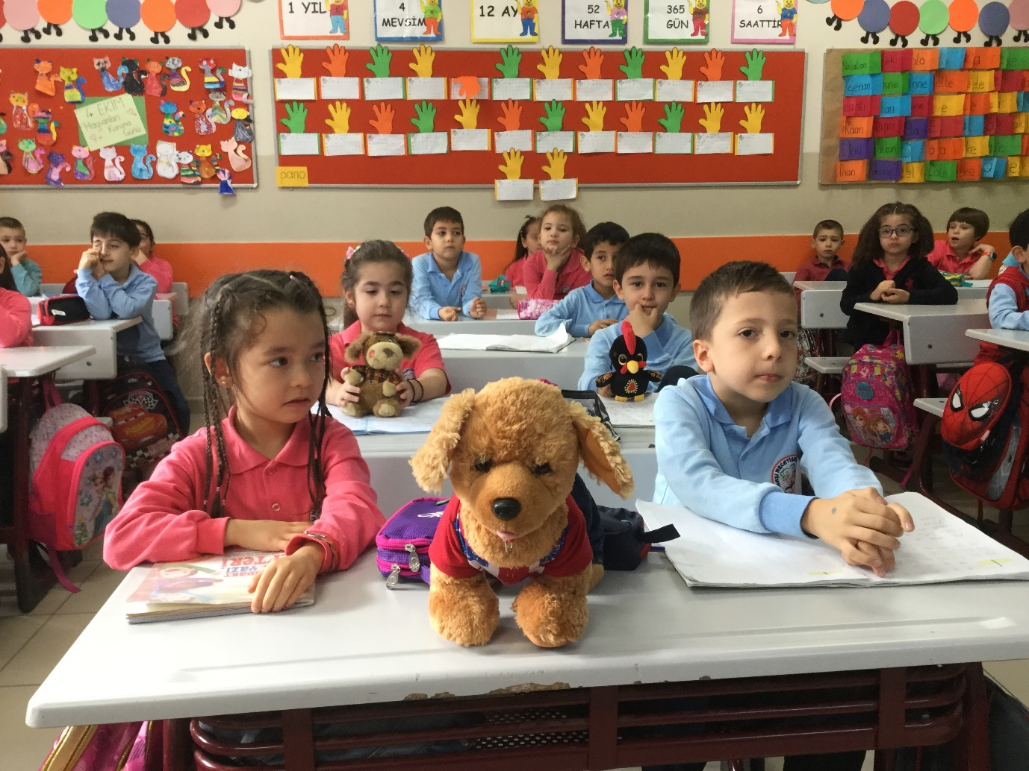
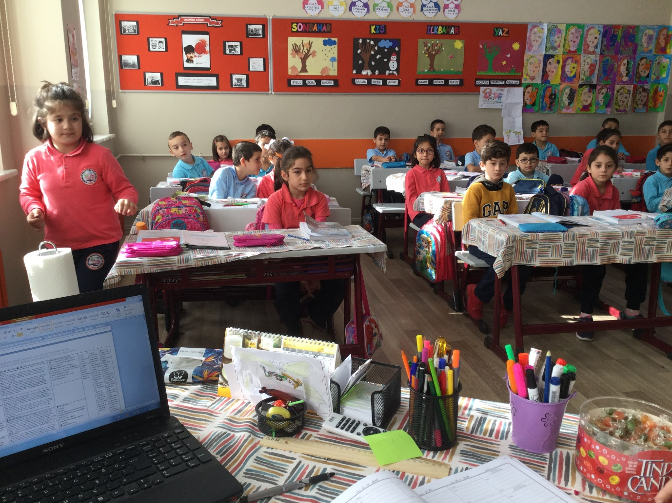

The following day, I visited some famous tourist attractions like the Grand Bazaar and the Blue Mosque. The mosque is a place of worship for Muslims. The building was beautifully decorated with intricate architecture and plush carpets.
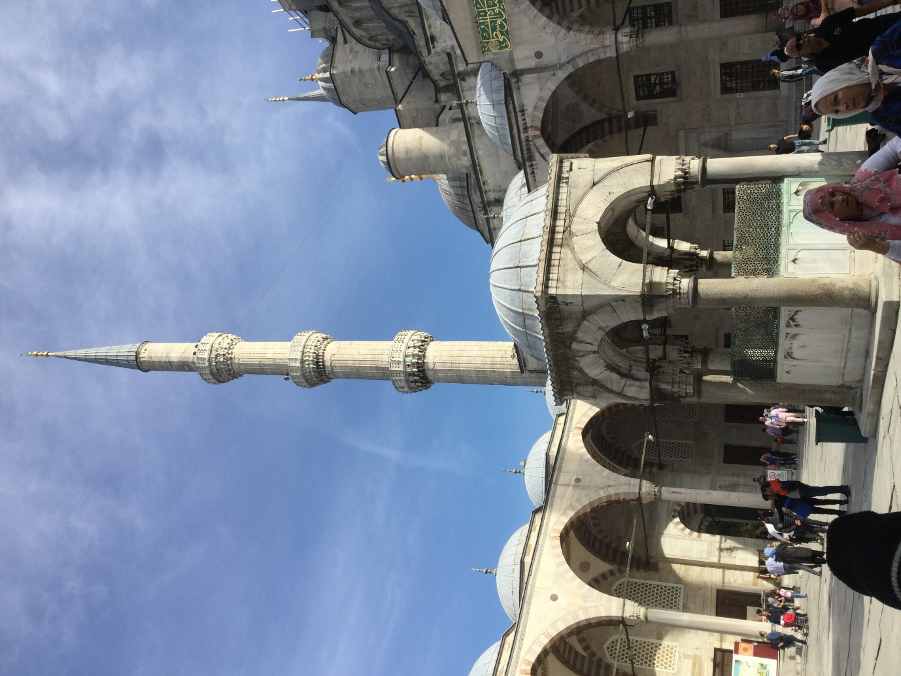

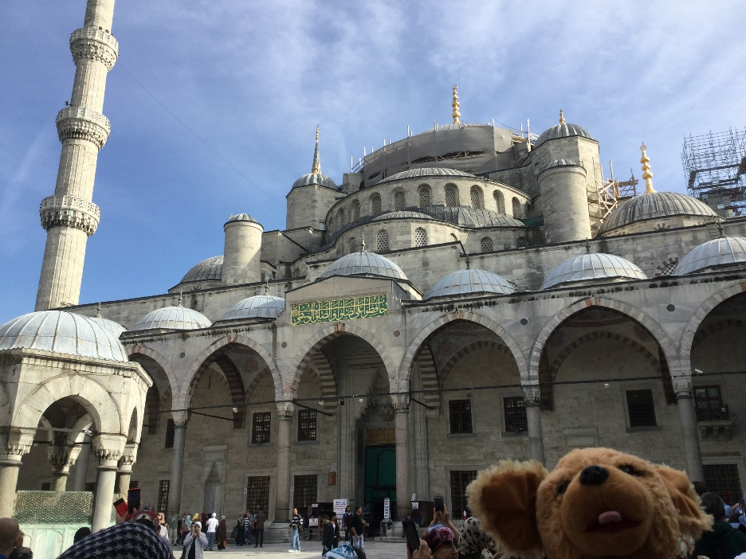

Outside the mosque.
Can you see the minaret?
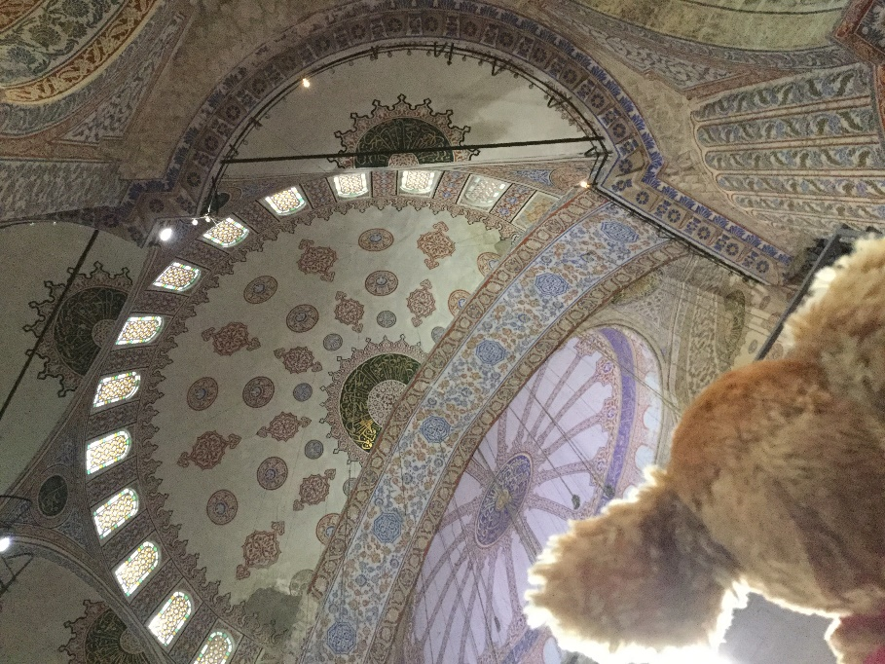

Ornately painted ceilings.

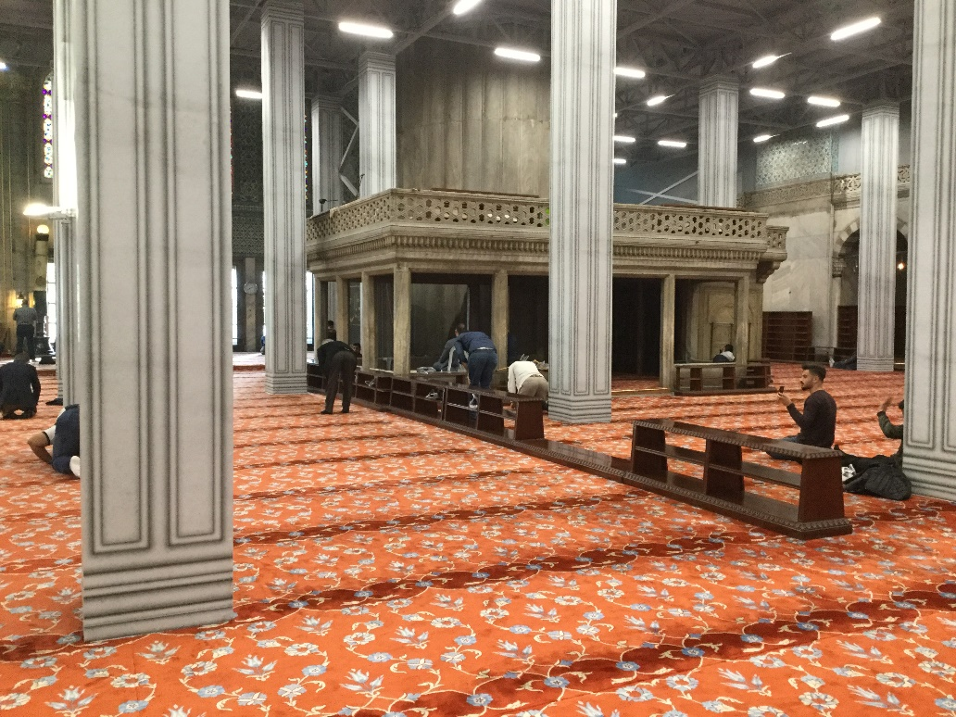

Inside the mosque.

In the markets, you can buy spices, sweets (Turkish Delight) and beautiful scarves, fabrics and lights.
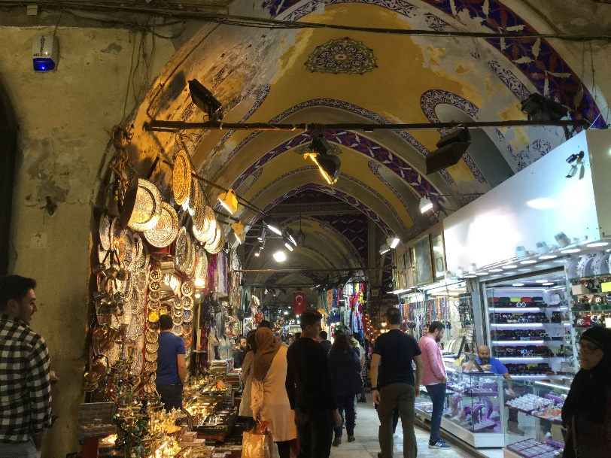
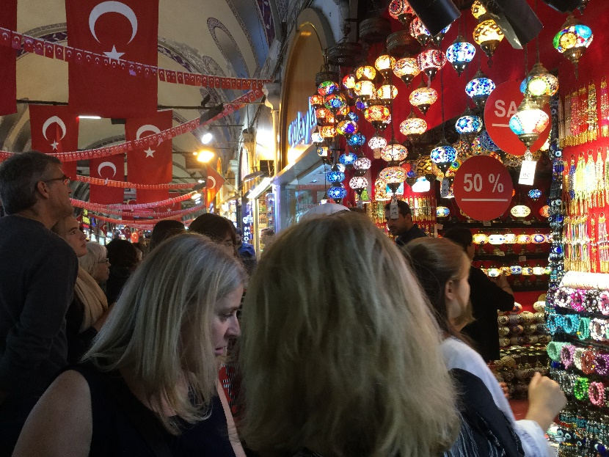

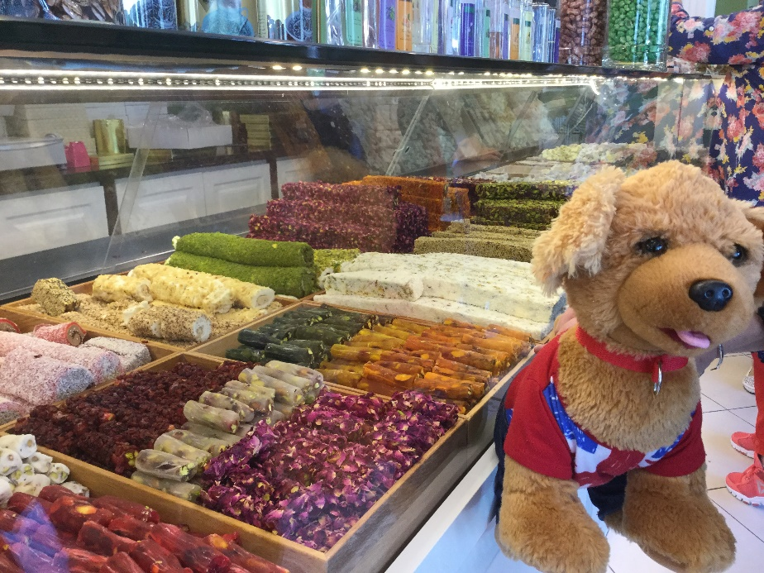

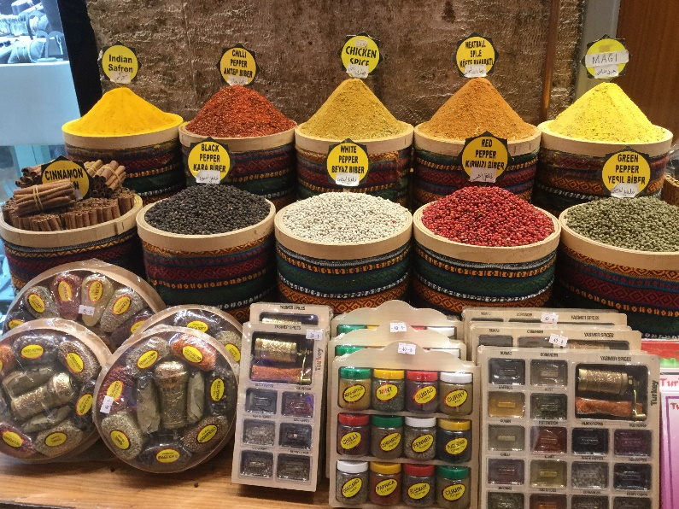
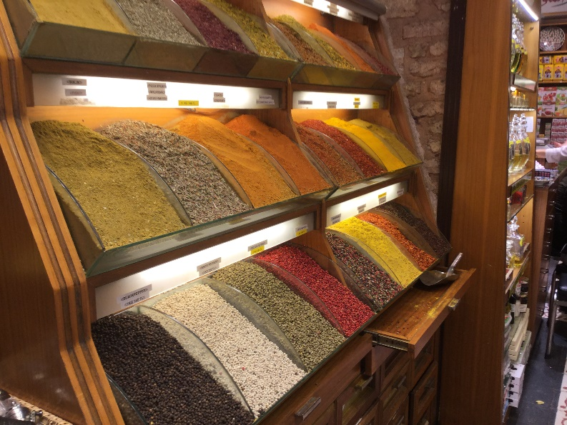

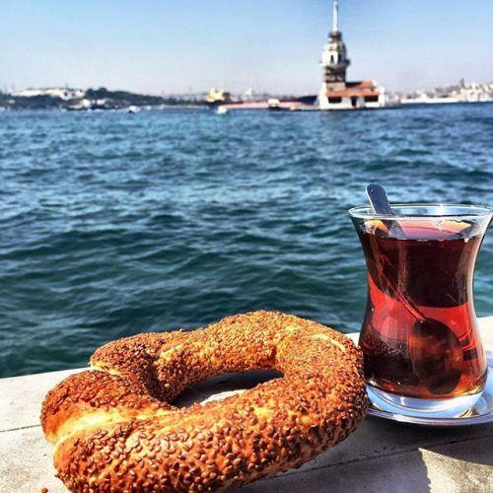
The food here is delicious. Look at all the tasty things I tried!
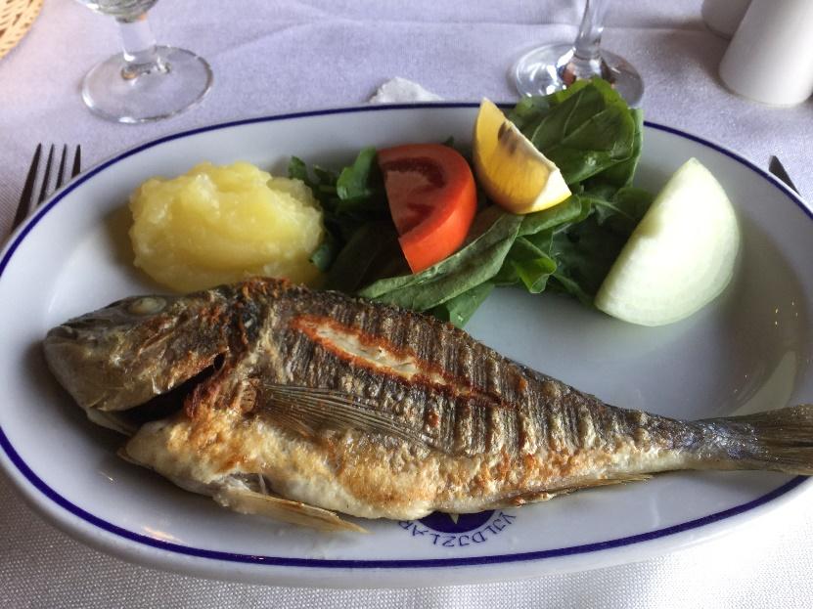

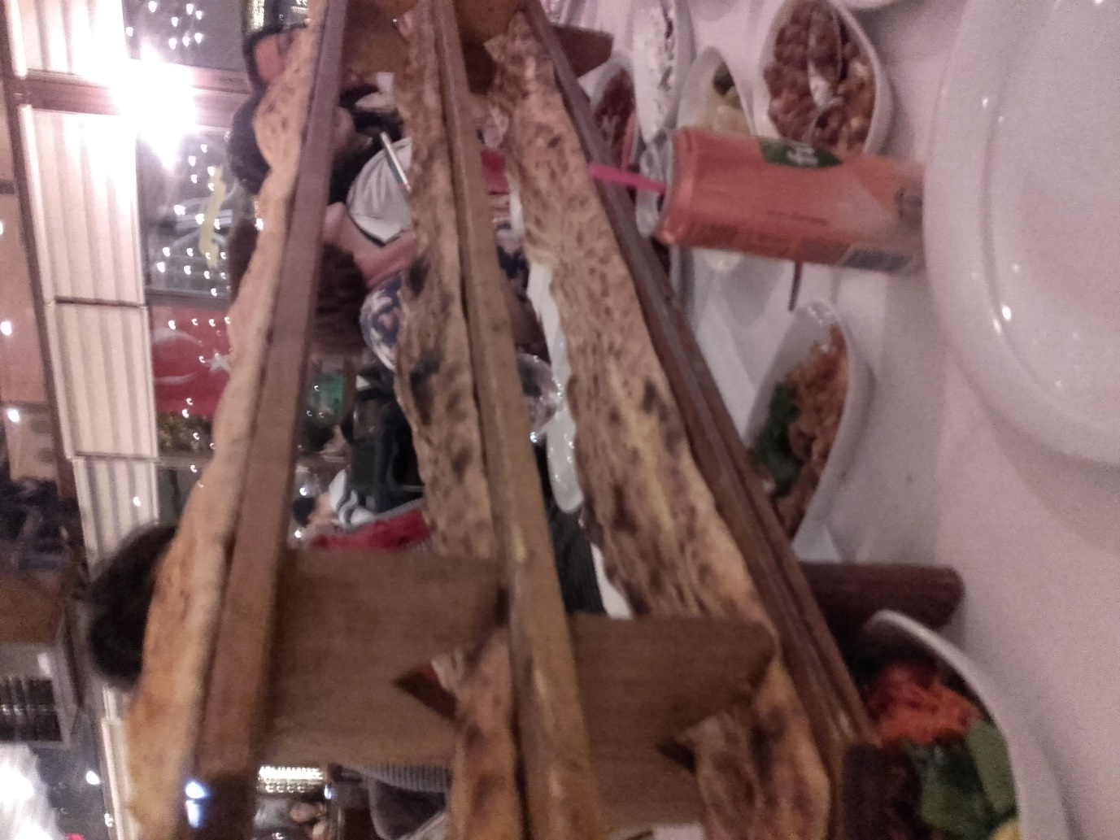

I had a great time in Turkey with all my friends!

