HOW CLIMATE CHANGES WILL DEVASTATE ITALY

Twenty percent of Europe's Alpine glaciers melted between 1980 and 2000. With the speed of melting picking up, the glaciers could be gone by 2050. A case in point would be Europe's most southerly glacier, the Calderone, which sits on the Gran Sasso massif in Abruzzo.
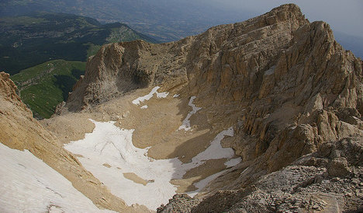
Climate change has already sealed its fate and experts now say it will be gone by 2020.As Italy's Alpine glaciers recede, the melted water contributes to rising sea levels. The loss of glaciers also increases global temperatures as the large tracts of white ice are no longer present to reflect the sun's rays back out to space. Fragile Alpine environments are particularly susceptible to climate change and are warming at three times the rate of coastal areas, something which threatens Italy's ski industry.
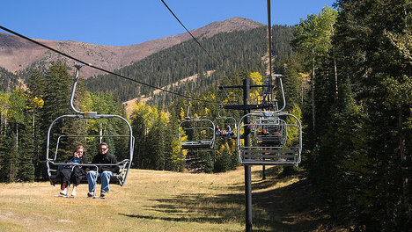
As Italy's glaciers wilt in the sun, the coastal waters around the country will rise, putting low-lying cultural treasures at risk. These include a slew of UNESCO World Heritage sites such as the archaeological sites of Pompeii and Herculaneum, which would be swallowed by the rising tide.
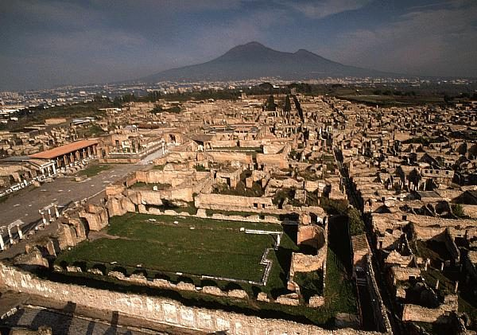
In Italy the food system is responsible for 37% of global emissions, one third of which due to food waste. Eating habits can have an important impact on greenhouse gas emissions. A dietary shift away from meat (particularly red meat) and dairy products, to the levels recommended by the World Health Organization, is a win-win solution for both the climate and our heath. How we produce, consume and waste food is a very important part of the report. Since 1961, food calories per capita have increased by about one third, water resources for irrigation have increased by 100%, and the use of fertilizers has increased by 800%.

https://www.thelocal.it/20151201/five-ways-climate-change-is-affecting-italy/

