ECOLOGY Climate change: what will be the effects on Italy?
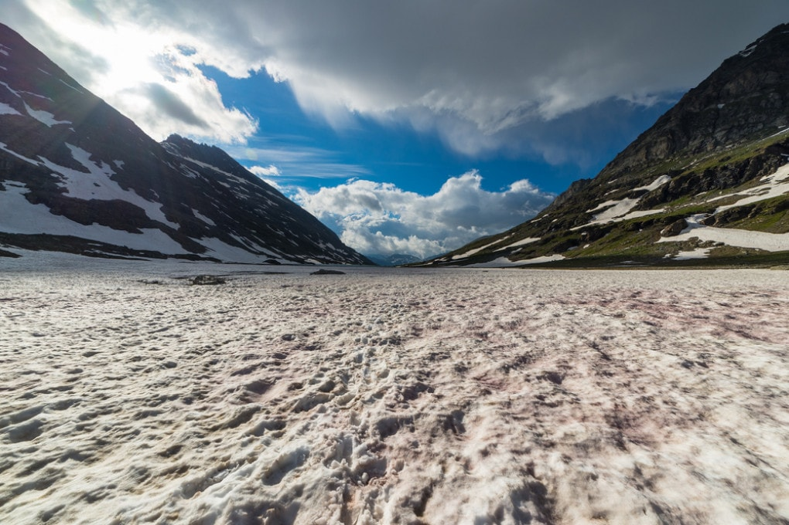
A set of maps describes the effects of climate change in our country now and by the end of the century, based on more or less optimistic scenarios.
The melting of alpine ice: one of the most visible consequences of climate change in Italy.
2021 will be - at least in good intentions - an important year for the fight against the climate crisis, which Italy will fight on the front line: our country will coordinate the G20 and host the preparatory events of COP26 (a pre-Cop and the Cop of young people), the Conference of the Parties on climate change, which is going to be held in Glasgow next November.
We often talk about the impact of climate change on the planet in general, but what is our
attitude towards our territory instead? What concrete risks does Italy face?
A photograph of the expected climate on the peninsula from 2021 to the end of the century comes from the CMCC Foundation, the Euro-Mediterranean Center on Climate Change, a scientific research facility that operates in the field of climate science and which carries out simulations in particular for the Mediterranean area .
The CMCC has developed a series of interactive maps to answer very practical questions: how much will the temperature rise? How will the rains change? What will be the effects on our seas?
IF NOTHING CHANGES… As in a story with many endings, the answer depends on our choices, here two of the scenarios usually considered by the IPCC, the Intergovernmental Panel on Climate Change are introduced.
The first predicts that if we continue to live as we live now, catastrophe will be inevitable.
If this unfortunate scenery were to come true, in 2100 we would find ourselves with atmospheric CO2 concentrations tripled or quadrupled compared to pre-industrial levels.

IF WE TRY... The second scenario provides for some initiatives to be put in place to avoid emissions.
For this scenario, however, strong stabilization interventions are imagined, in which CO2 emissions begin to drop below current levels by 2070, and in which the atmospheric concentration of greenhouse gases stabilizes, by the end of the century, at no more than double the pre-industrial levels.
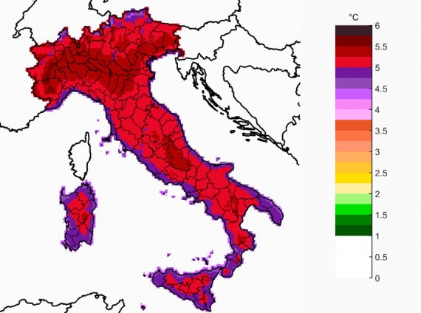
RISING TEMPERATURES. As regards as temperatures, both scenarios agree confirm the prediction of up to 2 ° C in the period 2021-2050 (compared to the period 1981-2010): an increase to the limits of the maximum threshold indicated by the Paris Agreements. In the most pessimistic scenario, the one without any mitigation, temperature rises of up to 5-6 ° C are expected by the end of the century in the Alpine areas and during the summer season.

The increase in average temperatures between 2071 and 2100 compared to the averages of the period 1981-2010 according to the worst scenario among those considered by the CMCC.
LESS RAIN, ALL TOGETHER. The rain will tend to concentrate in more intense and less frequent records: the summer rains will be at the same time less frequent (especially in the South) and more violent, especially in the "business as usual" scenario.
In summer, between a downpour and the next, the dry periods will lenghten: in both scenarios, an increase in the days with a minimum temperature above 20 ° is expected.
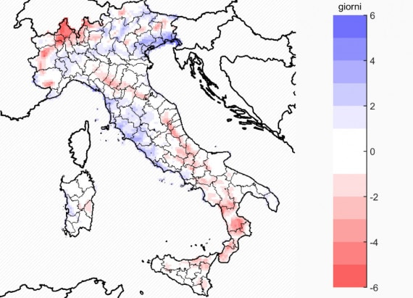
The days of intense rainfall on Italy between 2071 and 2100, according to the most pessimistic of the scenarios among those foreseen by the CMCC.

