Óravázlat 2. | Teacher: Schuszter Klára
School/group: Kossuth Lajos Bilingual Grammar School
Group profile: Mixed groups of students (German, Austrian, Romanian and Hungarian)
Topic of the lesson: Logos, slogans, brands – Coca Cola
Content Aims and Objectives: To speak about global issues, international companies and their products
Language Aims and Objectives:
Speaking : to communicate in English with foreign students who also speak English as a second language.

Special skills Development: Cognitive Social: how to work in groups with foreign students, co-operation via lingua-franca( bridge language)
(thinking skills;-metacognitive skills;-social skills)
Teaching materials: handouts, audio files
Anticipated problems: working in groups, having difficulties with the topic itself
Time | Stage | Procedure | Aim | Interaction patterns | Skills | Materials | Comments
2’ | Warm-up | -Greeting students | to create the atmosphere | Frontal work  T-Ss | Speaking
7’ | Lead in | Taboo game  T: The world is said to be a global village. In a village everybody knows everybody. Not only do you know the same famous brands, foods and drinks, but actors, musicians, politicians as well. So, let’s play Taboo game. You have to find out famous people. | to activate students’ knowledge | Group work | Speaking | Taboo cards  Handout 1 | T walks and checks
6’ |  | T:  Last lesson we were talking about Coca Cola company. To brush up your knowledge let’s watch a short video. | to introduce the topic | Frontal work |  | https://www.youtube.com/watch?v=jwCYxwkjw90
5’ | Reading and writing | T. Now you will be given a new handout about the company, you have to read and find the missing words. |  | Group work | Speaking, reading, writing | Handout 2  Handout 3
5’ | Post reading | T: Tell your solution. | To provide opportunity to check the information | Group work | Speaking |  | T checks
15’ | Speaking | T: Now you are going to do a roleplay exercise.  4 roles  A Coca Cola New Products Director, B, Coca Cola Marketing Director  C Coca Cola Market Researcher,  D Coca Cola Shareholder  You have 10 minutes to come to an agreement.  Let me give you a list of Expressions for Agreeing and Disagreeing. | To provide opportunity for debating | Group work | Speaking,  Conversation skills | Handout 4  Handout 5 | T walks and helps if needed
5’ | Post Speaking | T: Please share your decision with the other groups | To provide opportunity for using the acquired vocabulary in context | Frontal work | Speaking

• Handouts/Additional material:
Taboo cards
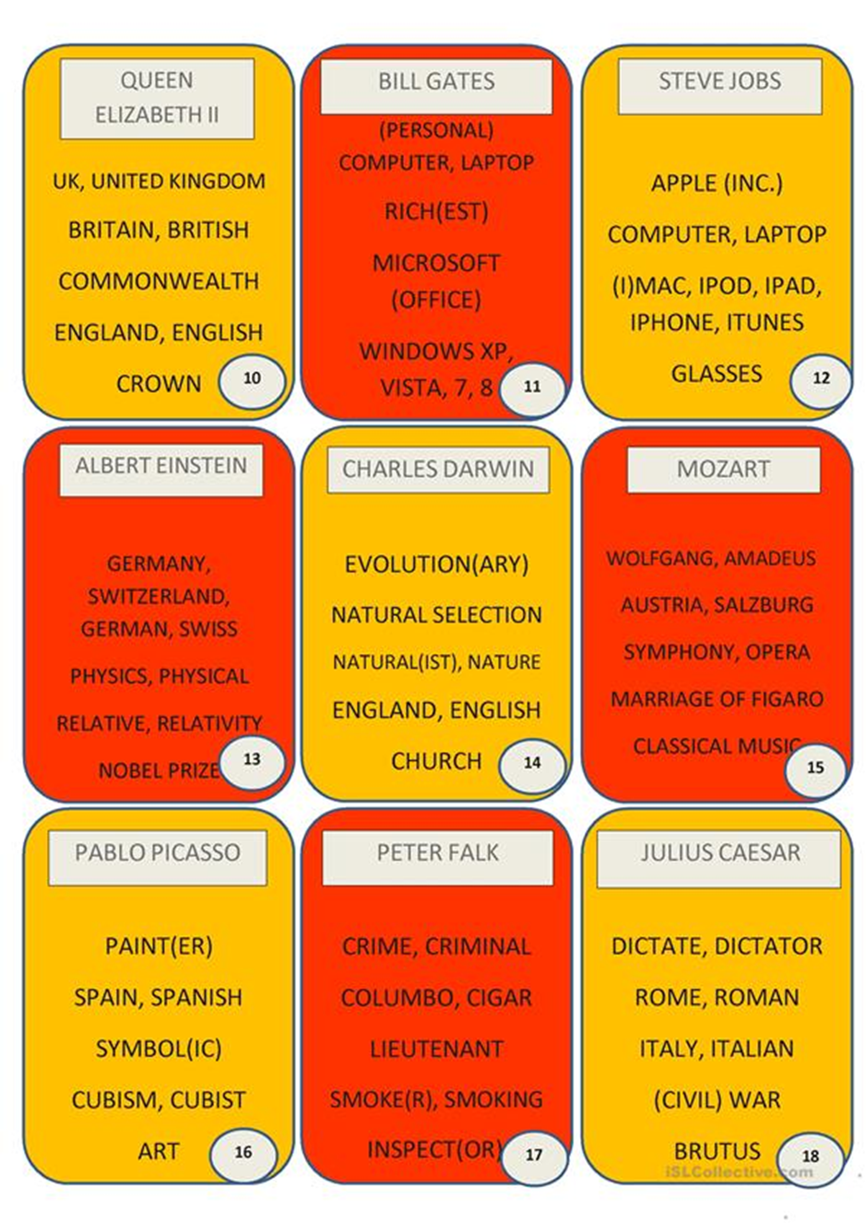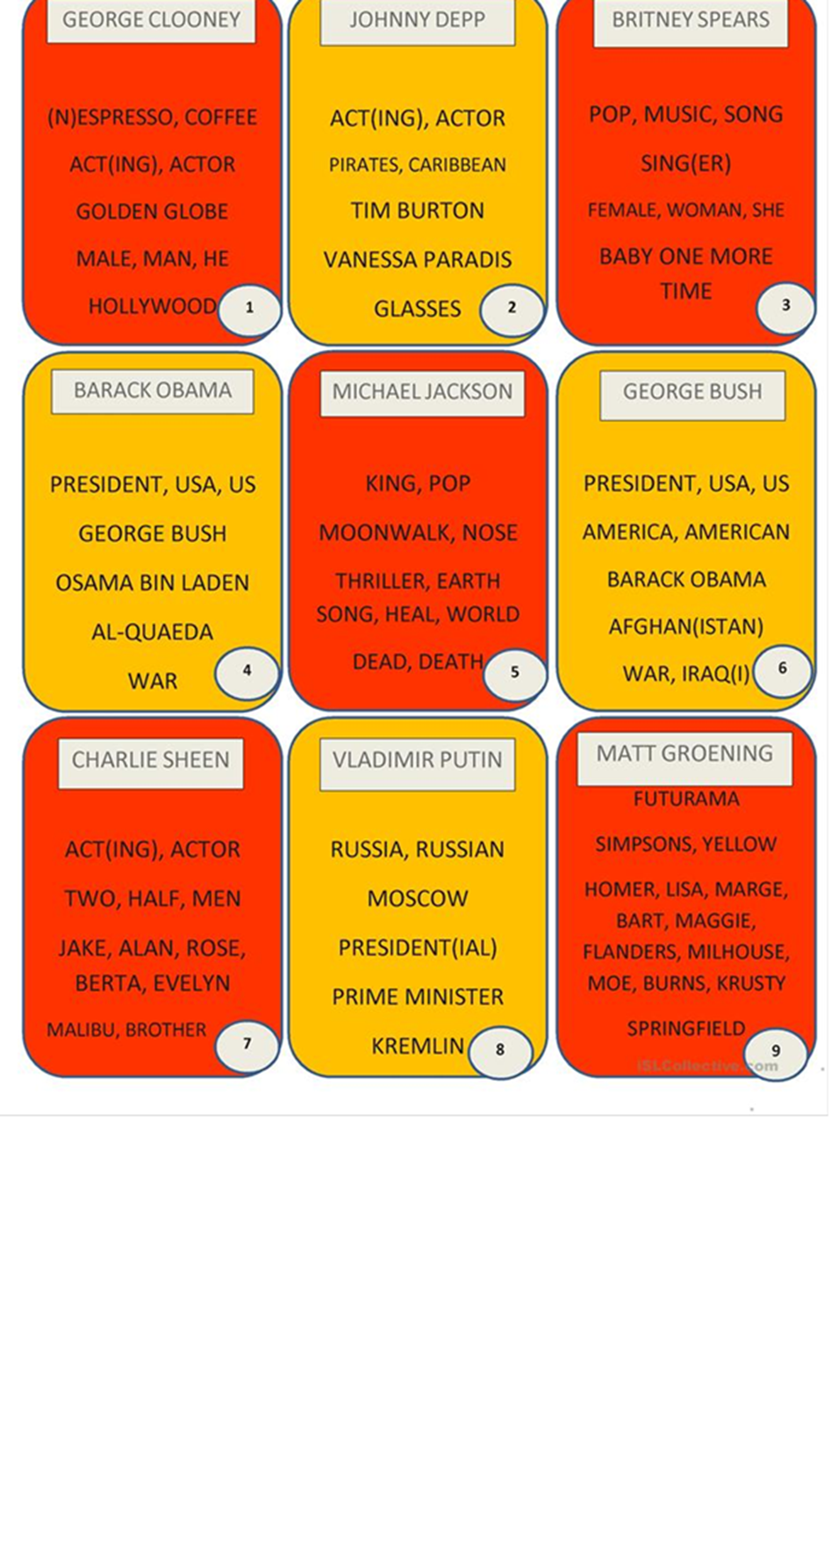
Handout 2

The Coca-Cola Company is a soft d……… giant that was e……… in 1886. Its mission is “to strive to refresh the world, inspire moments of optimism and happiness, create value and make a d……………”. It often tops the list of being the world’s most recognizable b……... Its iconic Coca Cola drink, also known as C………, started life as m………. Today it is one of the biggest selling products on the planet. The company w…………… says its 3,300+ beverages are sold in over 200 countries. It sells 1.6 billion drinks a day and e………… close to 100,000 people. One secret to the company's phenomenal s…………… is what it calls the 'Coca-Cola system' - the more than 300 worldwide b…………… partners that work together to distribute its products. Another is its catchy advertising s…………, such as “Coke Is It”. Its biggest r………… is Pepsi.

Handout 3

The Coca-Cola Company is a soft drinks giant that was established in 1886. Its mission is “to strive to refresh the world, inspire moments of optimism and happiness, create value and make a difference”. It often tops the list of being the world’s most recognizable brand. Its iconic Coca Cola drink, also known as Coke, started life as medicine. Today it is one of the biggest selling products on the planet. The company website says its 3,300+ beverages are sold in over 200 countries. It sells 1.6 billion drinks a day and employs close to 100,000 people. One secret to the company's phenomenal success is what it calls the 'Coca-Cola system' - the more than 300 worldwide bottling partners that work together to distribute its products. Another is its catchy advertising slogans, such as “Coke Is It”. Its biggest rival is Pepsi.

Handout 4
Coca Cola Role play
Role A: Coca Cola New Products Director
You have created a new product for Coca Cola. You believe that the new product will be the company’s best ever. It will be a bestseller. There are people who do not agree with you. You need B,C,D on your side. Tell the why this is a product that will bring great things to Coca Cola.
Role B: Coca Cola Marketing Director
You think the company’s new product is a really bad idea. It will give your company a really bad name. You think the New Products Director is trying to destroy the company. Try to get him/her to understand there’s no way the new product will sell. Try to get person C and D on your side.
Role C: Coca Cola Market Researcher
You have interviewed thousands of people about the new product. They don’t like it or hate it. You think it will be successful if they make many changes. Tell the New Products Director he/she needs to change the product. You neither like nor trust person B. Disagree him/her.
Role D: Coca Cola shareholder
You know a lot about Coca Cola’s new product. You are worried it will not sell and share prices will go down. You think A is crazy and must find a new. You agree with everything B says. You don’t agree with C. The new product should not go on the market.

Handout 5

Expressions for Agreeing and Disagreeing

Stating an opinion
- In my opinion...
- The way I see it...
- If you want my honest opinion....
- According to Lisa...
- As far as I'm concerned...
- If you ask me...

Asking for an opinion
- What's your idea?
- What are your thoughts on all of this?
- How do you feel about that?
- Do you have anything to say about this?
- What do you think?
- Do you agree?
- Wouldn't you say?

Expressing agreement
- I agree with you 100 percent.
- I couldn't agree with you more.
- That's so true.
- That's for sure.
- (slang) Tell me about it!
- You're absolutely right.
- Absolutely.
- That's exactly how I feel.
- Exactly.
- I'm afraid I agree with James.
- I have to side with Dad on this one.
- No doubt about it.
- (agree with negative statement) Me neither.
- (weak) I suppose so./I guess so.
- You have a point there.
- I was just going to say that.

Expressing disagreement
- I don't think so.
- (strong) No way.
- I'm afraid I disagree.
- (strong) I totally disagree.
- I beg to differ.
- (strong) I'd say the exact opposite.
- Not necessarily.
- That's not always true.
- That's not always the case.
- No, I'm not so sure about that.

Interruptions
- Can I add something here?
- Is it okay if I jump in for a second?
- If I might add something...
- Can I throw my two cents in?
- Sorry to interrupt, but...
- (after accidentally interrupting someone) Sorry, go ahead. OR Sorry, you were saying...
- (after being interrupted) You didn't let me finish.

Settling an argument
- Let's just move on, shall we?
- Let's drop it.
- I think we're going to have to agree to disagree.
- (sarcastic) Whatever you say./If you say so.

