UNIQUE MONUMENTS THAT BRING US TOGETHER
Or
MONUMENTS AS UNIQUE AND PRECIOUS AS DIAMONDS

Lesson aims:
- to practise language used to describe historic tourist attractions
- to practise reading for detail
- to practise discussing as a group
- to practise writing a pros and cons analysis of the historic tourist attractions (advantages and disadvantages)
Level: Intermediate +/ Upper – intermediate
Time: 50 minutes

Procedure:
- Warmer: - display word cloud to learners and ask them to work together to complete the table in Task 1. Learners have to identify places from the word cloud and should note any new words in the second column. The T checks the meaning of the new words with the class. Ask Ss what they know about the places that they have added to the table. Elicit as much info as possible. (Where is it from?/Who is it related/associated to?/ What is it famous for?/ Have you visited it?/Did you like it?/ What did you most like about it?/ Would you like to visit it?Why (not)? etc.)

- Vocabulary practice: - Ss will work in groups of 5. Each S will get a text from Card Sheets 1 & 2 along with Task 2. Ss have to find words/phrases from the grid in their texts.
- The T gives each group a set of shapes cut from Puzzle Pages 1-5 (one set per group/pair) and explains to learners that they have to match the words and definitions to complete the puzzle. The T highlights that their puzzle will look like the shape in Task 2 when it is complete.
- Ss will work together to match the words and definitions to complete the puzzle. The T emphasises that their texts will help them find the meaning of the words. The first group to finish could split up to help the other groups in the class.

- Jigsaw reading: - the T explains to Ss that they will have to work together to find the answers to the questions in Task 3. Ss read their texts to find the answers to the questions. The T supports the groups with vocabulary if needed.

- Writing practice: - Ss get Task 4. They have to choose one of the places mentioned in the texts to visit. In their groups Ss have to write down the advantages and disadvantages of that particular place or attraction. Groups should come to agreement and give reasons for their choice. The T monitors and supports Ss’ language use during this task.

- Speaking practice: - each group should present their choice of monuments to the other groups. Discussions may follow. Ss can agree/disagree.

Worksheet
Task 1
- Look at the word cloud – work with a partner and sort the words into these categories:
Monuments | Architectural styles | New words/ phrases

Worksheet
Card Sheet 1

Monument 1

Hungarian Parliament Building, Budapest

The Hungarian Parliament is situated on the east side of the Danube River in Budapest, the nation’s capital. The Parliament Building is a magnificent example of Neo-Gothic architecture. It was inaugurated on the 1,000th anniversary of Hungary in 1896 and fully completed in 1902. The Budapest Parliament Building is the third largest parliament building in the world. It has 691 rooms, 18 courtyards, 20 kilometers of stairs and at 96 meters is the same height as the Saint Stephen’s Basilica. Unfortunately, modern air pollution attacks the porous limestone walls, requiring frequent restoration.

Monument 2

Buda Castle, Budapest

Buda Castle is a royal historic palace built in the 13th century. That castle was destroyed. The current incarnation of Buda Castle is a massive 18th century Neo-Baroque style structure of more than 200 rooms. These are arranged in a symmetrical layout around the 62 meter-high central dome facing the Danube. The castle was badly damaged in World War II, but much of the exterior has since been fully restored. Outside the castle walls, a number of Turkish tombstones can still be seen, while in front of the domed buildings stands a bronze equestrian statue of Prince Eugene of Savoy.

Monument 3

Schönbrunn Palace (Beautiful Spring), Vienna

Schönbrunn Palace is one of Europe’s most beautiful Baroque complexes, which impresses with imperial ceremonial rooms and magnificent gardens. It was the main summer residence of the Habsburgs rulers. The palace and garden complex created from 1696 onwards following the siege of Vienna was completely redesigned under Maria Theresa after 1743. Today, due to its historical significance, its unique layout and magnificent furnishings, the palace is a UNESCO World heritage site. Schönbrunn Palace has a total of 1,441 rooms, 45 of which can be visited. The interior are in Rococo style. The Round Chinese Cabinet, the Vieux Laque, the Blue Chinese Salon, the Millions Room rank amongst the most beautiful Rococo rooms in existence.

Worksheet
Card Sheet 2

Monument 4

Saint Stephen’s Cathedral, Vienna

Saint Stephen’s Cathedral is a symbol of Vienna and one of the most important Gothic style cathedrals in Austria. It is 107,2 meters long and 34,2 meters wide. It has four towers. The tallest of these is the south tower at 136,44 meters. The tower room, from which there is a gigantic view across Vienna, is reached via 343 steps. A total of 13 bells hang here. The best known bell is the Pummerin, which is located in the 68,3 meter tall north tower. It is the 2nd biggest free swinging chimed church bell in Europe. On the roof of the cathedral, colorful roof tiles were laid to create the Royal and Imperial double-headed eagle and the coat of arms of the city of Vienna. The interior of the Saint Stephen’s Cathedral was changed again and again over the centuries. In addition to valuable altars and side chapels, the impressive art treasure can also be seen, including relics decorated with gold and precious stones, liturgical texts and works as well as vestments.

Monument 5
Neuschwanstein Castle, Schwangau
Neuschwanstein Castle, a royal palace in the Bavarian Alps of Germany, is the most famous of three royal palaces built for Ludwig II of Bavaria. The castle is the embodiment of 19th century romanticism. In a fantastical imitation of a medieval castle, Neuschwanstein is set with towers and spires and is spectacularly sited on a high point over the Pöllat River gorge. Neuschwanstein Castle was originally commissioned by King Ludwig II of Bavaria as a retreat and homage to composer Richard Wagner. It is said that the king was so heavily involved in every step of the construction, that the castle has been referenced as his own creation. The ruins of the previous medieval castles were demolished in 1868 and, by 1884, the king moved into the unfinished castle. For decades the site employed around 200 craftsmen in addition to suppliers and other workers. It is believed that 465 tons of Salzburg marble, 1,550 tons of sandstone and 400,000 bricks were used. By the time of his death, in 1886, Ludwig’s creation was not complete. This castle inspired Walt Disney’s iconic Cinderella Castle.

Monument 6
Brandenburg Gate, Berlin
Brandenburg Gate is an 18th-century city gateway in the historic center of the German capital, Berlin. Named after the province in which Berlin is located, the Brandenburg Gate was built between 1788 and 1791 in a Neoclassical style. It was designed by German architect Carl Gotthard von Langhans, who modeled it on the Propylaea, the ceremonial entrance to the Acropolis in Athens, Greece. German sculptor Gottfried Schadow decorated the gate with a number of reliefs and with the Quadriga, a statue of Victory as a winged woman driving a chariot drawn by four horses, which was placed on the monument's flat top in 1794. In 1806 French Emperor Napoleon I stole the Quadriga to have it mounted atop the Arc de Triomphe in Paris, but in 1814 the statue was recaptured and returned to Berlin.

Worksheet
Card Sheet 3

Monument 7
Cologne Cathedral, Cologne
Cologne Cathedral, Roman Catholic cathedral in Gothic style in the German city of Cologne was not the first structure to be erected on the site. It is believed that the ground was previously home to a Roman temple.. Cologne Cathedral was erected on the site of a stone chapel built in the 6th century. The foundation stone on the cathedral was laid in august 1248 by Archbishop Konrad von Hochstaden. The cathedral choir, the design of which shows the influence of the Gothic cathedrals of northern France, especially Amiens Cathedral and Reims Cathedral, was finished in 1322. Today, 84 misericords (mercy seats) remain from this period on the building. In 1473, work paused, leaving the tower incomplete at the top near the bell tower. A huge crane remained at the top of the cathedral for 400 years. Work in Germany's largest cathedral was resumed in august 1880, after the discovery of the original plan for the façade. The present building is dedicated to the Three Kings who are said to have visited the infant Jesus. It houses a shrine, constructed between 1180 and 1230 and designed by French goldsmith Nicholas of Verdun, which contains what are believed to be the remains of the Three Kings. The building's twin spires, 156 m high, were begun in 1310. The interior of the cathedral is notable for a statue of the Virgin Mary known as the Mailänder Madonna and made about 1290, 104 richly carved wooden choir stalls dating from about 1320, several 14th-century stained-glass windows and a carpet woven about 1640 and modeled on a design by Flemish painter Peter Paul Rubens.During the World War II, the cathedral was badly damaged. Having been carefully maintained, Cologne Cathedral was given UNESCO World Heritage status in 1996.

Monument 8

The Black Church, Brasov

The huge evangelical church in the centre of Brasov was built towards the end of the 14th century. Initially known as Saint Mary’s Church, the building is the largest Gothic Church in south-eastern Europe and it can hold up to 5,000 people. A huge fire broke out in 1689 which devastated the city. The walls of the church were blackened with smoke and ever since it had been called the Black Church. It is a Gothic structure comprising three equal height storeys. The arches destroyed during the 1689 fire were rebuilt in the Baroque style. Inside the church there is the heaviest bell in Romania (6 tons), mural paintings in the Italian Renaissance style and a 4,000 tube organ. Organ concerts have been held here since 1953.

Worksheet
Card Sheet 4

Monument 9

The Medieval Citadel of Sighișoara, Sighișoara

The only inhabited medieval citadel in Eastern Europe was established by German colonists in the 12th century. The town territory has been continuously occupied from ancient times. The construction of the fortress wall, which was to protect the citadel against Tatar and Ottoman raids was begun in 1350 and lasted until the 17th century. The 950 metre wall was initially 4 metres high, but this was increased by another 3-4 metres. The citadel had 14 towers (each the responsibility of one of the craft guilds) and 4 bastions, of which 9 towers and 3 bastions still exist. In 1999, the citadel was registered in the UNESCO world cultural heritage. Vlad the Impaler, the Romanian ruler who inspired Bram Stoker’s infamous Count Dracula was allegedly born in Sighișoara în 1431.

Monument 10

Peleș Castle, Sinaia

The first king of Romania, Carol I, charmed by the landscape of Sinaia, decided to build a royal residence there. Peles Castle was completed in 1883, after 10 years. The castle was used as a royal summer residence and also a venue for several important political events such as the Crown Council in 1914 that decided the initial neutrality of Romania in the First World War. The Royal Family welcomed important guests at Peles, including Emperor Franz Josef, who was enchanted by the castle. The exterior of the castle is German Neo Renaissance style, while the about 160 rooms are finished in a variety of different styles, including German, Italian and English Renaissance, German Baroque, French Rococo. The Council Room, the Florentin Room, the Armories, the Playhouse, the Concert Hall and others are all sumptuously decorated and are among the most spectacular in the castle.

Worksheet
Task 2
Look for the following words in your texts (you should have three) and underline them.

incarnation | siege | Quadriga | organ | citadel
dome | coat of arms | homage | shrine | craft guilds
anniversary | treasure | creation | stained-glass | armories

Now use your texts to help you match the words to their definitions to solve your puzzle. When you
have completed the puzzle, the shape you will have will look like this:

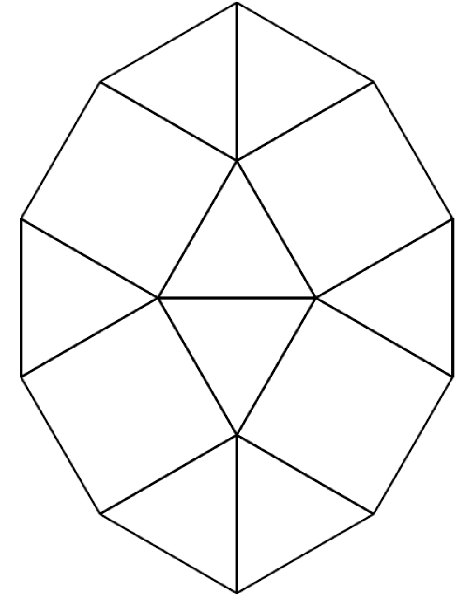

Worksheet
Task 3
Jigsaw reading:
Read the texts again and answer the following questions in your groups.

1.
2.
3.
4.
5.
6.
7.
8.
9.
10.

Task 4
Writing and Speaking
As a group you have to choose one place to visit. Discuss the advantages and disadvantages of your tourist attraction and write them down on your flipchart paper. Motivate your ideas. Then present it to the other groups.

Puzzle Sheet 1

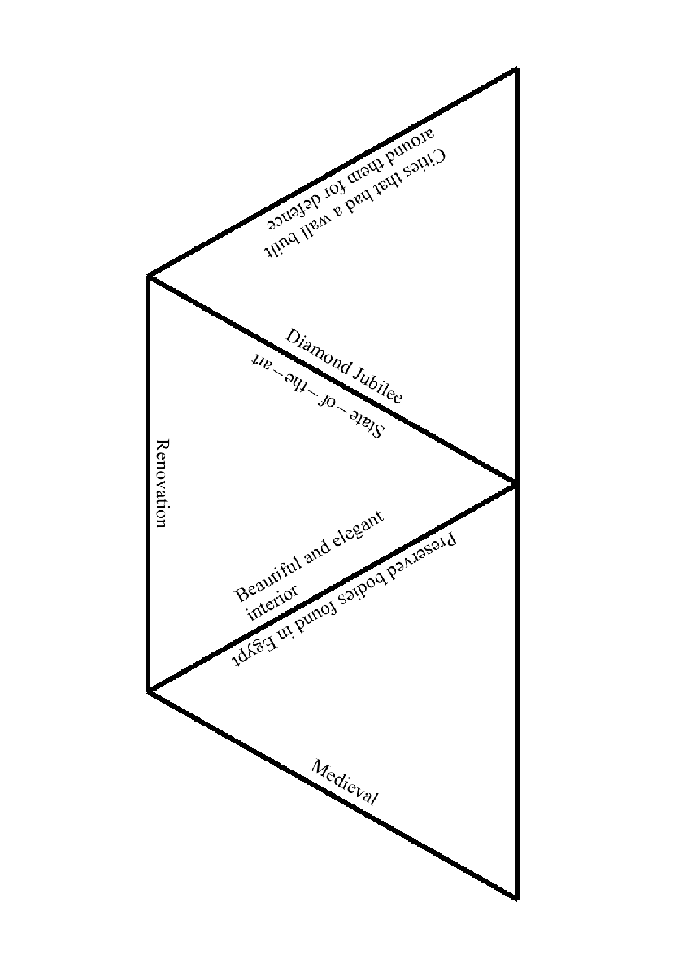

Puzzle Sheet 2
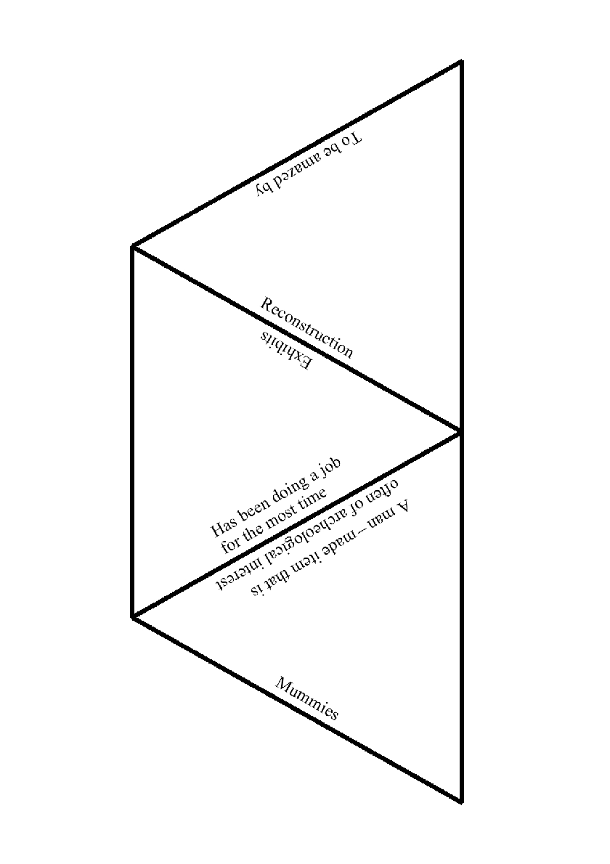

Puzzle Sheet 3
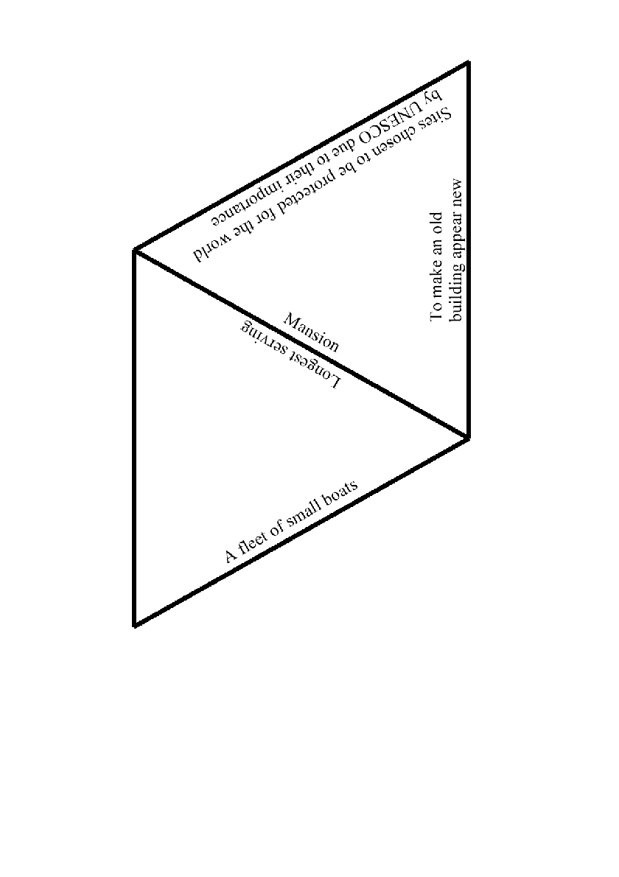

Puzzle Sheet 4
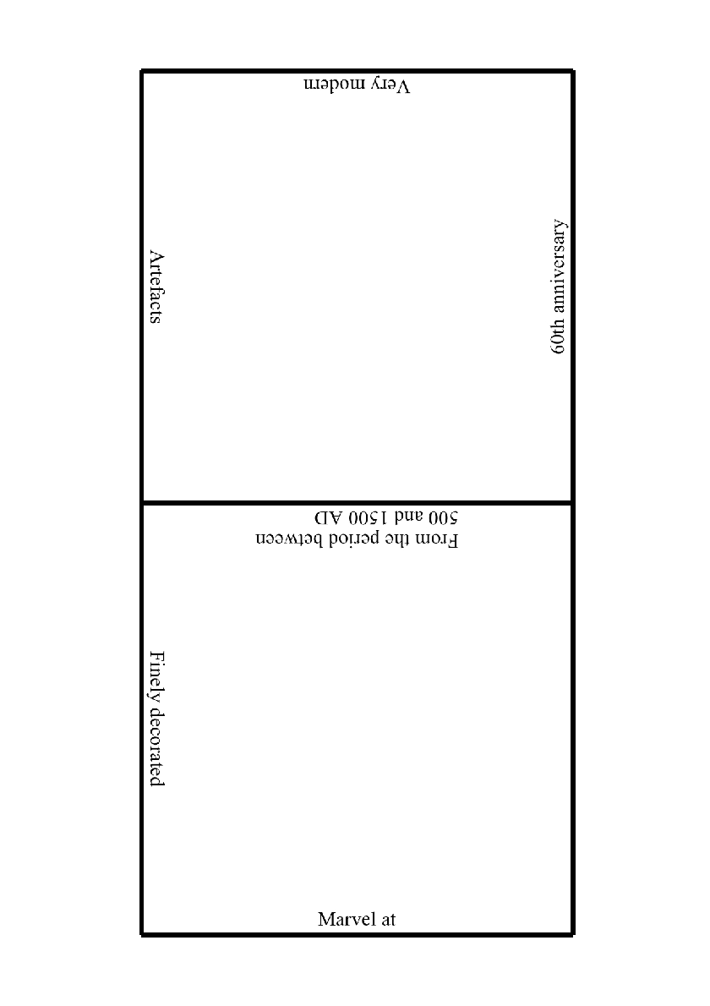

Puzzle Sheet 5

