The History and Foundation of EU - sketch and Folk Costume Parade

Among the cultural activities in Zarnesti, there was a sketch which has as main theme The History and Foundation of the European Union. The students retraced the entry in the EU of each of the countries involved in the project (Austria, Germany, the Netherlands, Romania, Hungary), pointing out the year in which the country entered the EU, cultural-historical and geographic aspects of each of the countries as well as characteristic traditions. The students presented each country in the project by wearing their national costumes and the colors found on the flags of each country. Also, the blue dresses with golden stars on them worn by the two girls, symbolized the development of the European Union as each country adhered to it.

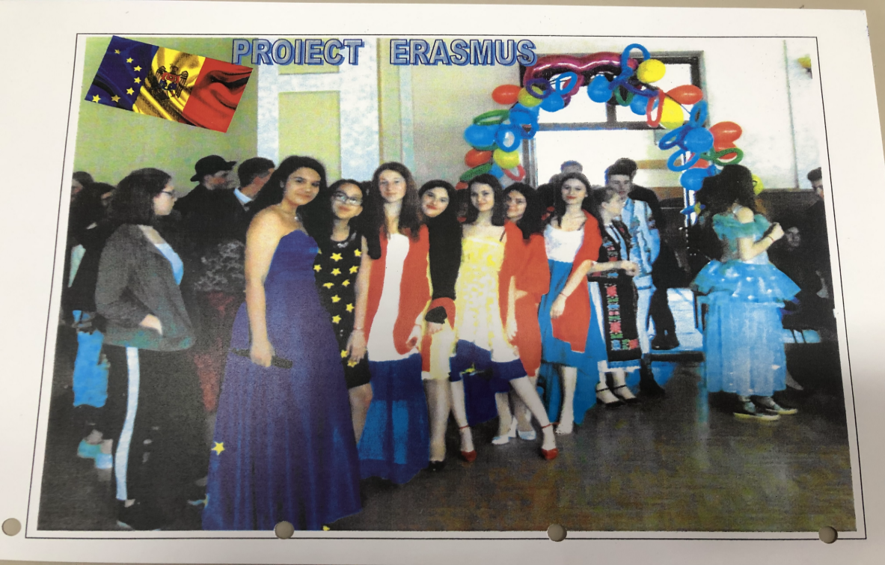

The sketch was followed by a folk costume parade, costumes which were specific to each geographical area where the partner schools come from (Rhauderfehn - Ostfriesland, Zwickau - Sachsen, Budapest - Hungary, Brasov - Transilvania, Abtenau - Bundesland Salzburg).
The musical background was representative for each country. In this way the participants in the project could find out information about historical, cultural - traditional elements characteristic for each region where the schools involved in the project are from.

