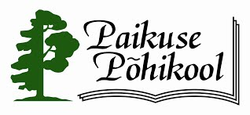

Cultural Art for the Development of European Education

The schools-partners’ meeting in Paikuse, Estonia
11th –15th October, 2016

AGENDA

11th October  Tuesday | 12th October  Wednesday | 13th October  Thursday | 14th October  Friday | 15th October  Saturday
Arrivals | 8.30 - meeting at the hotel, a trip to Paikuse Basic School by school bus (ab 9 km)  9.00 – opening ceremony at school  - partners`presentations (max 5 min per country)  - a guided tour at school  11.00 – coffee break  11.30 – project meeting  13.30 – lunch break  14.15 – project meeting  - coffee  16.15 – to Pärnu by school bus  19.00 – dinner  www.edelweiss.ee | 8.30 – meeting at the hotel  9.00 – project meeting  11.00 – coffee break  11.30 – project meeting  13.30 – lunch break  14.15 – project meeting  - coffee  16.30 – to Pärnu by school bus  17.00 – 18.30 a guided tour in Pärnu (on foot and by bus)  19.30 – dinner (10 – 20 eur) | 8.30 – meeting at the hotel  9.00 – project meeting  11.00 – coffee break  11.15 – project meeting  - certificates  12.15 – to Pärnu by school bus  Departures | Departures

- During the breaks there is coffee and snacks in our media classroom.
- The participant`s fee for the arrangements is 25.- € per person. Each person /school gets invoice.
- Information: +372 56696906, kersti.rohtmets@ppk.edu.ee

