The Treaty of Versailles
Read the clauses of the treaty.

- Germany had to accept total responsibility for starting the war. This was called the ‘War Guilt Clause’, or Article 231.

- Germany had to pay £6,600 million to the Allies to cover the damage it had caused during the war. This was a form of compensation known as reparations.

- Germany had to hand over 70,000 square kilometres of land to the Allies. The allies shared this land out amongst countries within Europe. For example, Alsace-Lorraine was returned to France (the Germans had taken it off France in 1871), West Prussia and Posen were given to Poland, and Eupen and Malmedy were given to Belgium. This was supposed to make Germany weaker, and make other European countries stronger. This would help to prevent Germany invading its neighbours within Europe in future years.

- Germany had to hand over all its colonies to the Allies
Colonies are areas of land that are governed by a Parent State although they are outside of that state – they are abroad. Germany’s colonial Empire amounted to about one million square miles. One of the largest areas to be taken from Germany was in Africa. The Union of South Africa administered German South-West Africa. Britain, France and Belgium divided up the rest of the African land governed by Germany.

- The German armed forces were to be reduced greatly. The Reichwehr (Army) were only allowed 100,000 men, and were not allowed to use conscription (forcing ordinary men to join the army for a period of time). The Navy was limited to 15,000 sailors.

- The German navy had to be reduced greatly. They were only allowed to keep 6 battle ships. They were only allowed 15,000 men.

- The use and production of weaponry was limited.
The Germans were not allowed an airforce or any submarines. The Navy was only allowed six battleships and the buying of any further war materials was banned.

- The Rhineland had to be occupied by Allied troops.
This area bordered France and was meant to give the French greater security. The occupation was to last for fifteen years and no German troops were to be allowed into the area.

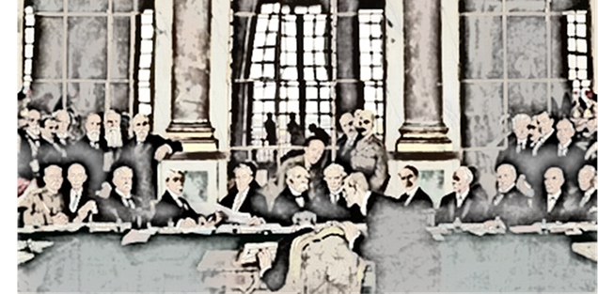
What impact did the treaty have on Germany? Fill the grid with how it affected Germany.

Clause from the  treaty | Economic Impact | Military Impact | Pschological Impact

