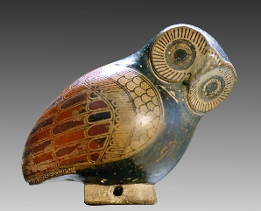
Ancient Greece Word Search
AESCHYLUS AGAMEMNON ALEXANDER ANTIGONUS ARCHIMEDES ARISTARCHUS ARISTIDES ARISTOPHANES ARISTOTLE CIMON CLISTHENES DARIUS DEMOCRITUS DEMOSTHENES DIOGENES DRACO EPAMINONDAS EPICURUS ERATOSTHENES EUCLID EURIPIDES HECTOR HELEN HERODOTUS HESIOD HIPPOCRATES HOMER ICTINUS LEONIDAS MYRON ODYSSEUS PARIS PERICLES PHEIDIPPIDES PHIDIAS PHILIP II PINDAR PLATO PRAXITELES PTOLEMY PYTHAGORAS SAPPHO SELEUCUS SOCRATES SOLON SOPHOCLES THALES THUCYDIDES XENOPHON XERXES ZENO

