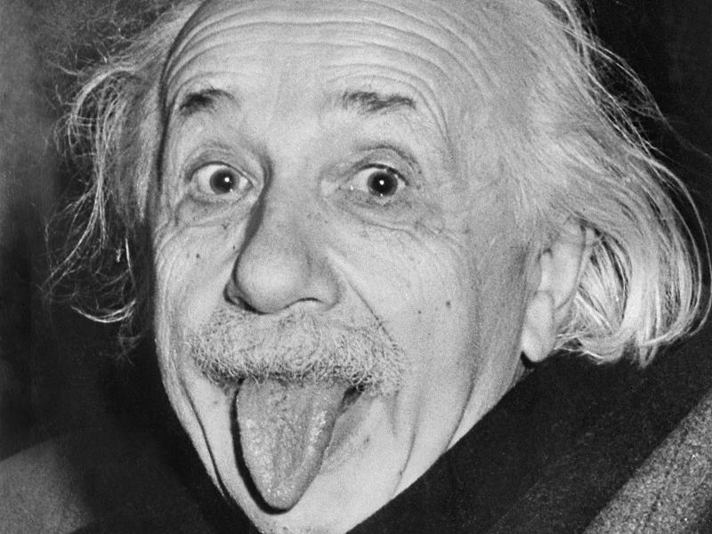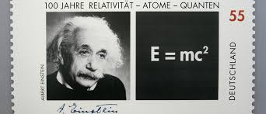

The parents Hermann Einstein (30 August 1847 to 10 October 1902) and Pauline Einstein, b. Koch (February 8, 1858 to February 20, 1920, born in Cannstatt, Württemberg, died in Berlin), both came from Jewish families who had already been living in Swabia for centuries. The maternal grandparents had changed their surname Dörzbacher in Koch. The paternal grandparents still wore traditional Jewish names, Abraham and Hindel Einstein. That changed with the parents of Albert Einstein. His father Hermann Einstein came from the Upper Swabian town of Buchau, in which there was an important Jewish community within the territory of the secular Ladel in Buchau since the Middle Ages (see also: Family Einstein in Bad Buchau).

**His life and work**

1879

March 14: Albert Einstein is born in Ulm as the son of the merchant Hermann Einstein and his wife Pauline (née Koch).

1896

He begins his studies in mathematics and physics at the Technical University of Zurich after being rejected there in the previous year.

1900

Diploma as a subject teacher for mathematics and physics.

1902-1909

Technical auditor at the Swiss Federal Office of Intellectual Property (Patent Office) in Bern.

Albert Einstein

physicist

Albert Einstein is a born ulmer .He is born in the year 1879 on the 14th of march.

Albert Einstein   
is considered one of the most important theoretical physicists in the history of science and the world's most famous scientist of modern times. His research on the structure of matter, space and time as well as the nature of gravity significantly changed the previously valid Newtonian world view.

**His Family**

Kurfürst Balduin

Realschule +

Trierweilerweg

54290 Trier

Marvin Genty

1921

Einstein receives the Nobel Prize in Physics for the introduction of the concept of light quanta and his work in the field of theoretical physics.

1945

6 and 9 August: Einstein founds the "Emergency Committee of Atomic Scientists" after the atomic bombs on Hiroshima and Nagasaki were dropped by the US Air Force. As President of the Committee, he is committed to the peaceful use of atomic energy.

1955

April 18: Albert Einstein dies in Princeton (New Jersey).

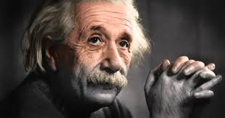

1915

October: Einstein formulates the "General Theory of Relativity", which replaces the previously valid physical explanatory approaches.

1920

Due to his research and his Jewish origin Einstein is hostile in Germany.

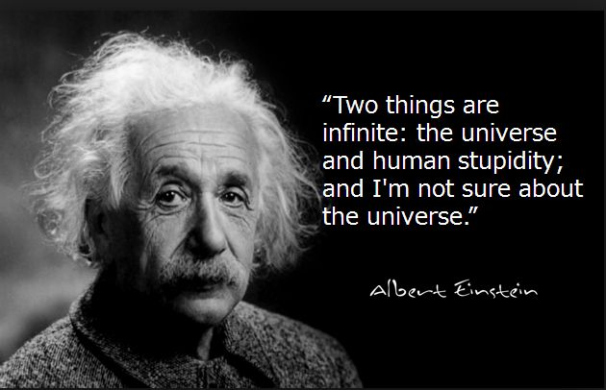

1905

With the justification of the "Special Theory of Relativity" the transition to the science of the 20th century begins. Shortly thereafter, he provides a supplement to the theory of relativity with the formula E = mc².

1907

Habilitation at the University of Bern.

1909

Einstein receives an associate professor of theoretical physics at the University of Zurich.

1911

Ordinary at the University of Prague.

1912

He works at the Swiss Federal Institute of Technology in Zurich, where, in addition to his research, he is required to teach theoretical physics.

1914

April 1: Einstein receives the call to the Prussian Academy of Sciences in Berlin. He can

**His life and work**

**His life and work**

**His life and work**