Karl Marx
Life
Karl Marx was born on 5th May 1818 in Trier, grow up with 5 brothers and sisters, he died 14th March 1883 in London and was 65 years old. After the school-leaving qualification of the Gymnasiums with best marks he for several months study legal sciencies based on the model of his Dad. But after he identifified, that it is not for him, instead he study the History and the Philosophy.
As his father died 10th May 1838, become Marx as his legal Guardians was now Johann Heinrich Schlonk, because Marx was 20 years old and to this time as 25 years as stand adult.
He interessing to all time on Politik, worked parallel to the new Studium as a Journalist in the Rheinisch Newspaper and proounce against the Society of class.
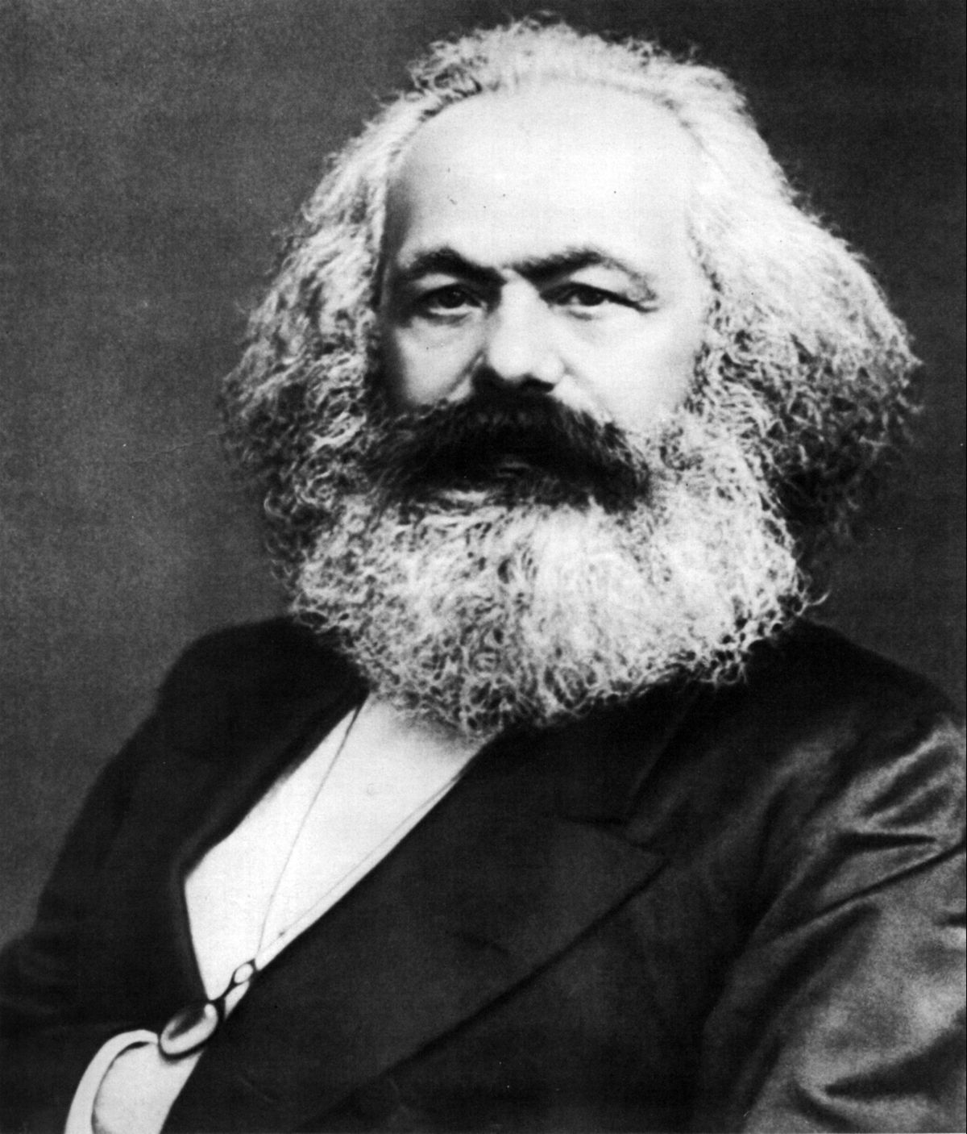
The industrial Revolution Karl Marx experienced very close, in this period the handicraft was replaced from the Fabrics, the factory owners (capitalists) become richer and the larger measure of the Worker (proletarians) sunk into poverty more and more.
The complete sociaty be in revolt and above all stand off Karl Marx be out his thinking and writing as one of the first, that the problem are the social relationships, not the greed of the factory owner, but his Texts was baned and be censorious from the riches and aristocrats.
It is for this Karl Marx reason rolled past to Paris, about he can express his mind and get to know kindred spirits. He get to know his friend Friedrich Engels. But he don’t can a long time stayed: he identified 1844, not long time later from Brüssel and finally from Germany. In the year 1849 he journey to England and.

How Karl Marx changed the World
Karl Marx and Friedrich Engels they got to be best friends in Paris. The father from Engels was a factory owner, but he upheld the worker position, support Marx´s mind and worked with him the political concept of the comunismus, what come from the Latin Word for united.
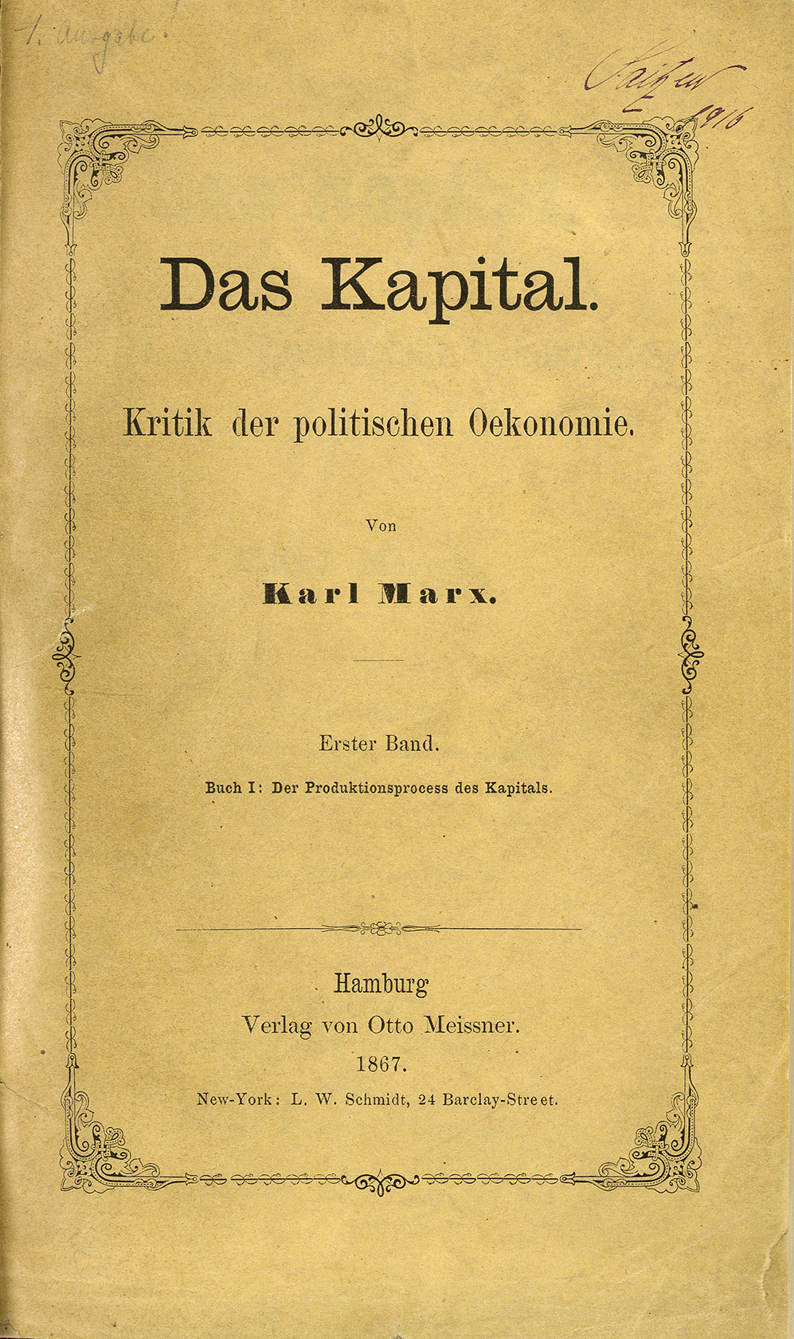
This state form heard to the socialism and follow the objective from a classless Sociaty, in this the goods shared comradely, exist no poor and rich, all persons have the same property and belong to everting objectives all persons. The teaching of Marxismus, how the called today, called to a revolution, in this the discriminated worker restist against the capitalists.
Marx and Engels lived for her manifest. They was active in political groups, organised first revolts and released the communist manifest in the year 1848. It belongs to the most reading books on the world today. Later Karl Marx released his detailed teaching in a book with the name ,,Das Kapital“.
Marx and Engels become role models for a lots of workers and triggerd revolutions in many lands. In the year 1917 taked the teaching from Marx and Engels the Russian Revolution and a political change, but both was to this time a long time dead. Karl Marx died in 1883 at the age of 65 before the Russian Revolution 34 years. Friedrich Engels died in the year 1895 at the age of 75.

