What rights do we have as citizens of the EU?

The main rights of EU citizens:
1. The right to move freely within the territory of the EU.
2. Active and passive right to vote in all municipal and European elections at the place of residence in other EU countries
3. Right to protection by the diplomatic and consular representations of any EU Member State
4. Right to petition Parliament, complaints to the Ombudsman and the EU Citizens' Initiative

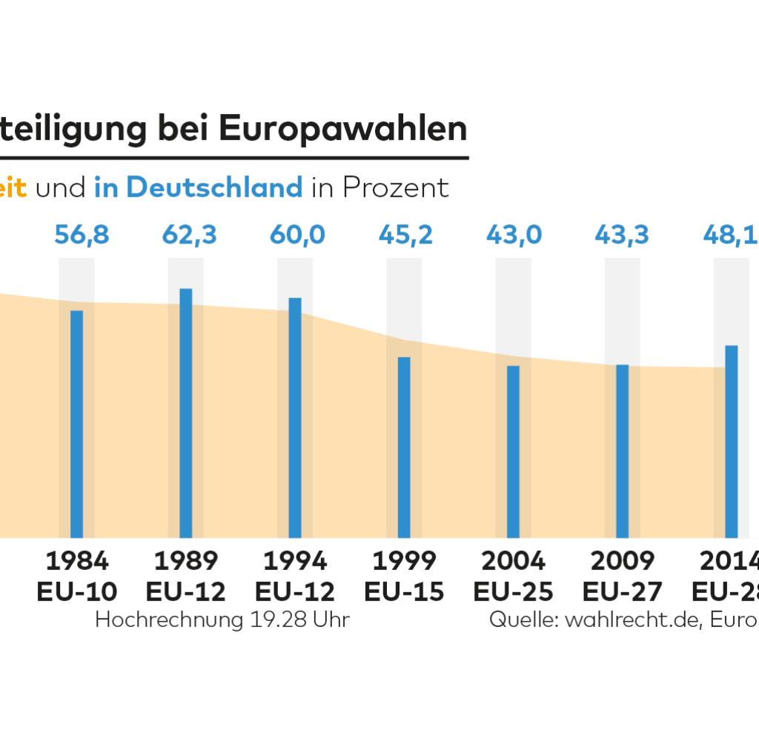
Political participation:

1. All citizens have the right to participate in the democratic life of the Union.
2. The most important form of political participation is the biennial elections.
3. Voter turnout for Europeans has never been above the 50 percent mark.
4. In the first referendum in EU history in 2013, nearly 1.7 million EU citizens supported the call for a European Citizens' Initiative.
5. Such a request is only valid if it has at least one million signatures.

Citizenship:

1. All EU citizens have European citizenship, which extends citizenship but does not replace it.
2. You have the rights that you have as an EU citizen, even if you are in other member states of the EU.

