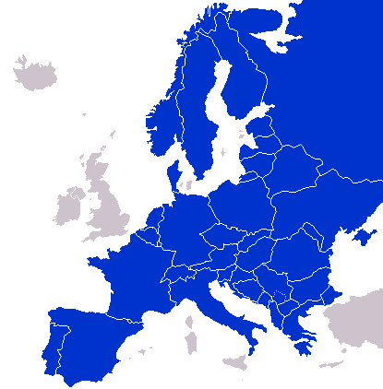**Germany**

History:

He led the Protestant Reformation against the Catholic Church:

_____________________________

Following World War One, Germany signed this treaty:

___________________________________

_____________________________

In what year were East Germany

and West Germany reunified?

_____________________________

Economy:

Per capita GDP:

World Rank GDP:

**Government:**

**Form of Government:**

**______________________________**

**Head of Government:**

**______________________________**

**Head of State:**

**______________________________**

**Number of Federal States:**

**______________________________**

Overview:

Population:

Capital:

Largest City:

Neighboring Countries:

**Label Germany on the map**