The european single market…

… is the common internal market of the member states of the european union. (EU) It currently includes 28 countries with over 500 million inhabitants and an economic output of around 15 billion euros.

Basis are the four freedoms…
Free movements of goods
- no customs duties and quantitative restriction, approximation of standards, free competition

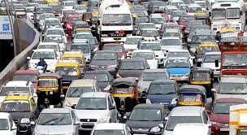
Free service traffic
- cross-border offer of services such as transport, energy, telecommunications, insurance, crafts, …

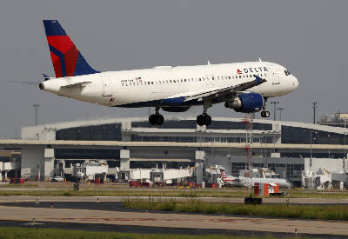
Free passanger traffic
- no border controls, freedom of establishment (residence, workplace), recognition of vocational and school qualifications

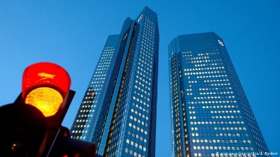
Free capital traffic
- free money and capital movements, common market and financial services, company investments in the eu

