Places of interest:
The Saxon Polar express - Santa Claus trips with the steam locomotive train
The landscape is covered with snow, the candle arches shine
in the windows and a steam locomotive runs through the village steaming and snorting. What sounds like a polar express becomes reality in Saxony
The Langenhennersdorfer waterfall is located near Pirna. Thanks to a small parking place at the waterfall a short stop is worthwhile.
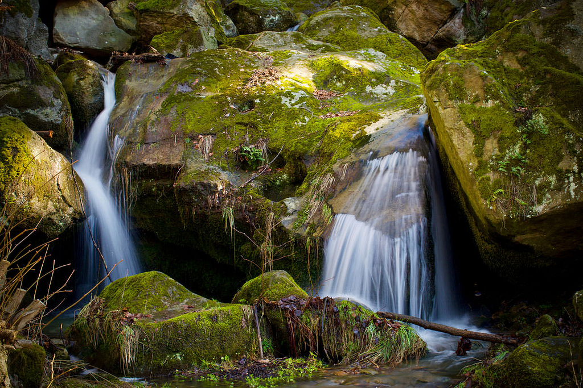
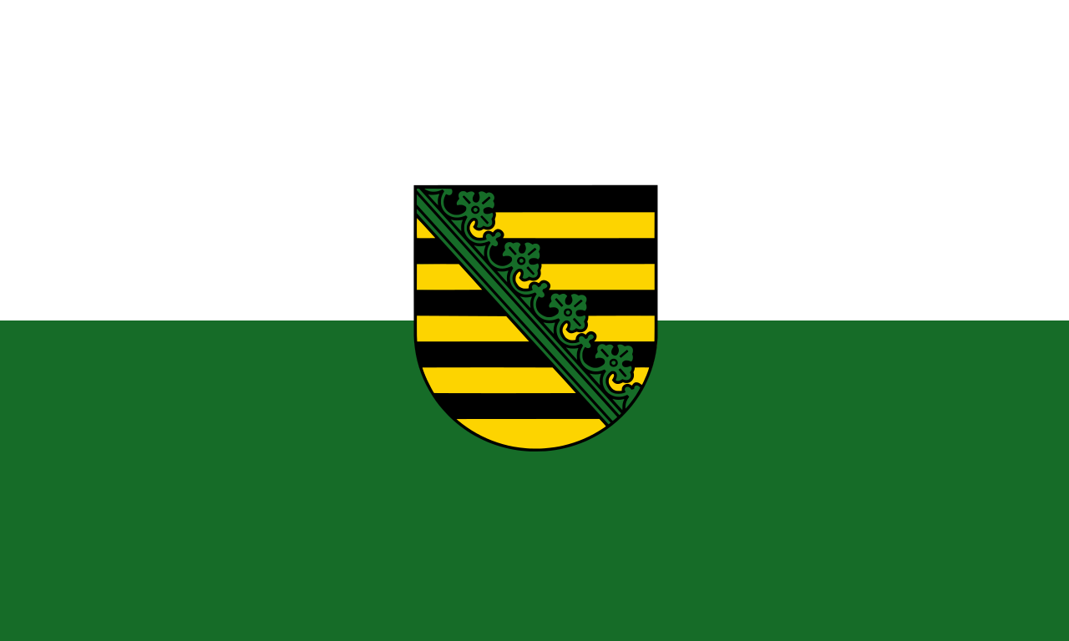

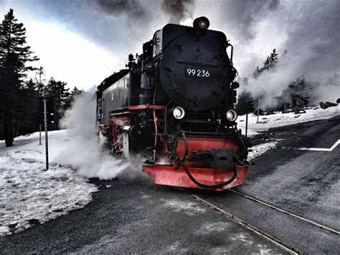

Travel
Your
Dream

Travel
Guide
Saxony

Travel
Your
Dream

Facts about Saxony:

The Population :4.081.308 since 2017

Big City’s:
Dresden (capital), Görlitz ,Leipzig ,Delitzsch ,Meißen ,Plauen , Zwickau, Bautzen, Chemnitz

Geographical location:
Saxony lies in the east of central Germany and borders the states of Bavaria, Thuringia, Saxony-Anhalt, Brandenburg, the Republic of Poland and the Czech Republic. The Free State of Saxony as well as Thuringia and parts of Saxony-Anhalt belong to the region Central Germany.

industry:
As early as the 18th century, the industrial age began in Saxony with the construction of the first mechanical engineering companies. The region was thus a pioneer on the European mainland. The first locomotive constructed in Germany, the first six-cylinder engine, the centered gear lever in the car - all innovations from Saxony.

Festivals Worth Seeing:

Altenberg:
Garden Festival ,Naturmarkt ,
herbal firmly
and Christmas Market

Rechenberg-Bienenmühle:
Clausnitzer funfair

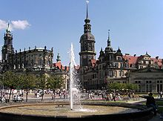

Dresden
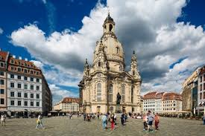

Leipzig
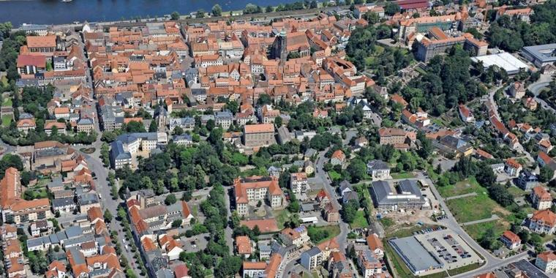

Pirnas

