Bremen is an hanseatic town which consists of Bremen and Bremerhaven together it has an population of 680.000 pepole. Bremen is one of the 3 city states in germany it is also called the two city state Bremen because it consist of Bremen and Bremerhaven.

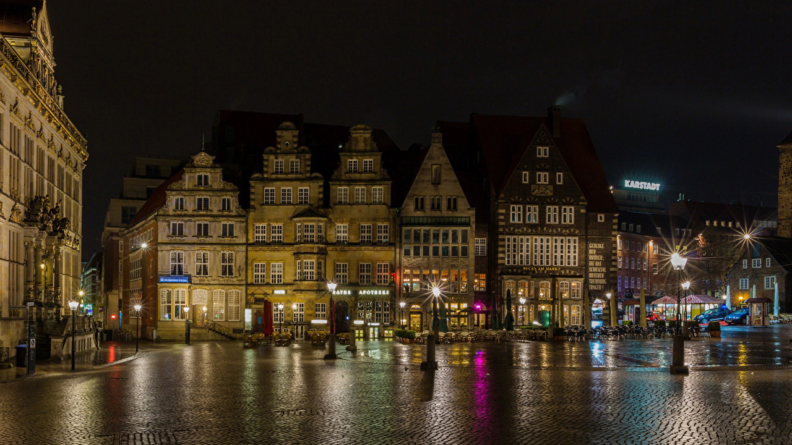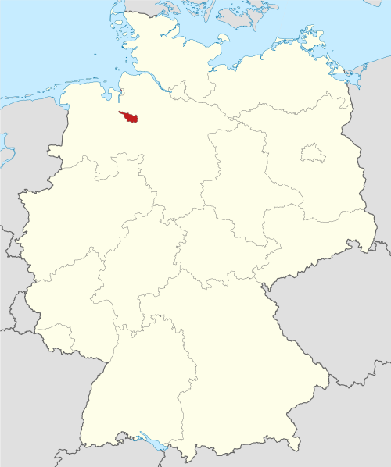

Even tho it has one of the most low-populations it is very intresting.

You can visit the bremer townhall which is 600 years old or the st petri dom which is out of the 11th century and gaze at its beautiful architecture.

The bremer city musicans

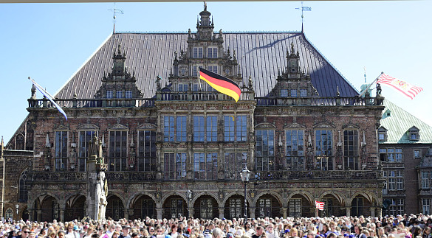

The bremer city musicans is an famous fable out of bremen it plays of 4 animals an chicken, an dog, a cat and a donkey who were to be killed because they were no use for their owners anymore. They all escare and are now trying to become city musicans in bremen.

You can see the animals standing on top of each other. If u go to Bremen you should really read the fable its an fun story and an big part of its culture.