The Berlin Wall 1961-1989

Before the construction of the wall

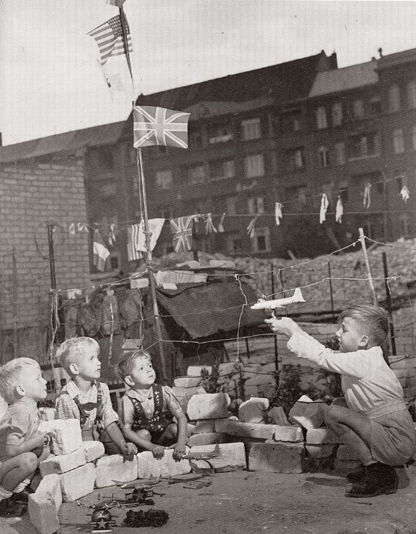
After the 2. World War Germany was divided in 4 occupied zones, Berlin in 4 sectors . East-Berlin belonged tot he Soviet, West-Berlin to the Western sectors (US, GB, France)
Differences between West-Allies and the Sovietunion made it impossible to have a common administration and led to different devolpments in the occuoied zones.
From June 1948 until May 1949 Berlin was blocked by the Sovietunion as an reaction on the introduction oft he „Deutsche Mark“ in the Western zones. West-Berlin could onlys be supplied by air („Rosinenbomber).
, https://commons.wikimedia.org/w/index.php?curid=73611059
In 1949 the Federal Republic of Germany (democratic, liberal, capitalistic) and the German Democratic Republic ( socialistic, dictatorial, planned economy) were founded.
The BRD joined the Western alliances (NATO, EEC) and the GDR the Eastern (Warsow Pact).

The border before the construction of the wall

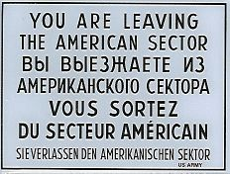
Until 1952 the demarcation line was more secured and patroled, but it was still permeable. After 52‘ it was closed and border fortifications to West Germany were upgraded. From December 1957 escape and tying to escape from East Germany were prsoecuted and sentenced with up to three years in jail. Berlin was the last possibility the leave the GDR at a relativ low risk. About 3,5 millions of people left the GDR between 1945 and 1961.This mass exodus led to a lack of workers and was bad publicity.

Building of the Wall 13. August 1961
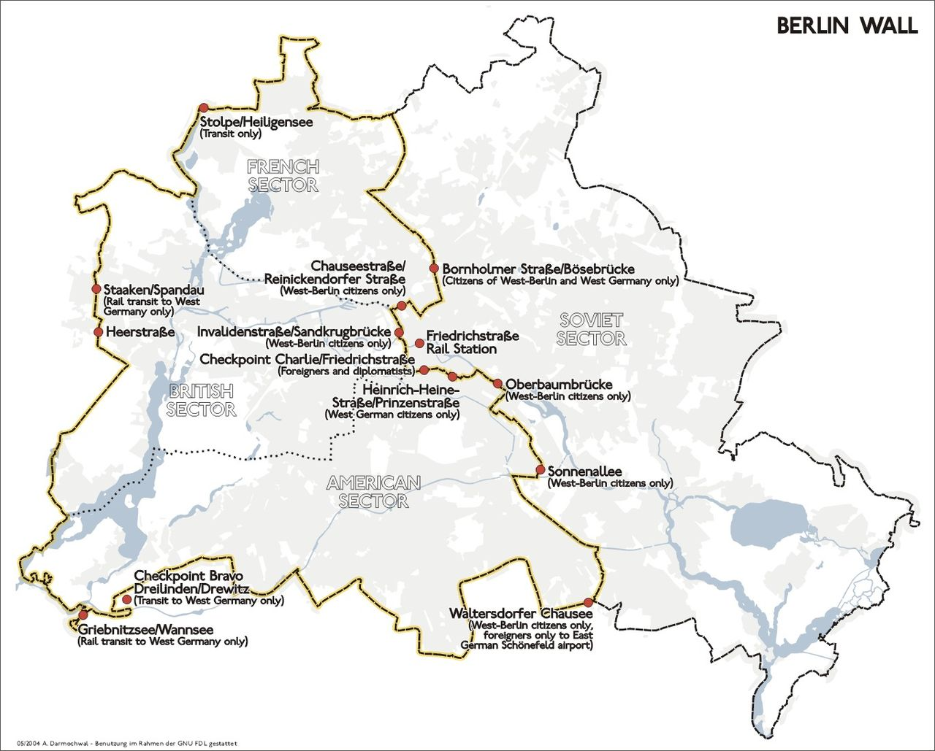
"Nobody has the intention of building a wall," GDR head of state Walter Ulbricht, East Berlin, said in a speech on June 15th 1961. A month later work started with the complete closure oft he sectors border. Rail traffic between East and west-Berlin ended. Soldiers oft he GDR and the Soviet Union took their positions in and around Berlin. Barricades were built and secured with barbed wire first, in the following days they were replaced by wall stones, in the later years by reinforced concrete panels each about 2,6 tons heavy. More than 300 watchtowers were erected, minefields and automatic firing devices were installed.

While the wall stood at least 136 people lost their life directly at the wall. The number of people killed by mines is unknown.

The wall is wavering

In May 1989 Hungary opened ist border to Austria . from the 10th of September on people from the GDR could legaly travel through Hungary and Austria to West-Germany. 10thousands people from the GDR fled to the West-German Embassy in Prague and were allowed to leave at September 30th.

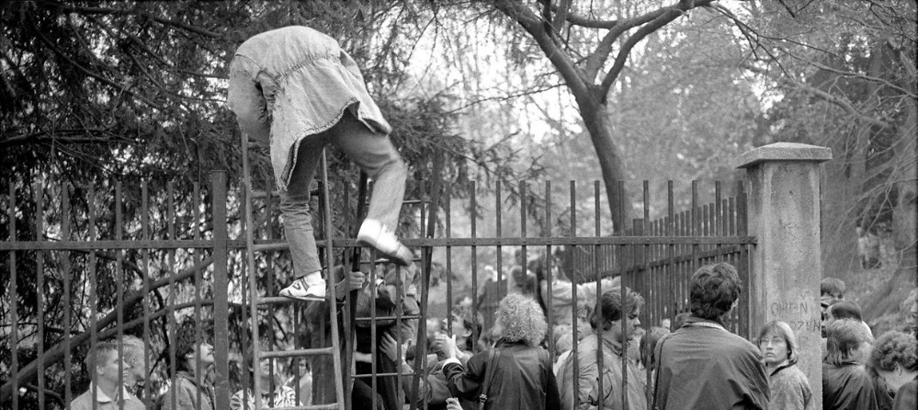
Botschaftsflüchtlinge 1989, © Blanka Lamrová

The fall of the wall

When a press conference went wrong on November 9th 1989 (a GDR politician should inform about new travel regulations, but said they were immidiately valid instead oft he next day), masses of people from East and West gathered spontaneously at the
border crossing points, where the soldiers had no command how to react. When the pressure from the masses got to high, the soldiers opened the frontier.
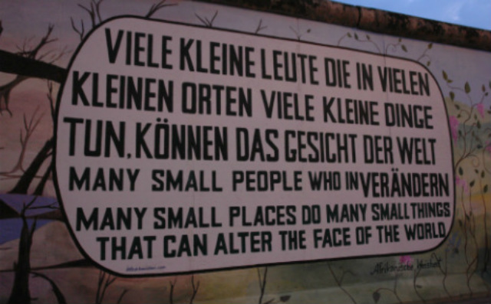
The artwork at the Eastside Gallery. Photo: Kolossos / Wikimedia Commmons

