It was founded on 3 October 1990.
Erfurt is the state capital of Thuringia.
The area is 16,200 square kilometers.
The population is more than 2,3 million.

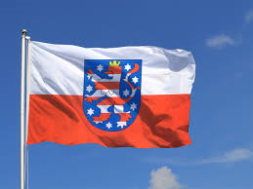

Kurfürst-Balduin Realschule Plus
Trierweilerweg 12a
Trier/ Germany, 54294
Phone 0651- 820394
Fax 0651- 9932466
rsplus.west@gmx.de

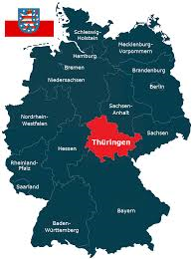

It is described as the green heart of Germany.
It lies in the east.
In the federal state lies the geographical center of Germany.

Places of interest
-Weimar, Wartburg Castle (was founded around 1067 by Ludwig the Knight and has been a UNESCO World Heritage Site since 1999) , Cathedrale, Egapark

- a special monument is the Goethe-Schiller Statue

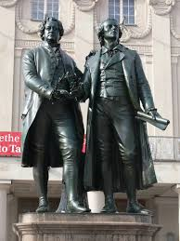
School system
- Community school class 1-12
- Primary school class 1-4
- Regular school class 5-10
- Gymnasium class 5-10
- Comprehensive school class 5-10/13
- Vocation school classes up to 15
- Special school

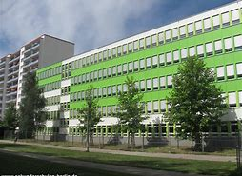

Free-time activities
- GalaxSea Leisure Pool Jena
- Altenburg Nobitz flight world
- Ghosts & Playhouse
Information about the federal state
- in Erfurt is the seat of the state government
- Parliament sits in Erfurt
- Chair: Birgit Diezel (CDU)

The largest cities are Erfurt, Gera and Jena.

A famous dish from Thuringia is the Thuringian sausage.

